Name: Year 5 Autumn 1 Week 4
accommodate | competition | existence | muscle | rhyme
accompany | conscience | explanation | necessary | rhythm
according | conscious | familiar | neighbour | sacrifice
achieve | controversy | foreign | nuisance | secretary
aggressive | convenience | forty | occupy | shoulder
amateur | correspond | frequently | occur | signature
ancient | criticise | government | opportunity | sincere
apparent | curiosity | guarantee | parliament | soldier
appreciate | definite | harass | persuade | stomach
attached | desperate | hindrance | physical | sufficient
available | determined | identity | prejudice | suggest
average | develop | immediate | privilege | symbol
awkward | dictionary | individual | profession | system
bargain | disastrous | interfere | programme | temperature
bruise | embarrass | interrupt | pronunciation | thorough
category | environment | language | queue | twelfth
cemetery | equipment | leisure | recognise | variety
committee | especially | lightning | recommend | vegetable
communicate | exaggerate | marvellous | relevant | vehicle
community | excellent | mischievous | restaurant | yacht

Y5 and Y6 Spelling Word List

Year 5 and Year 6 Spelling Patterns
Children in Year 5 and Year 6 will continue to revise previously taught spelling patterns as well as learn the following new work:
cious  or  tious | cial  or  tial | -ant  -ance  -ancy  -ent  -ence  -ency | -ible  -ibly | Homophones | Use of the hyphen
ei after c | ough | -fer | -able  -ably | Silent letters | Nouns end with –ce  Verbs end with -se

These are your spellings to learn this week. Can you work out why these words have been chosen?
If they have a common spelling pattern, you could think of other words that could be added to this list. If they are from the Y5 spelling list, you need to be very familiar with their spelling through practise.

doubt | knight
island | numb
lamb | autumn
solemn | whistle
thistle | vehicle

Tick
here!
Handwriting
Make sure that you use an appropriate pen or pencil to practise your handwriting on the sheet. It must be joined-up handwriting!
Tick
here!
Doodle Maths
How many stars have you achieved this week? Try to use the app frequently and aim to earn 40 stars each week.
Tick
here!

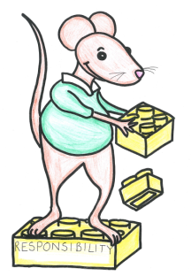
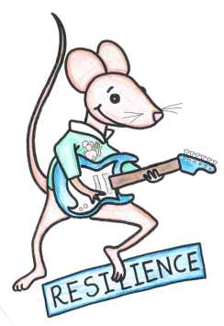
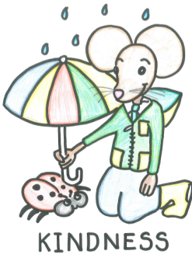
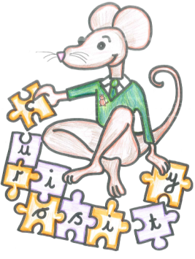
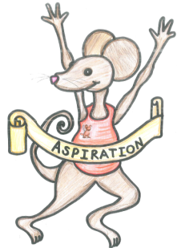

English Assignment
Over this half term, your child should aim to complete some writing at home each week. The time they invest in their written homework will vary from child to child – parental discretion is advised. Alternatively, you may wish to focus on just one or two of the activities this half term and develop them over several weeks with your child.
Week 4:
Imagine you are an Oompa Loompa. Write a postcard home to convince your friends to join you in Wonka’s factory.

What have you read at home?
Monday

Tuesday

Wednesday

Thursday

Friday

Saturday

Sunday

Here’s a book from our extended reading spine that your child could try and read this month independently or alongside an adult (and we do encourage adults to continue to read to their child in Y5). Reading this book would be a step towards earning a very special reading pin badge.
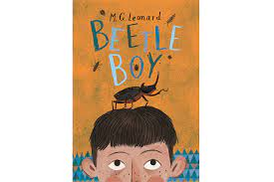

Darkus can't believe his eyes when a huge insect drops out of the trouser leg of his horrible new neighbour. It's a giant beetle – and it seems to want to communicate.
But how can a boy be friends with a beetle? And what does a beetle have to do with the disappearance of his dad and the arrival of Lucretia Cutter, with her taste for creepy jewellery?

If you read 5 times this week, you will be one step closer to achieving a reading star. Total reads this week:

Parental Signature…………………………………..
You are signing to confirm that your child has completed the homework tasks for this week, including reading at home.

Name: Year 5 Autumn 1 Week 4

Stop! Before you get started on this handwriting, check that you have the correct tool to write with. Don’t use felt tip pens or highlighters… Do sit at a table.

………………………………………………………………………………………………………………………………………………………………………………………………………………………………………………………………………………………………………………………………………………………………………………………………………………………………………………………………………………………………………………………………………………………………………………………………_____________________________________________________________________________________________________________________________________________________

………………………………………………………………………………………………………………………………………………………………………………………………………………………………………………………………………………………………………………………………………………………………………………………………………………………………………………………………………………………………………………………………………………………………………………………………_____________________________________________________________________________________________________________________________________________________

………………………………………………………………………………………………………………………………………………………………………………………………………………………………………………………………………………………………………………………………………………………………………………………………………………………………………………………………………………………………………………………………………………………………………………………………_____________________________________________________________________________________________________________________________________________________

………………………………………………………………………………………………………………………………………………………………………………………………………………………………………………………………………………………………………………………………………………………………………………………………………………………………………………………………………………………………………………………………………………………………………………………………_____________________________________________________________________________________________________________________________________________________

………………………………………………………………………………………………………………………………………………………………………………………………………………………………………………………………………………………………………………………………………………………………………………………………………………………………………………………………………………………………………………………………………………………………………………………………_____________________________________________________________________________________________________________________________________________________

………………………………………………………………………………………………………………………………………………………………………………………………………………………………………………………………………………………………………………………………………………………………………………………………………………………………………………………………………………………………………………………………………………………………………………………………_____________________________________________________________________________________________________________________________________________________

Maths Homework Year 5 Autumn 1 Week 4

Year 5 Key Skills
These questions have been chosen by your teacher as they are crucial skills that we want you to secure.
Reflect on your work at school and the strategies that we have learnt to help you.
1.  What is 10 000 more than 367 000? | 2.  767 000 + _______ = 777 000 | 3.  What is 100 000 less than 267 000? | 4.  What is 70 000 more than 810 000? | 5.  What is 60 000 less than 530 000
6.  205 123, 206 123, 207 123  What are the next 3 numbers that follow this pattern? | 7.  343 456, 363 456, 383 456  What are the next 3 numbers that follow this pattern? | 8.  420 000, 410 000, 400 000  What are the next 3 numbers that follow this pattern? | 9.  238 550, 208 550, 178 550  What are the next 3 numbers that follow this pattern? | 10.  Round 54 789 to the nearest 10 000.
Next challenge? Visit Maths Frame (https://mathsframe.co.uk/) and practise finding equivalent fractions.

