Name: Year 5 Autumn 1 Week 1
accommodate | competition | existence | muscle | rhyme
accompany | conscience | explanation | necessary | rhythm
according | conscious | familiar | neighbour | sacrifice
achieve | controversy | foreign | nuisance | secretary
aggressive | convenience | forty | occupy | shoulder
amateur | correspond | frequently | occur | signature
ancient | criticise | government | opportunity | sincere
apparent | curiosity | guarantee | parliament | soldier
appreciate | definite | harass | persuade | stomach
attached | desperate | hindrance | physical | sufficient
available | determined | identity | prejudice | suggest
average | develop | immediate | privilege | symbol
awkward | dictionary | individual | profession | system
bargain | disastrous | interfere | programme | temperature
bruise | embarrass | interrupt | pronunciation | thorough
category | environment | language | queue | twelfth
cemetery | equipment | leisure | recognise | variety
committee | especially | lightning | recommend | vegetable
communicate | exaggerate | marvellous | relevant | vehicle
community | excellent | mischievous | restaurant | yacht

Y5 and Y6 Spelling Word List

Year 5 and Year 6 Spelling Patterns
Children in Year 5 and Year 6 will continue to revise previously taught spelling patterns as well as learn the following new work:
cious  or  tious | cial  or  tial | -ant  -ance  -ancy  -ent  -ence  -ency | -ible  -ibly | Homophones | Use of the hyphen
ei after c | ough | -fer | -able  -ably | Silent letters | Nouns end with –ce  Verbs end with -se

These are your spellings to learn this week. Can you work out why these words have been chosen?
If they have a common spelling pattern, you could think of other words that could be added to this list. If they are from the Y5 spelling list, you need to be very familiar with their spelling through practise.

aspiration | chocolate
resilience | factory
curiosity | competition
responsibility | poverty
kindness | desperate

Tick
here!
Handwriting
Make sure that you use an appropriate pen or pencil to practise your handwriting on the sheet. It must be joined-up handwriting!
Tick
here!
Maths frame!
Have a go at the question attached to your homework sheet!
Tick
here!

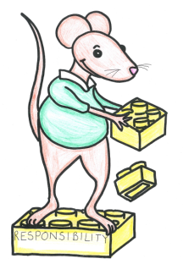
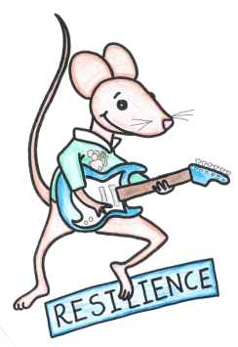
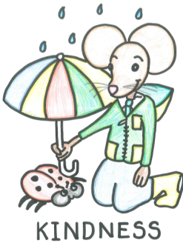
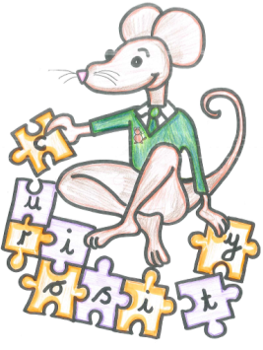
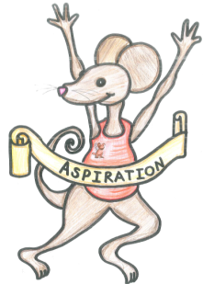

English Assignment
Over this half term, your child should aim to complete some writing at home each week. The time they invest in their written homework will vary from child to child – parental discretion is advised. Alternatively, you may wish to focus on just one or two of the activities this half term and develop them over several weeks with your child.
Week 1:
As this unit focuses on characterisation, invent your own villain. Consider other villains from stories that you know. Create a character profile – you’ll need to describe the character’s looks but think carefully also about the mannerisms that could deepen the level of characterisation. For example, an evil teacher might look over his glasses with a sneer. Finally, what might they say and how would they say it?

What have you read at home?
Monday

Tuesday

Wednesday

Thursday

Friday

Saturday

Sunday

Here’s a book from our extended reading spine that your child could try and read this month independently or alongside an adult (and we do encourage adults to continue to read to their child in Y5). Reading this book would be a step towards earning a very special reading pin badge.
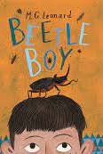

Darkus can't believe his eyes when a huge insect drops out of the trouser leg of his horrible new neighbour. It's a giant beetle – and it seems to want to communicate.
But how can a boy be friends with a beetle? And what does a beetle have to do with the disappearance of his dad and the arrival of Lucretia Cutter, with her taste for creepy jewellery?

If you read 5 times this week, you will be one step closer to achieving a reading star. Total reads this week:

Parental Signature…………………………………..
You are signing to confirm that your child has completed the homework tasks for this week, including reading at home.

Name: Year 5 Autumn 1 Week 1

Stop! Before you get started on this handwriting, check that you have the correct tool to write with. Don’t use felt tip pens or highlighters… Do sit at a table.

………………………………………………………………………………………………………………………………………………………………………………………………………………………………………………………………………………………………………………………………………………………………………………………………………………………………………………………………………………………………………………………………………………………………………………………………_____________________________________________________________________________________________________________________________________________________

………………………………………………………………………………………………………………………………………………………………………………………………………………………………………………………………………………………………………………………………………………………………………………………………………………………………………………………………………………………………………………………………………………………………………………………………_____________________________________________________________________________________________________________________________________________________

………………………………………………………………………………………………………………………………………………………………………………………………………………………………………………………………………………………………………………………………………………………………………………………………………………………………………………………………………………………………………………………………………………………………………………………………_____________________________________________________________________________________________________________________________________________________

………………………………………………………………………………………………………………………………………………………………………………………………………………………………………………………………………………………………………………………………………………………………………………………………………………………………………………………………………………………………………………………………………………………………………………………………_____________________________________________________________________________________________________________________________________________________

………………………………………………………………………………………………………………………………………………………………………………………………………………………………………………………………………………………………………………………………………………………………………………………………………………………………………………………………………………………………………………………………………………………………………………………………_____________________________________________________________________________________________________________________________________________________

………………………………………………………………………………………………………………………………………………………………………………………………………………………………………………………………………………………………………………………………………………………………………………………………………………………………………………………………………………………………………………………………………………………………………………………………_____________________________________________________________________________________________________________________________________________________
Maths homework- For this first week do a brain dump (in the style of journalling) of everything you know about place value! Show us what place value headings you know, use denes to help show us, use them in a question and even draw out a place value chart.

PLACE VALUE!

