Handwriting
Make sure that you use an appropriate pen or pencil to practise your handwriting on the sheet. It must be joined-up handwriting!
Name: Year 6 Summer 1 Week 3
Weekly Homework Tasks

Reading
Tick each day that you have completed your 15 minutes of reading. Use the notes section for anything reading related you wish to convey to the teacher.
Monday | Tuesday | Wednesday | Thursday | Friday | Saturday | Sunday
Notes:

Spelling
Practice the following spellings. You could use Look, Say, Cover, Write Check or create some rainbow writing or maybe even create an online wordsearch.
physical | nuisance
pronunciation | curiosity
twelfth | correspond
system | frequently
programme | accommodate

Tick
here!

Tick
here!

English
Over this half term, your child should aim to complete some writing at home each week. The time they invest in their written homework will vary from child to child – parental discretion is advised.
Week 3:
Research the life of your favourite author and write a short biography.

CGP Complete the following pages:
 | Task | Complete?
Maths – Choose the correct level book to complete.
Maths Foundation | Revision Book p44  Question Book p50
Maths Standard/Stretch | Revision Book p74-75  Question Book p63
Complete all the pages below.
Reading | CGP Book 2 Set A Test 2
Spelling | ent, ant words p18
Punctuation | Proof reading p46
Grammar | Mixed Practice p44-45

Parent signature……………………………………..

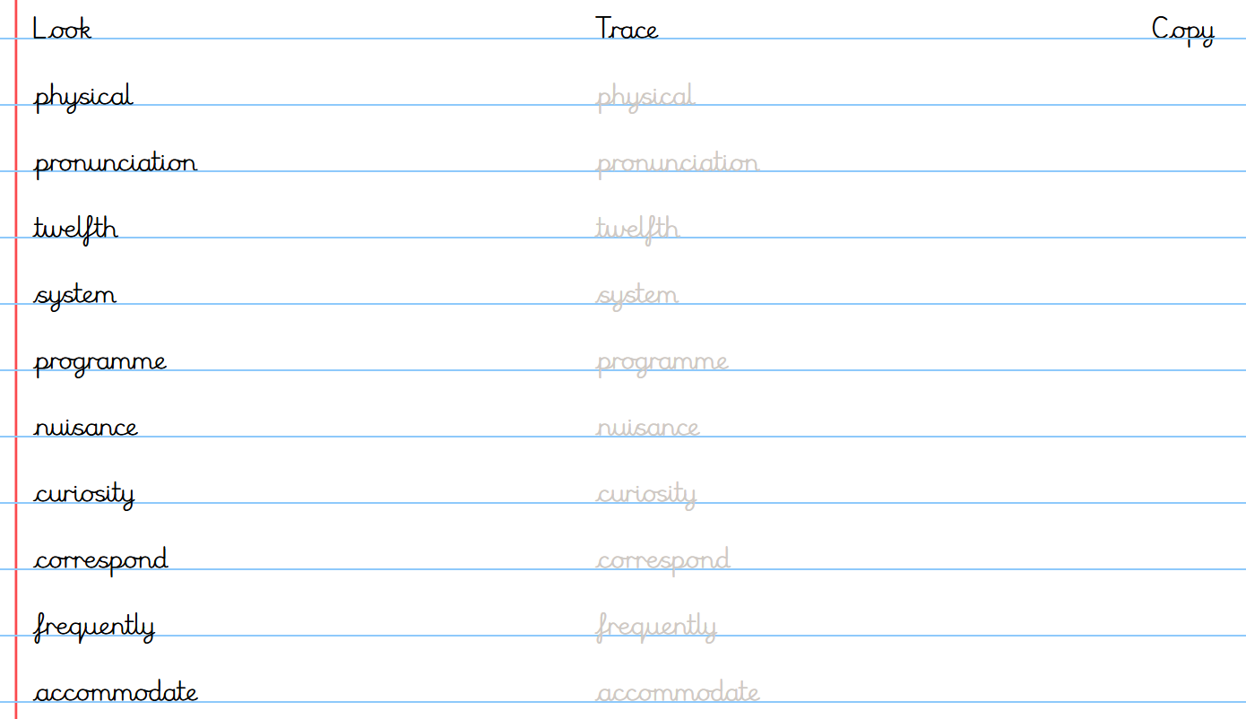
Handwriting Practice
Make sure you have a pen or pencil. Take time to write out each word in your best joined handwriting.

