Handwriting
Make sure that you use an appropriate pen or pencil to practise your handwriting on the sheet. It must be joined-up handwriting!
Name: Year 6 Summer 1 Week 4
Weekly Homework Tasks

Reading
Tick each day that you have completed your 15 minutes of reading. Use the notes section for anything reading related you wish to convey to the teacher.
Monday | Tuesday | Wednesday | Thursday | Friday | Saturday | Sunday
Notes:

Spelling
Practice the following spellings. You could use Look, Say, Cover, Write Check or create some rainbow writing or maybe even create an online wordsearch.
available | familiar
desperate | identity
develop | vegetable

Tick
here!

Tick
here!

English
Over this half term, your child should aim to complete some writing at home each week. The time they invest in their written homework will vary from child to child – parental discretion is advised.
Week 4:
Think about your dream career, create a mind map with the key skills you will need to pursue your dream.

CGP Complete the following pages:
 | Task | Complete?
Maths – Choose the correct level book to complete.
Maths Foundation | Revision Book p55  Question Book p62-63
Maths Standard/Stretch | Revision Book p86-87  Question Book p73
Complete all the pages below.
Reading | CGP Book 2 Set A Test 3
Spelling | ei, ie words p43
Punctuation | Any missed page
Grammar | Mixed Practice p60-61

Parent signature……………………………………..

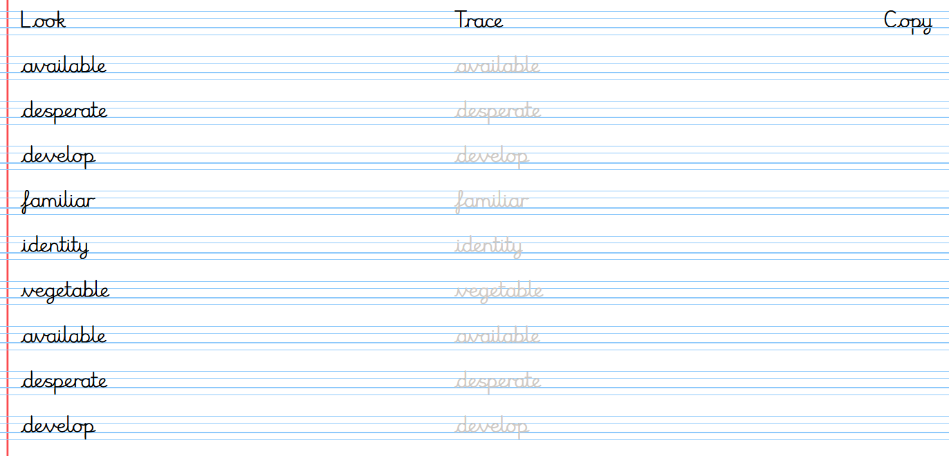
Handwriting
Stop! Before you get started on this handwriting, check that you have the correct tool to write with. Don’t use felt tip pens or highlighters… Do sit at a table.

