Handwriting
Make sure that you use an appropriate pen or pencil to practise your handwriting on the sheet. It must be joined-up handwriting!
Name: Year 6 Summer 2 Week 3
Weekly Homework Tasks

Reading
Tick each day that you have completed your 15 minutes of reading. Use the notes section for anything reading related you wish to convey to the teacher.
Monday | Tuesday | Wednesday | Thursday | Friday | Saturday | Sunday
Notes:

Spelling
Practice the following spellings. You could use Look, Say, Cover, Write Check or create some rainbow writing or maybe even create an online wordsearch.
accommodate | sacrifice
existence | signature
necessary | temperature
explanation | programme
sincere | disastrous

Tick
here!

Tick
here!

English - compulsory
Over this half term, your child should aim to complete some writing at home each week. The time they invest in their written homework will vary from child to child – parental discretion is advised.
Week 3:
We would love to hear more about what you do outside of school. Write a paragraph about what ‘drives you’ or about what enthuses you outside of school. In other words, what do you like doing and what does it give you?

Since you have completed your SATs tests, it has been decided that the CGP pages are no longer required as part of your homework.

We would like you instead to consider your English task as compulsory. This means that for this term it as an expectation that children complete the following task to be brought in on Monday mornings:
- English task
- Reading
- Handwriting
If children wish to continue filling in any pages in their CGP books that they have not yet completed, then this is an optional task.

Parent signature……………………………………..

Handwriting
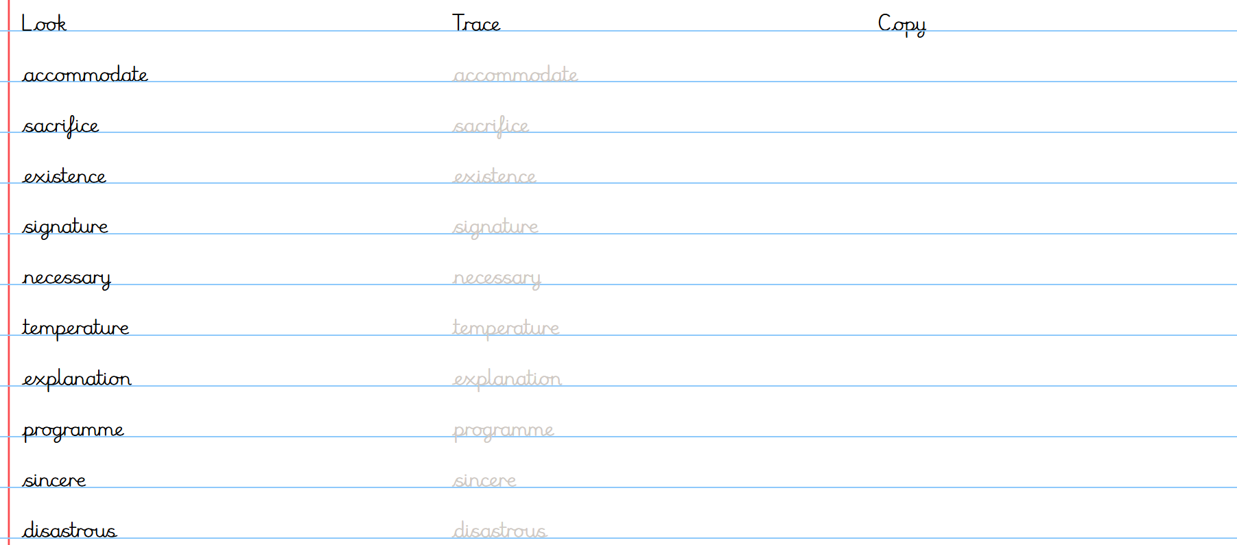
Stop! Before you get started on this handwriting, check that you have the correct tool to write with. Don’t use felt tip pens or highlighters… Do sit at a table.

