100 Books To Read In Year 3 and 4
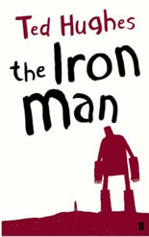
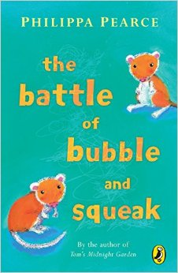
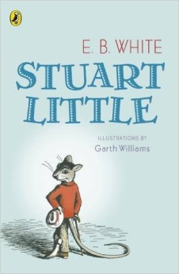
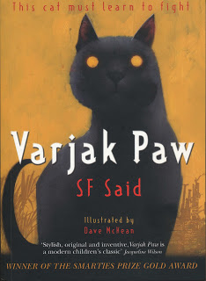
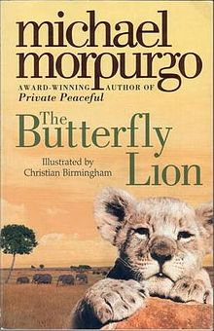
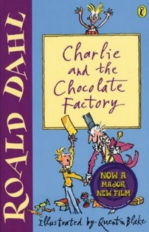
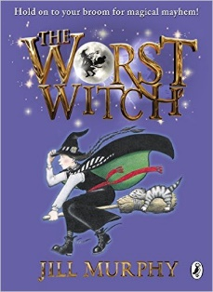
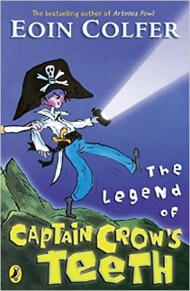
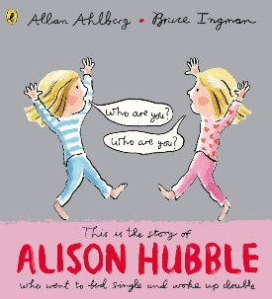
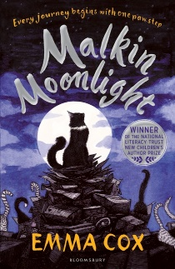
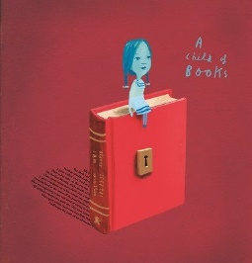
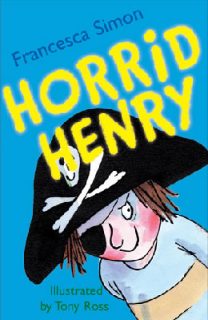
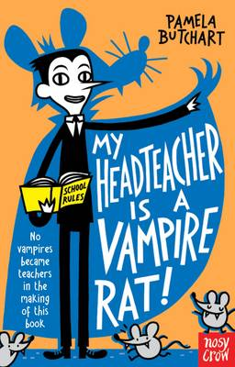
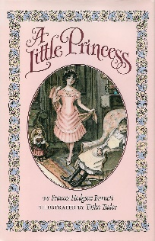
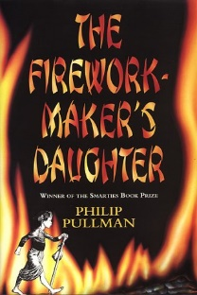
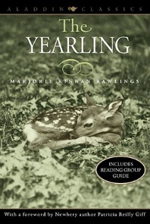
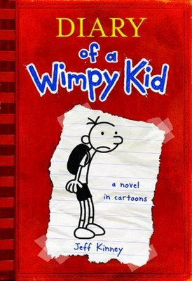
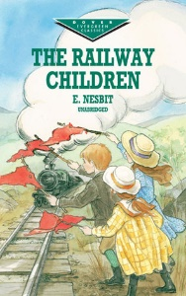
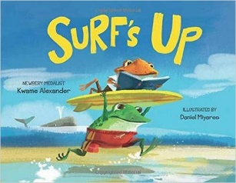
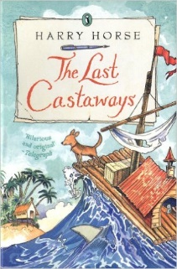
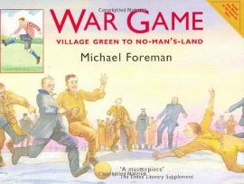
War Game
Michael Foreman
The Worst Witch
Jill Murphy
The Legend of Captain Crow’s Teeth
Eoin Colfer
Alison Hubble
Allan Ahlberg and Bruce Ingham
Malkin Moonlight
Emma Cox
A Child Of Books
Oliver Jeffers
Horrid Henry
Francesca Simon
My Headteacher is a Vampire Rat
Pamela Butchart
The Iron Man
Ted Hughes
A Little Princess
Frances Hodgson Burnett
The Firework-Maker’s Daughter
Phillip Pullman
The Yearling
Marjorie Kinnan Rawlings
The Railway Children
E Nesbit
Diary Of A Wimp Kid
Jeff Kinney
Surf’s Up
Kwame Alexander
The Last Castaways
Harry Horse
The Battle of Bubble and Squeak
Phillips Pearce
Stuart Little
E B White
Varjak Paw
S F Said
The Butterfly Lion
Michael Morpurgo
Charlie and the Chocolate Factory
Roald Dahl

