Name: Year 5 Summer term Week 4
accommodate | competition | existence | muscle | rhyme
accompany | conscience | explanation | necessary | rhythm
according | conscious | familiar | neighbour | sacrifice
achieve | controversy | foreign | nuisance | secretary
aggressive | convenience | forty | occupy | shoulder
amateur | correspond | frequently | occur | signature
ancient | criticise | government | opportunity | sincere
apparent | curiosity | guarantee | parliament | soldier
appreciate | definite | harass | persuade | stomach
attached | desperate | hindrance | physical | sufficient
available | determined | identity | prejudice | suggest
average | develop | immediate | privilege | symbol
awkward | dictionary | individual | profession | system
bargain | disastrous | interfere | programme | temperature
bruise | embarrass | interrupt | pronunciation | thorough
category | environment | language | queue | twelfth
cemetery | equipment | leisure | recognise | variety
committee | especially | lightning | recommend | vegetable
communicate | exaggerate | marvellous | relevant | vehicle
community | excellent | mischievous | restaurant | yacht

Y5 and Y6 Spelling Word List

Year 5 and Year 6 Spelling Patterns
Children in Year 5 and Year 6 will continue to revise previously taught spelling patterns as well as learn the following new work:
cious  or  tious | cial  or  tial | -ant  -ance  -ancy  -ent  -ence  -ency | -ible  -ibly | Homophones | Use of the hyphen
ei after c | ough | -fer | -able  -ably | Silent letters | Nouns end with –ce  Verbs end with -se

These are your spellings to learn this week. Can you work out why these words have been chosen?
If they have a common spelling pattern, you could think of other words that could be added to this list. If they are from the Y5 spelling list, you need to be very familiar with their spelling through practise.

aggressive | apparent
communicate | community
appreciate | attached
occupy | occur
committee | recommend

Tick
here!
Handwriting
Make sure that you use an appropriate pen or pencil to practise your handwriting on the sheet. It must be joined-up handwriting!
Tick
here!
Doodle Maths
How many stars have you achieved this week? Try to use the app frequently and aim to earn 40 stars each week.
Tick
here!

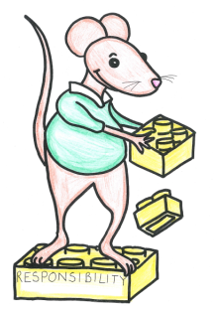
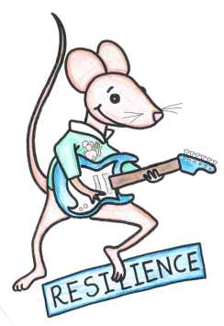
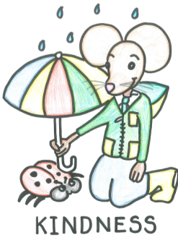
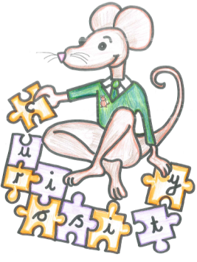
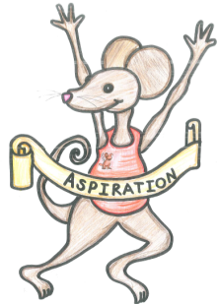

English Assignment
Over this half term, your child should aim to complete some writing at home each week. The time they invest in their written homework will vary from child to child – parental discretion is advised. Alternatively, you may wish to focus on just one or two of the activities this half term and develop them over several weeks with your child.
Week 4:
Auggie wants to take Daisy to school with him. Write a letter persuading the head teacher to let him. Remember to use: strong modal verbs (must, should, will); super conjunctions (although, however, in addition) and powerful punctuation – like parenthesis and semi-colons.

What have you read at home?
Monday

Tuesday

Wednesday

Thursday

Friday

Saturday

Sunday

Here’s a book from our extended reading spine that your child could try and read this month independently or alongside an adult (and we do encourage adults to continue to read to their child in Y5). Reading this book would be a step towards earning a very special reading pin badge.
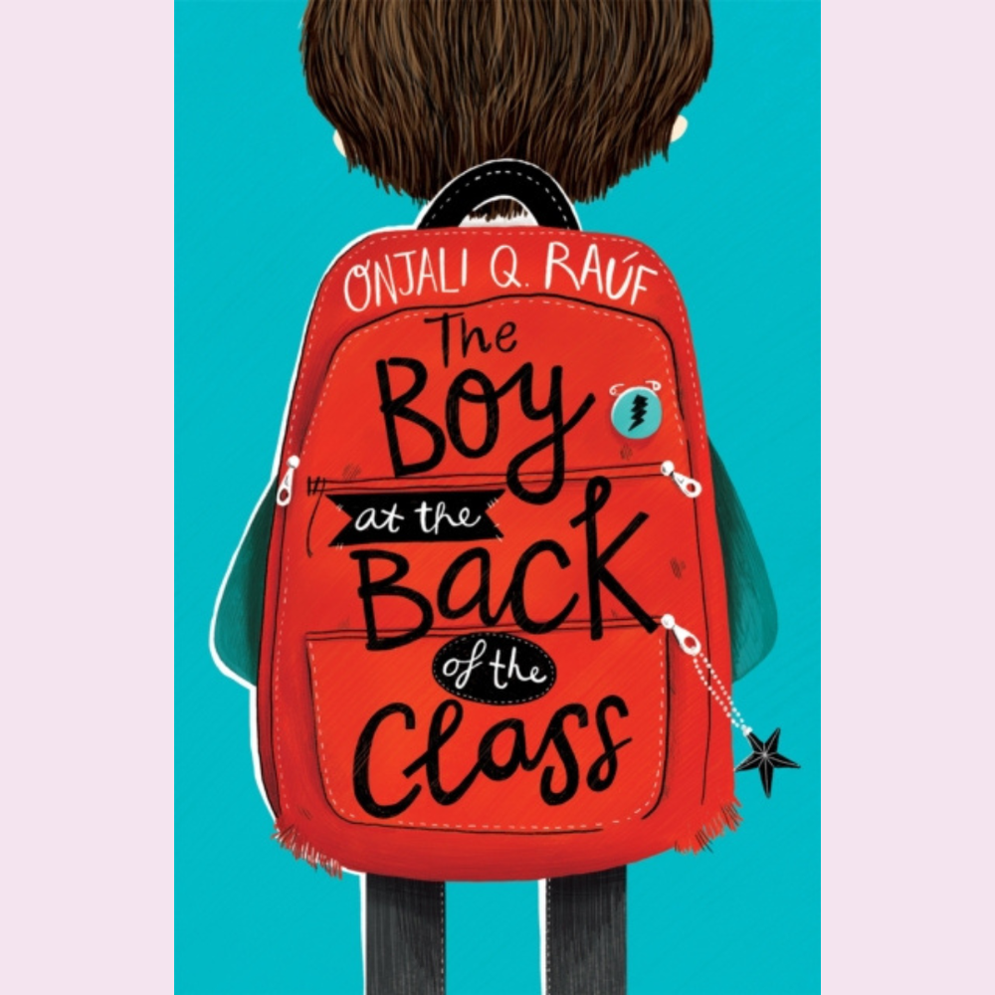

Told with heart and humour, The Boy at the Back of the Class is a child's perspective on the refugee crisis, highlighting the importance of friendship and kindness in a world that doesn't always make sense. ‘Syrian refugee Ahmet is struggling to adapt to his new life in London, until our nine-year-old narrator and friends come up with a very clever plan to reunite him with his lost family. Utterly delightful, Rauf's book centres on the importance of friendship and encourages children not to fear those who are different'. ― The Mail On Sunday

If you read 5 times this week, you will be one step closer to achieving a reading star. Total reads this week:

Parental Signature………………………………….
You are signing to confirm that your child has completed the homework tasks for this week, including reading at home.

Name: Year 5 Summer term Week 4

Stop! Before you get started on this handwriting, check that you have the correct tool to write with. Don’t use felt tip pens or highlighters… Do sit at a table.

………………………………………………………………………………………………………………………………………………………………………………………………………………………………………………………………………………………………………………………………………………………………………………………………………………………………………………………………………………………………………………………………………………………………………………………………_____________________________________________________________________________________________________________________________________________________

………………………………………………………………………………………………………………………………………………………………………………………………………………………………………………………………………………………………………………………………………………………………………………………………………………………………………………………………………………………………………………………………………………………………………………………………_____________________________________________________________________________________________________________________________________________________

………………………………………………………………………………………………………………………………………………………………………………………………………………………………………………………………………………………………………………………………………………………………………………………………………………………………………………………………………………………………………………………………………………………………………………………………_____________________________________________________________________________________________________________________________________________________

………………………………………………………………………………………………………………………………………………………………………………………………………………………………………………………………………………………………………………………………………………………………………………………………………………………………………………………………………………………………………………………………………………………………………………………………_____________________________________________________________________________________________________________________________________________________

………………………………………………………………………………………………………………………………………………………………………………………………………………………………………………………………………………………………………………………………………………………………………………………………………………………………………………………………………………………………………………………………………………………………………………………………_____________________________________________________________________________________________________________________________________________________

………………………………………………………………………………………………………………………………………………………………………………………………………………………………………………………………………………………………………………………………………………………………………………………………………………………………………………………………………………………………………………………………………………………………………………………………_____________________________________________________________________________________________________________________________________________________

