**Name: Year 4 Summer 1 Week 1**

|  |  |  |  |  |
| --- | --- | --- | --- | --- |
| accident | continue | group | natural | question |
| actually | decide | guard | naughty | recent |
| address | describe | guide | notice | regular |
| answer | different | heard | occasion | reign |
| appear | difficult | heart | often | remember |
| arrive | disappear | height | opposite | sentence |
| believe | early | history | ordinary | separate |
| bicycle | earth | imagine | particular | special |
| breath | eight | increase | peculiar | straight |
| breathe | enough | important | perhaps | strange |
| build | exercise | interest | popular | strength |
| business | experience | island | position | suppose |
| calendar | experiment | knowledge | possession | surprise |
| caught | extreme | learn | possible | therefore |
| centre | famous | length | potatoes | though |
| century | favourite | library | pressure | thought |
| certain | February | material | probably | through |
| circle | forward | medicine | promise | various |
| complete | fruit | mention | purpose | weight |
| consider | grammar | minute | quarter | women |

Spelling Word List

Year 3 and Year 4 Spelling Patterns

Children in Year 3 and Year 4 will continue to revise previously taught spelling patterns as well as learn the following new work:

|  |  |  |  |  |
| --- | --- | --- | --- | --- |
| ou | ous | y  (middle of word) | Endings:  sure  ture  cher | Negative prefixes:  un, dis, mis, in, il, im |
| ly | ation | ch  (middle of word) | Plurals:  s  es  ies | Prefixes:  re, sub, inter, super, anti, auto |
| sion | que  gue | ei  eigh  ey | tion  sion  ssion  cian | Near homophones |

These are your spellings to learn this week. Can you work out why these words have been chosen?

If they have a common spelling pattern, you could think of other words that could be added to this list. If they are from the Y4 spelling list, you need to be very familiar with their spelling through practise.

|  |  |
| --- | --- |
| science | scented |
| scissors | scene |
| ascend | scenery |
| descend | crescent |
| scent | muscle |

Tick

here!

**Handwriting**

Make sure that you use an appropriate pen or pencil to practise your handwriting on the sheet. It must be joined-up handwriting!

Tick

here!

**Doodle Maths**

How many stars have you achieved this week? Try to use the app frequently and aim to earn 40 stars each week.

Tick

here!

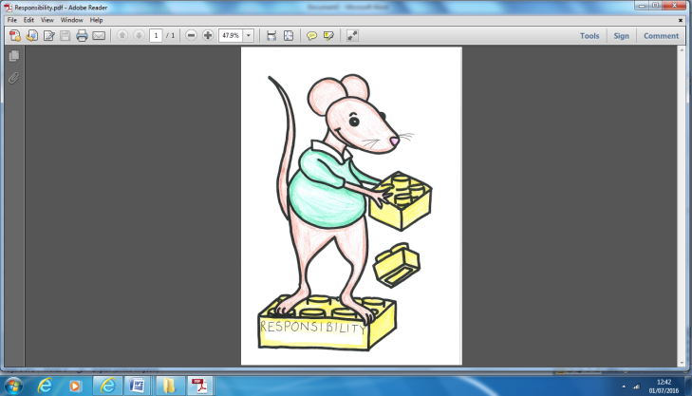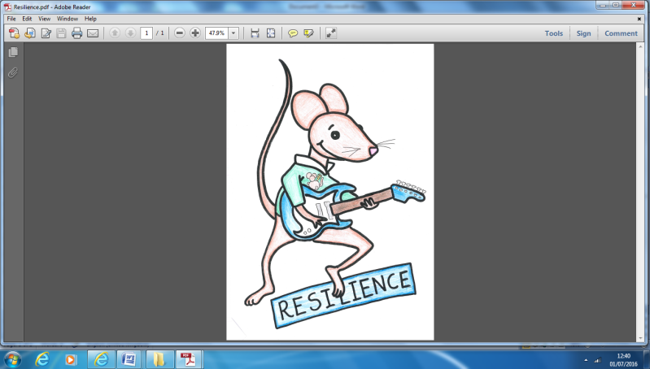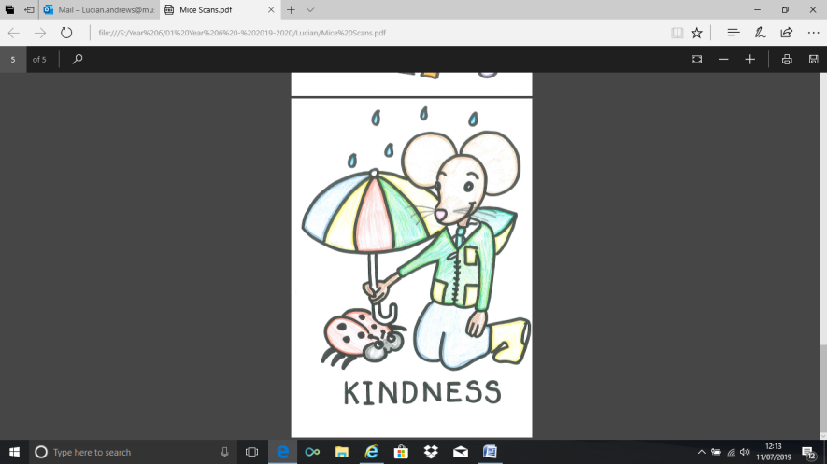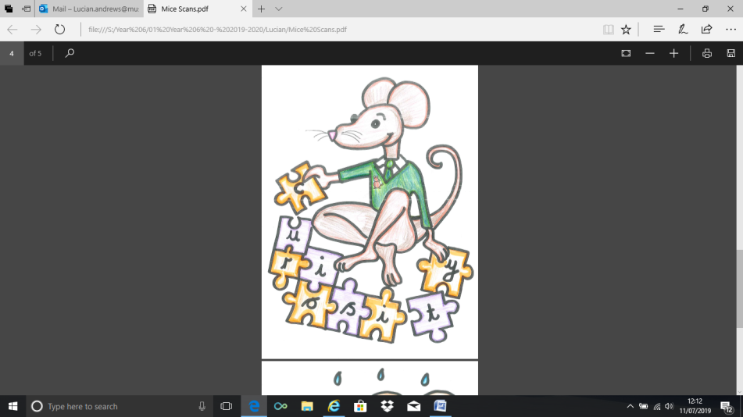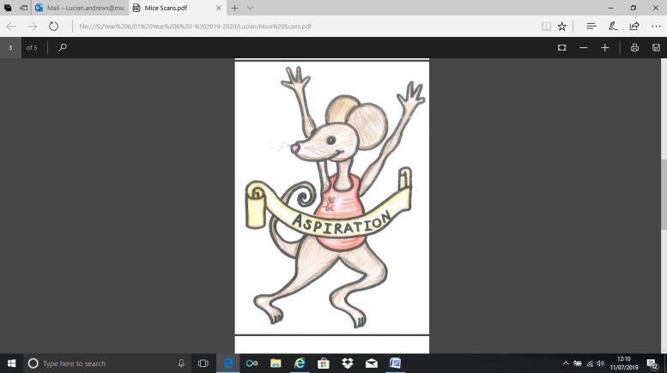

**English Assignment**

*Over this half term, your child should aim to complete some writing at home each week. The time they invest in their written homework will vary from child to child – parental discretion is advised. Alternatively, you may wish to focus on just one or two of the activities from the English Overview sheet and develop them over several weeks with your child.*

Pick up some leaflets about local attractions. Arrange them in order from most appealing to least appealing. What features do they all have in common? What MUST a leaflet have? What MIGHT a leaflet have?

|  |  |
| --- | --- |
|  | **What have you read at home?** |
| **Monday** |  |
| **Tuesday** |  |
| **Wednesday** |  |
| **Thursday** |  |
| **Friday** |  |
| **Saturday** |  |
| **Sunday** |  |

Here’s a book from our extended reading spine that your child could try and read this month independently or alongside an adult (and we do encourage adults to continue to read to their child in Y4). Reading this book would be a step towards earning a very special reading pin badge.

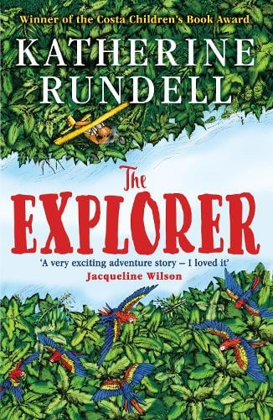

From his seat in the tiny aeroplane, Fred watches as the mysteries of the Amazon jungle pass by below him. He has always dreamed of becoming an explorer, of making history and of reading his name amongst the lists of great discoveries. If only he could land and look about him.  
As the plane crashes into the canopy, Fred is suddenly left without a choice. He and the three other children may be alive, but the jungle is a vast, untamed place. With no hope of rescue, the chance of getting home feels impossibly small.  
Except, it seems, someone has been there before them.

If you read 5 times this week, you will be one step closer to achieving a reading star. Total reads this week:

Parental Signature…………………………………..

You are signing to confirm that your child has completed the homework tasks for this week, including reading at home.

**Name: Year 4 Summer 1 Week 1**

Stop! Before you get started on this handwriting, check that you have the correct tool to write with. Don’t use felt tip pens or highlighters… Do sit at a table.

………………………………………………………………………………………………………………………………………………………………………………………………………………………………………………………………………………………………………………………………………………………………………………………………………………………………………………………………………………………………………………………………………………………………………………………………**_____________________________________________________________________________________________________________________________________________________**

………………………………………………………………………………………………………………………………………………………………………………………………………………………………………………………………………………………………………………………………………………………………………………………………………………………………………………………………………………………………………………………………………………………………………………………………**_____________________________________________________________________________________________________________________________________________________**

………………………………………………………………………………………………………………………………………………………………………………………………………………………………………………………………………………………………………………………………………………………………………………………………………………………………………………………………………………………………………………………………………………………………………………………………**_____________________________________________________________________________________________________________________________________________________**

………………………………………………………………………………………………………………………………………………………………………………………………………………………………………………………………………………………………………………………………………………………………………………………………………………………………………………………………………………………………………………………………………………………………………………………………**_____________________________________________________________________________________________________________________________________________________**

………………………………………………………………………………………………………………………………………………………………………………………………………………………………………………………………………………………………………………………………………………………………………………………………………………………………………………………………………………………………………………………………………………………………………………………………**_____________________________________________________________________________________________________________________________________________________**

………………………………………………………………………………………………………………………………………………………………………………………………………………………………………………………………………………………………………………………………………………………………………………………………………………………………………………………………………………………………………………………………………………………………………………………………**_____________________________________________________________________________________________________________________________________________________**