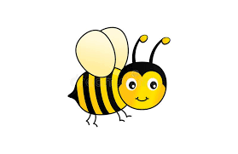

**PSED**

* Transition to year 1
* Children reflect on and self evaluate their own work..
* Ask children to explain to others how they thought about a problem or an emotion and how they dealt with it.
* Understand the importance of sleep, healthy foods and exercise.
* Explain the children and model how to travel safely in their local environment.

**Minibeastses**

**EAD**

* Move to and talk about music
* Explore and engage in music making and dance (ugly bug ball)
* Explore, use and refine a variety of artistic effects
* Colour mixing for minibeasts
* Large painting on sheets/shower curtains

**Literacy**

* Read longer words containing letter groups.
* Writing sentences that can be read by others
* Ext - Write short stories containing several sentences

**Understanding the World**

* Explore the natural world around them.
* Understand the effect of changing seasons on the natural world around them
* Describe what they can see, hear, feel whilst outside,

**Physical Development**

* Encourage children to use a wide range of equipment (time on play trail and climbing wall)
* Team games (sports day practise)
* Correct formation of letters and continue to check progress of handwriting.

**Maths**

Noticing patterns in numbers to 20

Doubling and halving and learning automatic recall of double facts to 12 (2,4,6,8,10,12).

Creating addition and subtraction number stories.

Introduce the concept of odd and even numbers.

To know number bonds to 10

**Communication & Language**

* Using language to clarify their thoughts, feelings and reasons.
* Listen attentively and respond with relevant questions and comments.
* Use new vocabulary learnt throughout the day in fun ways
* Articulate ideas and thoughts in well-formed sentences