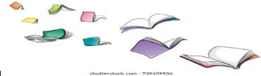
Book recommendations if you love The Accidental Billionaire.
OTHER BOOKS BY TOM MCLAUGHLIN
- The Day that Aliens (nearly) Ate Our
Brains.
- The Day I Became The Most Wanted Boy in the World.
- Attack of the Smart Speakers.
- Geek Tragedy.
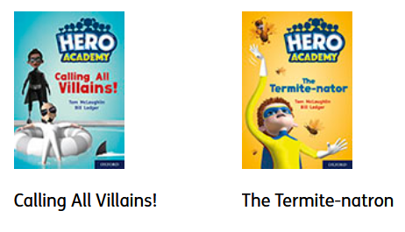

FOR SOME OTHER LAUGH OUTLOUD MOMENTS
- The Perilous Princess Plot
- Mr Stink
- Fizzlebert Stump
- Alice Dent and the Incredible Germs
- Aliens Invaded My Talent Show
- The Day The Screens Went Blank

You’ll find these 2 books on Oxford Owl

What else could you read?
- The Naughtiest Unicorn
- Dog Man
- Sam Wu
- The Worst Witch
- Harley Hitch
- My Parents cancelled My Birthday Party
- Charlie Changes Into A Chicken
- I Swapped My Brother on the Internet
- Cookie (Huq)
- 13 Storey Treehouse
- Stick Boy
- The Misfits Club
- Isadora Moon

We are reading The Accidental Billionaire by Tom McLaughlin. Why not look in your local library for some of his other books in the series?

