
Our Beautiful Texts
The Cave​ by Rob Hodgson
Bear Hunt​ by Michael Rosen
Can’t You Sleep Little Bear​ by Martin Waddell
The Castle the King Built​ by Rebecca Colby
George and the dragon​ – Christopher Wormell
Zog​ by Julia Donaldson

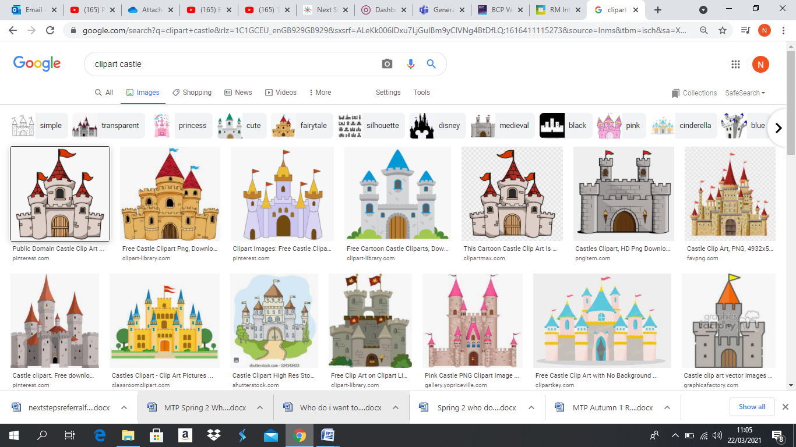
Castles and Caves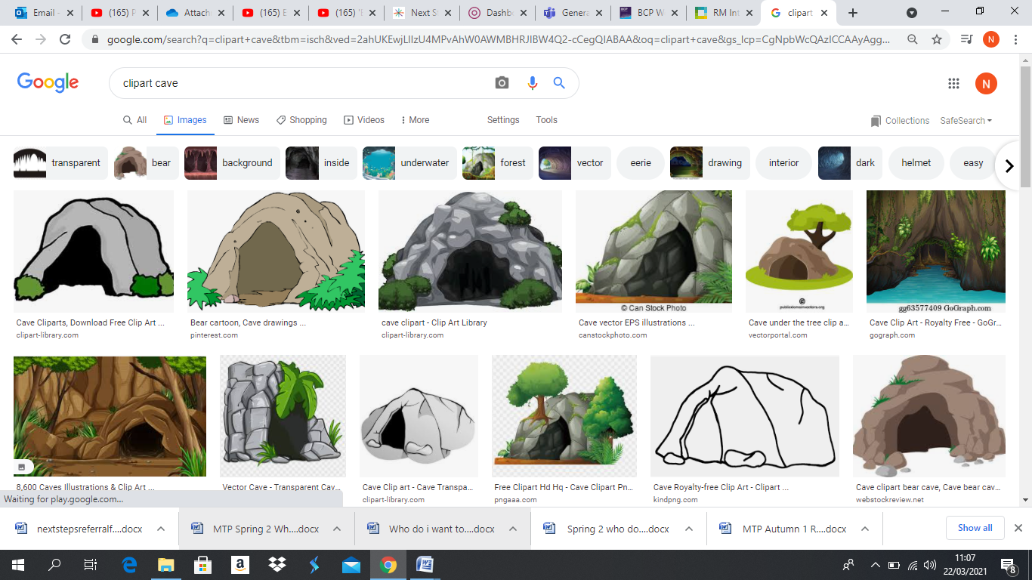
Communication & Language
Engaging in daily stories, talking about the plot and the characters
Identify the main characters and discuss their actions and motives.
Reading own story books Make comments /ask questions /using vocabulary about castles and caves.
Learning stories off by heart (story telling actions)

Connect ideas to actions using a range of

Understanding the World
*Draw information from a simple map. (we are going on a Bear hunt)​
​
*Compare and contrast characters from stories including figures from the past​
​
*Comment on images of familiar situations in the past (knights, kings and princesses- castles)​
​
*Recognise that people have different beliefs and celebrate special times in different ways.

PSED
*Manage own needs (toilet, getting changed, organising their belongings)
* Understand and moderate their feelings and know how to react 4-5 year old appropriately & use appropriate words to solve problems

EAD
*Junk modelling castles and caves, sharing their creations and explaining the processes they have used
*Role play castles and caves
*Making use of props and materials when den building caves
*Continue to use a range of tools and techniques

Literacy
* adjacent consonants (st/fr/sp etc), longer words
* root words ending in: –ing, –ed /t/, –ed /id/ /ed/ –est
* Write simple sentences that can be read by others
* Begin to write simple narratives
Physical Development
*Sports day preparation, playing team games
*Forming letters correctly
*Using a range of small tools efficiently
*Demonstrating strength balance and co-ordination in P.E. lessons and outside during Let’s Explore.

Maths
*Addition and subtraction of numbers less than 20
*Some automatic recall of number facts to 10 including subtraction.
*Confident counting to 30.
*Length, height, distance, capacity and weight – introducing standard measure and consolidating non-standard measure within play

