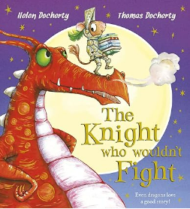

A lovely rhyming story about a little mouse called Leo. His parents want him to be a knight, but he just wants to read. He ends up using stories to become a hero!
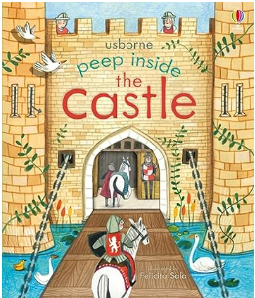

This ‘lift the flap’ book give the children a chance to explore what happened inside a castle.

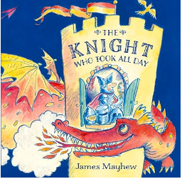

This is a funny book about a foolish knight who takes so long to get ready he misses his fight with the dragon.
The children will be able to point out some of the features of a castle and the people who lived there.

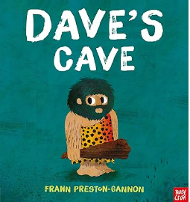

This is a great book which explores the idea that sometimes it better to be happy with what you have! The children will love the funny caveman language.
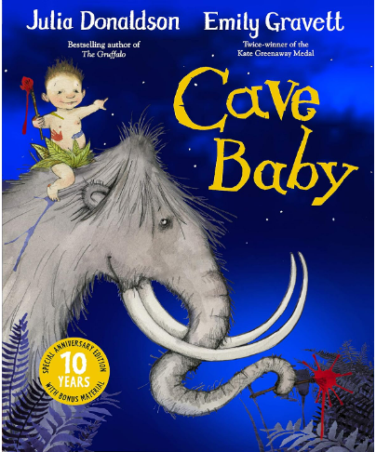

Another brilliant book by the author of The Gruffalo. This is great for encouraging children to spot words that rhyme.

