**Name: Year 5 Autumn 2 Week 2**

|  |  |  |  |  |
| --- | --- | --- | --- | --- |
| accommodate | competition | existence | muscle | rhyme |
| accompany | conscience | explanation | necessary | rhythm |
| according | conscious | familiar | neighbour | sacrifice |
| achieve | controversy | foreign | nuisance | secretary |
| aggressive | convenience | forty | occupy | shoulder |
| amateur | correspond | frequently | occur | signature |
| ancient | criticise | government | opportunity | sincere |
| apparent | curiosity | guarantee | parliament | soldier |
| appreciate | definite | harass | persuade | stomach |
| attached | desperate | hindrance | physical | sufficient |
| available | determined | identity | prejudice | suggest |
| average | develop | immediate | privilege | symbol |
| awkward | dictionary | individual | profession | system |
| bargain | disastrous | interfere | programme | temperature |
| bruise | embarrass | interrupt | pronunciation | thorough |
| category | environment | language | queue | twelfth |
| cemetery | equipment | leisure | recognise | variety |
| committee | especially | lightning | recommend | vegetable |
| communicate | exaggerate | marvellous | relevant | vehicle |
| community | excellent | mischievous | restaurant | yacht |

**Y5 and Y6 Spelling Word List**

**Year 5 and Year 6 Spelling Patterns**

Children in Year 5 and Year 6 will continue to revise previously taught spelling patterns as well as learn the following new work:

|  |  |  |  |  |  |
| --- | --- | --- | --- | --- | --- |
| cious  or  tious | cial  or  tial | -ant  -ance  -ancy  -ent  -ence  -ency | -ible  -ibly | Homophones | Use of the hyphen |
| ei after c | ough | -fer | -able  -ably | Silent letters | Nouns end with –ce  Verbs end with -se |

These are your spellings to learn this week. Can you work out why these words have been chosen?

If they have a common spelling pattern, you could think of other words that could be added to this list. If they are from the Y5 spelling list, you need to be very familiar with their spelling through practise.

|  |  |
| --- | --- |
| muscles | shoulders |
| neighbours | vegetables |
| develops | vehicles |
| bargains | individuals |
|  |  |

Tick

here!

**Handwriting**

Make sure that you use an appropriate pen or pencil to practise your handwriting on the sheet. It must be joined-up handwriting!

Tick

here!

**Doodle Maths**

How many stars have you achieved this week? Try to use the app frequently and aim to earn 40 stars each week.

Tick

here!

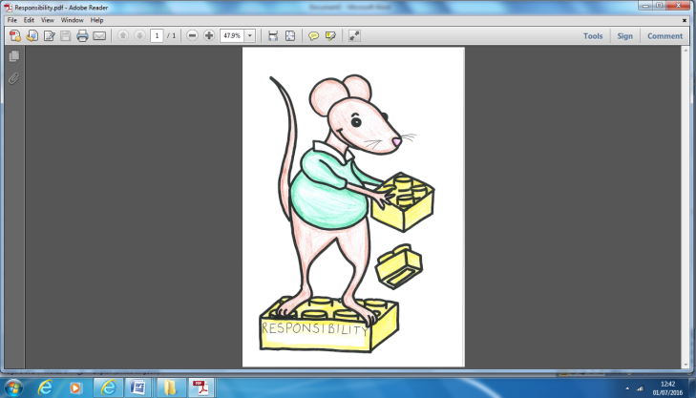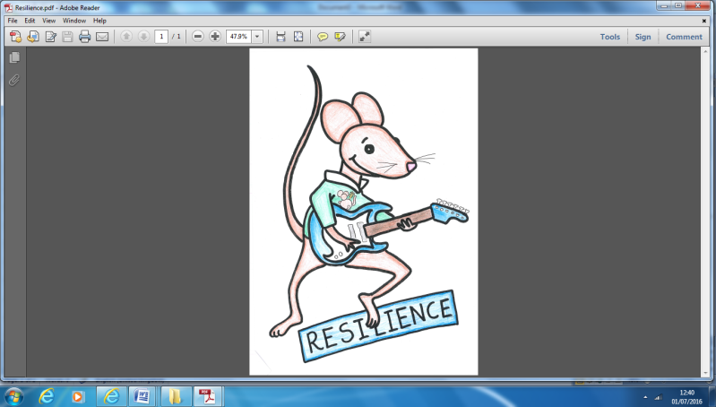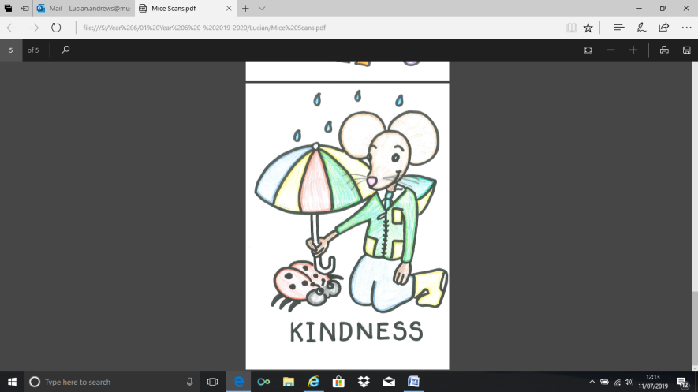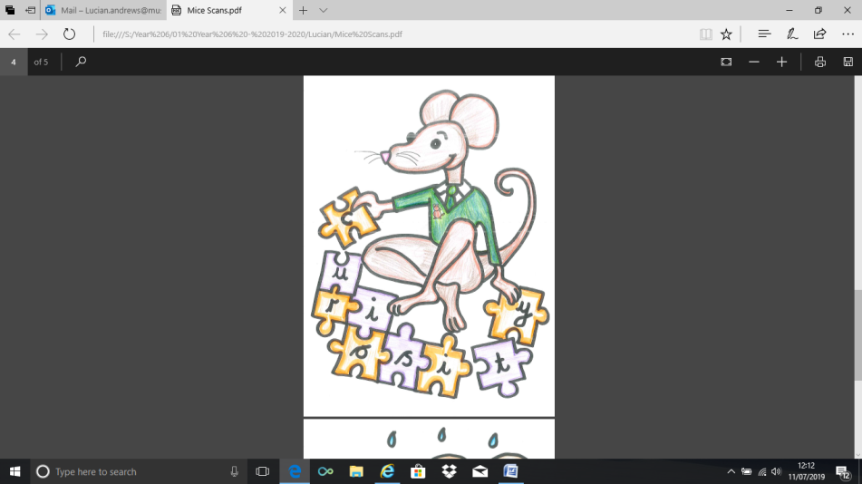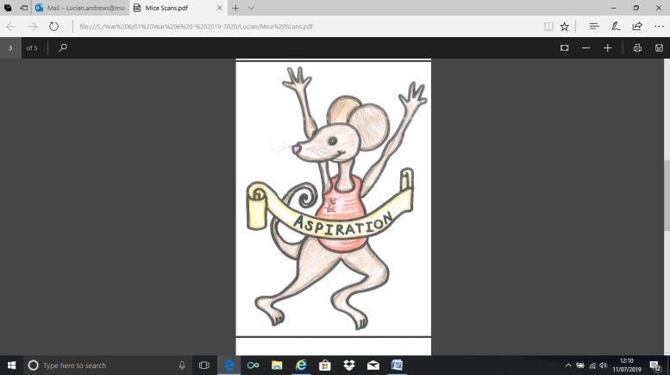

**English Assignment**

*Over this half term, your child should aim to complete some writing at home each week. The time they invest in their written homework will vary from child to child – parental discretion is advised. Alternatively, you may wish to focus on just one or two of the activities this half term and develop them over several weeks with your child.*

**Week 1:**

In school this week, children will be using a thesaurus to help them select the best words to describe Mr Tumnus, who is a rather magical character in his looks but faithful in his behaviour. At home, can you think of a character (from a book or film) whose appearance is somewhat mysterious or magical. For example, (and don’t use this one), Willy Wonka from our last unit presented as a character who we would want to find more about. Once you’ve chosen a character, begin to describe them – what is it specifically that makes them so mysterious or magical? To make this even better, you might use a thesaurus to expand your vocabulary with the support of an adult at home.

|  |  |
| --- | --- |
|  | **What have you read at home?** |
| **Monday** |  |
| **Tuesday** |  |
| **Wednesday** |  |
| **Thursday** |  |
| **Friday** |  |
| **Saturday** |  |
| **Sunday** |  |

Here’s a book from our extended reading spine that your child could try and read this month independently or alongside an adult (and we do encourage adults to continue to read to their child in Y5). Reading this book would be a step towards earning a very special reading pin badge.

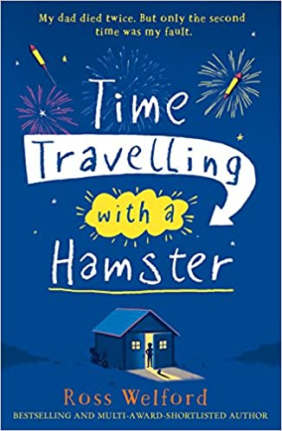

“My dad died twice. Once when he was thirty nine and again four years later when he was twelve.” On Al Chaudhury’s twelfth birthday his beloved Grandpa Byron gives him a letter from Al’s late father. In it Al receives a mission: travel back to 1984 in a secret time machine and save his father’s life.

Al soon discovers that time travel requires daring and imagination, all without losing his pet hamster.

If you read 5 times this week, you will be one step closer to achieving a reading star. Total reads this week:

Parental Signature…………………………………..

You are signing to confirm that your child has completed the homework tasks for this week, including reading at home.

**Name: Year 5 Autumn 2 Week 1**

Stop! Before you get started on this handwriting, check that you have the correct tool to write with. Don’t use felt tip pens or highlighters… Do sit at a table.

………………………………………………………………………………………………………………………………………………………………………………………………………………………………………………………………………………………………………………………………………………………………………………………………………………………………………………………………………………………………………………………………………………………………………………………………**_____________________________________________________________________________________________________________________________________________________**

………………………………………………………………………………………………………………………………………………………………………………………………………………………………………………………………………………………………………………………………………………………………………………………………………………………………………………………………………………………………………………………………………………………………………………………………**_____________________________________________________________________________________________________________________________________________________**

………………………………………………………………………………………………………………………………………………………………………………………………………………………………………………………………………………………………………………………………………………………………………………………………………………………………………………………………………………………………………………………………………………………………………………………………**_____________________________________________________________________________________________________________________________________________________**

………………………………………………………………………………………………………………………………………………………………………………………………………………………………………………………………………………………………………………………………………………………………………………………………………………………………………………………………………………………………………………………………………………………………………………………………**_____________________________________________________________________________________________________________________________________________________**

………………………………………………………………………………………………………………………………………………………………………………………………………………………………………………………………………………………………………………………………………………………………………………………………………………………………………………………………………………………………………………………………………………………………………………………………**_____________________________________________________________________________________________________________________________________________________**

………………………………………………………………………………………………………………………………………………………………………………………………………………………………………………………………………………………………………………………………………………………………………………………………………………………………………………………………………………………………………………………………………………………………………………………………**_____________________________________________________________________________________________________________________________________________________**

This page is for teachers to cut and paste from each week. It is not for the children!

* Week 1: As this unit focuses on characterisation, invent your own villain. Consider other villains from stories that you know. Create a character profile – you’ll need to describe the character’s looks but think carefully also about the mannerisms that could deepen the level of characterisation. For example, an evil teacher might look over his glasses with a sneer. Finally, what might they say and how would they say it? Once you’re happy with the character profile, begin building the information into a paragraph. Start by writing just simple sentences, which you should aim to expand using the Y5 skills that are on the reverse of this page.
* Week 2: Whilst you’ll be writing plenty of descriptions in school, you could write a non-fiction page based on some independent research about the Mayans. This can be created through your independent research or based on what you have already been taught in school. Take a look at some non-fiction books that you may have at home to help you decide how to organise your ideas.
* Week 3: Was Wonka right to ‘smuggle’ the Oompa Loompas into this country? Why was it the right choice and why might his actions be considered as wrong? Create an argument that outlines points for both sides.
* Week 4 Imagine you are an Oompa Loompa. Write a postcard home to convince your friends to join you in Wonka’s factory.
* Week 5 Newspapers feature in the story. Write the newspaper report that reveals that Wonka will be opening his factory to the finder of a golden ticket.

Spellings

|  |  |  |  |  |  |  |  |
| --- | --- | --- | --- | --- | --- | --- | --- |
|  | **Week 1** | **Week 2** | **Week 3** | **Week 4** | **Week 5** | **Week 6** | **Week 7** |
| **Autumn 1** | Revise | ough for off, uff, ew | ough for aw, oh, or | Silent letters | Ible/able | Ible/able | homophones |
| Aspiration  Resilience  Curiosity  Responsibility  Kindness  Chocolate  Factory  Competition  Poverty  desperate | cough  coughing  trough  enough  tough  rough  roughen  through  thorough  breakthrough | drought  plough  bough  although  dough  though  bought  fought  brought  thought | doubt  island  lamb  solemn  thistle  knight  numb  autumn  whistle  vehicle | horrible  terrible  possible  adorable  forgivable  enjoyable  available  vegetable  edible  sensible | reversible  invincible  legible  valuable  breakable  agreeable  disposable  identifiable  incredible  respectable | isle  aisle  aloud  allowed  affect  effect  herd  heard  past  passed |