**Name: Year 4 Spring 2 Week 6**

|  |  |  |  |  |
| --- | --- | --- | --- | --- |
| accident | continue | group | natural | question |
| actually | decide | guard | naughty | recent |
| address | describe | guide | notice | regular |
| answer | different | heard | occasion | reign |
| appear | difficult | heart | often | remember |
| arrive | disappear | height | opposite | sentence |
| believe | early | history | ordinary | separate |
| bicycle | earth | imagine | particular | special |
| breath | eight | increase | peculiar | straight |
| breathe | enough | important | perhaps | strange |
| build | exercise | interest | popular | strength |
| business | experience | island | position | suppose |
| calendar | experiment | knowledge | possession | surprise |
| caught | extreme | learn | possible | therefore |
| centre | famous | length | potatoes | though |
| century | favourite | library | pressure | thought |
| certain | February | material | probably | through |
| circle | forward | medicine | promise | various |
| complete | fruit | mention | purpose | weight |
| consider | grammar | minute | quarter | women |

Spelling Word List

Year 3 and Year 4 Spelling Patterns

Children in Year 3 and Year 4 will continue to revise previously taught spelling patterns as well as learn the following new work:

|  |  |  |  |  |
| --- | --- | --- | --- | --- |
| ou | ous | y  (middle of word) | Endings:  sure  ture  cher | Negative prefixes:  un, dis, mis, in, il, im |
| ly | ation | ch  (middle of word) | Plurals:  s  es  ies | Prefixes:  re, sub, inter, super, anti, auto |
| sion | que  gue | ei  eigh  ey | tion  sion  ssion  cian | Near homophones |

These are your spellings to learn this week. Can you work out why these words have been chosen?

If they have a common spelling pattern, you could think of other words that could be added to this list. If they are from the Y4 spelling list, you need to be very familiar with their spelling through practise.

|  |  |
| --- | --- |
| guardian | guess |
| guard | guide |
| guitar | guilt |

Tick

here!

**Handwriting**

Make sure that you use an appropriate pen or pencil to practise your handwriting on the sheet. It must be joined-up handwriting!

Tick

here!

**Doodle Maths**

How many stars have you achieved this week? Try to use the app frequently and aim to earn 40 stars each week.

Tick

here!

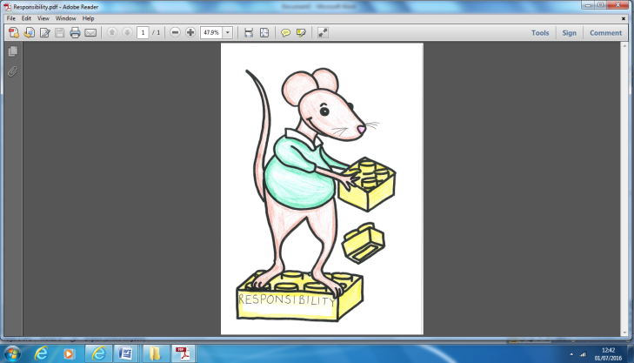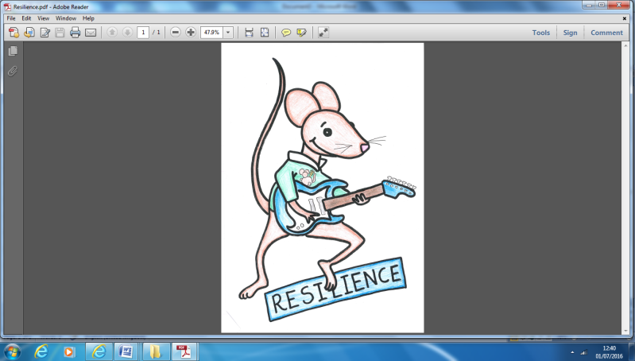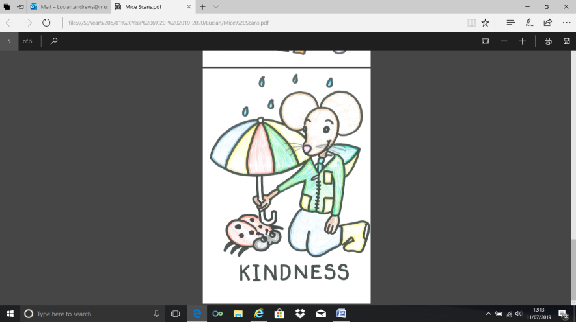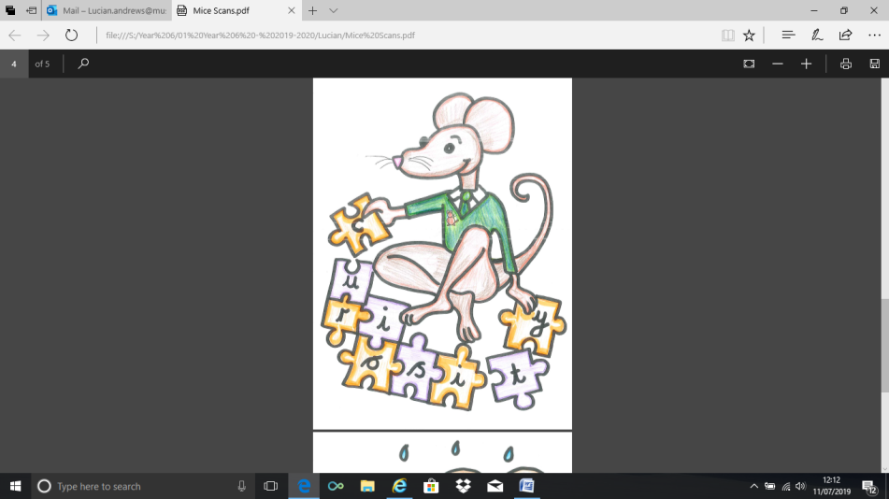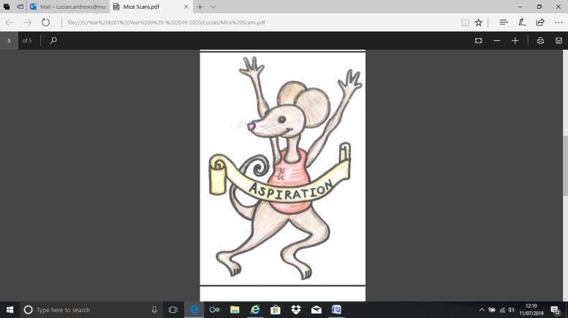

**English Assignment**

*Over this half term, your child should aim to complete some writing at home each week. The time they invest in their written homework will vary from child to child – parental discretion is advised. Alternatively, you may wish to focus on just one or two of the activities from the English Overview sheet and develop them over several weeks with your child.*

The story of Boudicca is one filled with betrayal and terror! Boudicca and the Iceni tribe are betrayed by the Romans and decide to take revenge on the Romans by burning down their cities and towns.

Can you research and then re-tell the story of Boudicca in your own words?

You can do it in the format of a storyboard, paragraphs or even a comic book!

We are looking for super presentation and an accurate re-tell of the story of Boudicca.

*Extra VIPs if you use colour to make your work stand out!*

|  |  |
| --- | --- |
|  | **What have you read at home?** |
| **Monday** |  |
| **Tuesday** |  |
| **Wednesday** |  |
| **Thursday** |  |
| **Friday** |  |
| **Saturday** |  |
| **Sunday** |  |

Here’s a book from our extended reading spine that your child could try and read this month independently or alongside an adult (and we do encourage adults to continue to read to their child in Y4). Reading this book would be a step towards earning a very special reading pin badge.

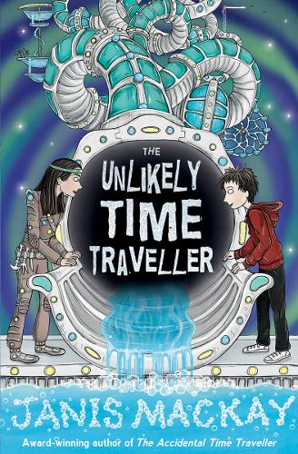

Robbie has disappeared. And, since he'd been asking Saul a lot of questions about time travel, Saul has a good idea where he might have gone...  
At school they've been doing a project on the future: will it be full of robots and shiny technology? Or will the environment have been destroyed? The last thing Saul wants to do is go there and find out for sure -- but there's no way Robbie will manage on his own in the twenty-second century.  
What does the future hold in store, and can Saul get Robbie safely back to their own time?

If you read 5 times this week, you will be one step closer to achieving a reading star. Total reads this week:

Parental Signature…………………………………..

You are signing to confirm that your child has completed the homework tasks for this week, including reading at home.

**Name: Year 4 Spring 2 Week 6**

Stop! Before you get started on this handwriting, check that you have the correct tool to write with. Don’t use felt tip pens or highlighters… Do sit at a table.

………………………………………………………………………………………………………………………………………………………………………………………………………………………………………………………………………………………………………………………………………………………………………………………………………………………………………………………………………………………………………………………………………………………………………………………………**_____________________________________________________________________________________________________________________________________________________**

………………………………………………………………………………………………………………………………………………………………………………………………………………………………………………………………………………………………………………………………………………………………………………………………………………………………………………………………………………………………………………………………………………………………………………………………**_____________________________________________________________________________________________________________________________________________________**

………………………………………………………………………………………………………………………………………………………………………………………………………………………………………………………………………………………………………………………………………………………………………………………………………………………………………………………………………………………………………………………………………………………………………………………………**_____________________________________________________________________________________________________________________________________________________**

………………………………………………………………………………………………………………………………………………………………………………………………………………………………………………………………………………………………………………………………………………………………………………………………………………………………………………………………………………………………………………………………………………………………………………………………**_____________________________________________________________________________________________________________________________________________________**

………………………………………………………………………………………………………………………………………………………………………………………………………………………………………………………………………………………………………………………………………………………………………………………………………………………………………………………………………………………………………………………………………………………………………………………………**_____________________________________________________________________________________________________________________________________________________**

………………………………………………………………………………………………………………………………………………………………………………………………………………………………………………………………………………………………………………………………………………………………………………………………………………………………………………………………………………………………………………………………………………………………………………………………**_____________________________________________________________________________________________________________________________________________________**