**Name: Year 4 Spring 1 Week 3**

|  |  |  |  |  |
| --- | --- | --- | --- | --- |
| accident | continue | group | natural | question |
| actually | decide | guard | naughty | recent |
| address | describe | guide | notice | regular |
| answer | different | heard | occasion | reign |
| appear | difficult | heart | often | remember |
| arrive | disappear | height | opposite | sentence |
| believe | early | history | ordinary | separate |
| bicycle | earth | imagine | particular | special |
| breath | eight | increase | peculiar | straight |
| breathe | enough | important | perhaps | strange |
| build | exercise | interest | popular | strength |
| business | experience | island | position | suppose |
| calendar | experiment | knowledge | possession | surprise |
| caught | extreme | learn | possible | therefore |
| centre | famous | length | potatoes | though |
| century | favourite | library | pressure | thought |
| certain | February | material | probably | through |
| circle | forward | medicine | promise | various |
| complete | fruit | mention | purpose | weight |
| consider | grammar | minute | quarter | women |

Spelling Word List

Year 3 and Year 4 Spelling Patterns

Children in Year 3 and Year 4 will continue to revise previously taught spelling patterns as well as learn the following new work:

|  |  |  |  |  |
| --- | --- | --- | --- | --- |
| ou | ous | y  (middle of word) | Endings:  sure  ture  cher | Negative prefixes:  un, dis, mis, in, il, im |
| ly | ation | ch  (middle of word) | Plurals:  s  es  ies | Prefixes:  re, sub, inter, super, anti, auto |
| sion | que  gue | ei  eigh  ey | tion  sion  ssion  cian | Near homophones |

These are your spellings to learn this week. Can you work out why these words have been chosen?

If they have a common spelling pattern, you could think of other words that could be added to this list. If they are from the Y4 spelling list, you need to be very familiar with their spelling through practise.

|  |  |
| --- | --- |
| daughter | elephant |
| Lalchand (name) | mountains |
| Lila (name) | apprentice |

This week’s spellings are words you will come across in our text, so make sure you practise them!

Tick

here!

**Handwriting**

Make sure that you use an appropriate pen or pencil to practise your handwriting on the sheet. It must be joined-up handwriting!

Tick

here!

**Doodle Maths**

How many stars have you achieved this week? Try to use the app frequently and aim to earn 40 stars each week.

Tick

here!

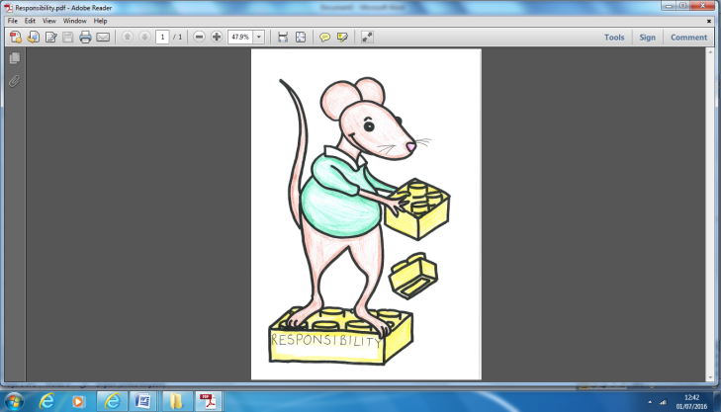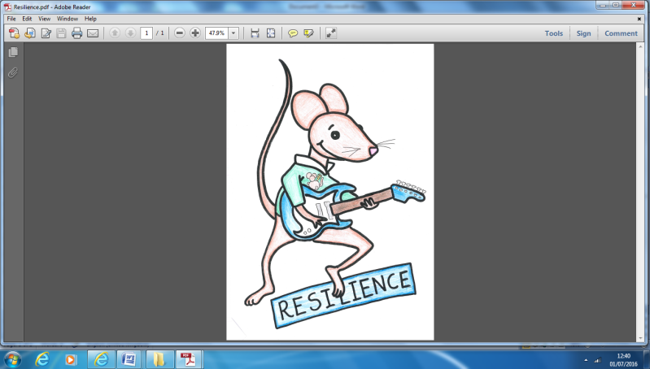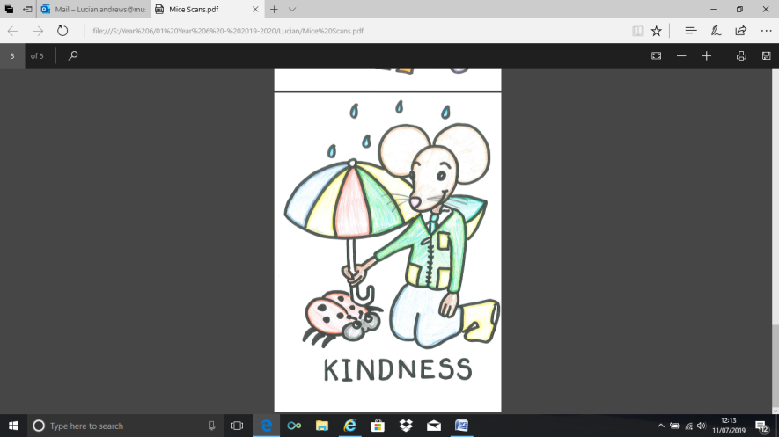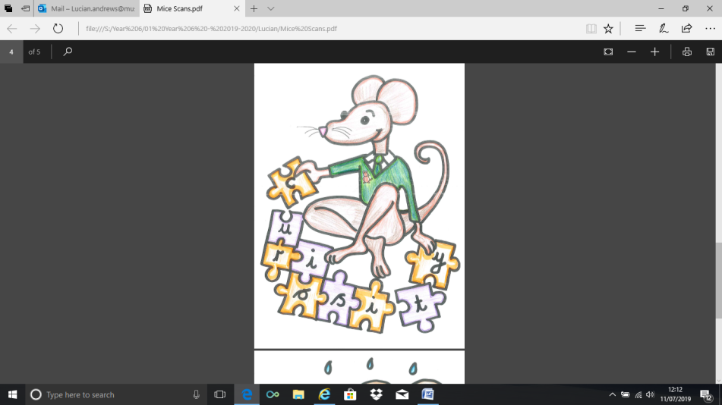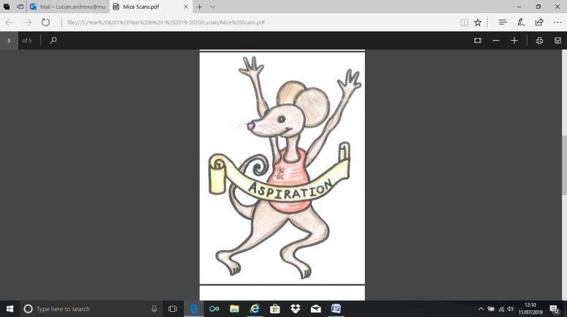

**English Assignment**

*Over this half term, your child should aim to complete some writing at home each week. The time they invest in their written homework will vary from child to child – parental discretion is advised. Alternatively, you may wish to focus on just one or two of the activities and develop them over several weeks with your child.*

Think of fairy tale villains… what do the villains say? Use full speech punctuation to write their words. Example characters could be the giant in Jack and the Beanstalk, “Fee, Fi, Fo, Fum, I smell the blood of an Englishman.” Or the wolf in The Three Little Pigs. “I’ll huff and I’ll puff and I’ll blow your house down.” You could then rehearse saying their lines out loud!

|  |  |
| --- | --- |
|  | **What have you read at home?** |
| **Monday** |  |
| **Tuesday** |  |
| **Wednesday** |  |
| **Thursday** |  |
| **Friday** |  |
| **Saturday** |  |
| **Sunday** |  |

Here’s a book from our extended reading spine that your child could try and read this month independently or alongside an adult (and we do encourage adults to continue to read to their child in Y4). Reading this book would be a step towards earning a very special reading pin badge.

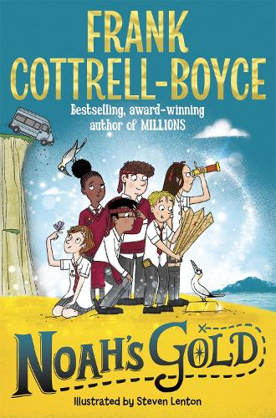

Being the smallest doesn't stop you having the biggest ideas.

Eleven-year old Noah sneaks along on his big sister's geography field trip. Everything goes wrong! Six kids are marooned on an uninhabited island. Their teacher has vanished. They're hungry. Their phones don't work and Noah has broken the internet. There's no way of contacting home ... Disaster!

Until Noah discovers a treasure map and the gang goes in search of gold.

If you read 5 times this week, you will be one step closer to achieving a reading star. Total reads this week:

Parental Signature…………………………………..

You are signing to confirm that your child has completed the homework tasks for this week, including reading at home.

**Name: Year 4 Spring 1 Week 3**

Stop! Before you get started on this handwriting, check that you have the correct tool to write with. Don’t use felt tip pens or highlighters… Do sit at a table.

………………………………………………………………………………………………………………………………………………………………………………………………………………………………………………………………………………………………………………………………………………………………………………………………………………………………………………………………………………………………………………………………………………………………………………………………**_____________________________________________________________________________________________________________________________________________________**

………………………………………………………………………………………………………………………………………………………………………………………………………………………………………………………………………………………………………………………………………………………………………………………………………………………………………………………………………………………………………………………………………………………………………………………………**_____________________________________________________________________________________________________________________________________________________**

………………………………………………………………………………………………………………………………………………………………………………………………………………………………………………………………………………………………………………………………………………………………………………………………………………………………………………………………………………………………………………………………………………………………………………………………**_____________________________________________________________________________________________________________________________________________________**

………………………………………………………………………………………………………………………………………………………………………………………………………………………………………………………………………………………………………………………………………………………………………………………………………………………………………………………………………………………………………………………………………………………………………………………………**_____________________________________________________________________________________________________________________________________________________**

………………………………………………………………………………………………………………………………………………………………………………………………………………………………………………………………………………………………………………………………………………………………………………………………………………………………………………………………………………………………………………………………………………………………………………………………**_____________________________________________________________________________________________________________________________________________________**

………………………………………………………………………………………………………………………………………………………………………………………………………………………………………………………………………………………………………………………………………………………………………………………………………………………………………………………………………………………………………………………………………………………………………………………………**_____________________________________________________________________________________________________________________________________________________**