


Our Beautiful Texts
Say Hello to the Dinosaurs by Ian Whybrow
Dinosaur Bones by Bob Barner
How to Look After Your Dinosaur by Jason Cockcroft
Dino Baby by Mark Sperring
Dear Dinosaur by Chae Strathie
Gigantosaurus by Johnny Duddle
The Dinosaur Who Lost His Roar by Russell Punter

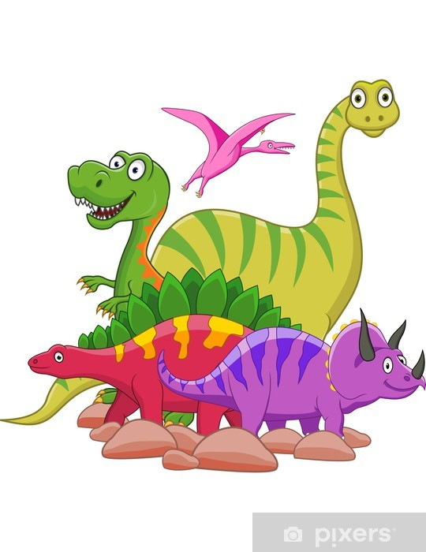
Physical Development
*Scissor & pencil control; posture
*Gymnastics: different rolls including tuck rolls, teddy bear rolls and forward rolls
*Outside: getting out of breath; obstacle courses; balancing;lifting and climbing
Dinosaurs
Understanding the World
*dinosaurs vs moon landing vs their birth timeline
* how were the dinosaurs discovered, how do we know about them?
* compare our physical world to dinosaur times

Literacy
* Learning about questions and how to write a simple question.
*Learning er/air and words ending in ing. Practise reading and writing words containing digraphs and trigraphs learnt so far.
*Write short sentences using capital letters and full stops.

Communication & Language
* Ask and answer questions about dinosaurs
*Articulate thoughts and ideas in well-formed sentences
* Learn to use dinosaur vocabulary accurately and effectively.
PSED
*Express their feeling and consider the feelings of others.
* Consider what makes a good friend.
* Think about things that we need to consider in order to be healthy.
*Think about how we grow and change. What did we need when we were a baby?

EAD
*make dinosaur dens
*construct using a range of materials
* move like different dinosaurs
*explore a range of instruments, engage in music making and dance

Maths
* Building numbers beyond 10.
* Counting on and back from different starting points.
* Learning number bonds
* Spatial reasoning
* Count beyond 10

