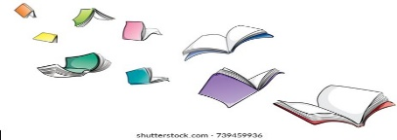Book recommendations if you love our new topic.

* **\***Ug: Boy Genius of the Stone Age
* The Way to Impossible Island
* **\***The Pebble in My Pocket
* 24 Hours in the Stone Age
* **\***A Rock Can Be
* The Rock Factory
* **\***A Rock is Lively
* **\***Stone Age Boy
* Stig of the Dump
* The Boy with the Bronze Axe
* The Stone Age: Hunters, Gatherers

and Woolly Mammoths

* **\***How to Wash a Woolly Mammoth
* The Secrets of Stonehenge

Did you know?

You can often find books being read aloud online.

Any book above with * means you can watch them on YouTube ☺

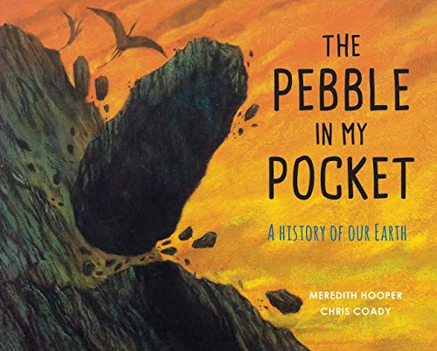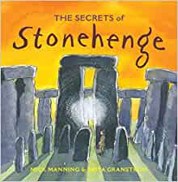

What else could you read?

* The Magic Faraway Tree (Mrs. Capstack’s favourite!)
* The Creakers
* Varjak Paw
* Dog Man
* Sam Wu
* Charlotte’s Web
* 13 Storey Treehouse
* Hilda and the Troll
* The Nothing to See Here Hotel
* Leon and the Place Between

Poetry recommendations

Micheal Rosen

Roger McGough

[Joseph Coelho](https://www.amazon.co.uk/Joseph-Coelho/e/B00P5HUREM?ref=sr_ntt_srch_lnk_1&qid=1635261552&sr=8-1)

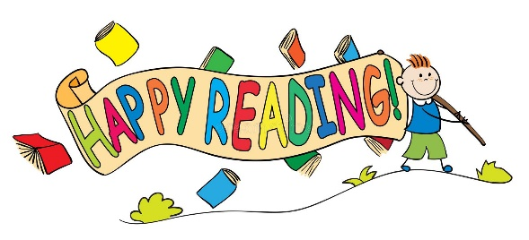

Some new suggestions for 2022

* ToTo the Ninja Cat
* The Wild Robot
* Amelia Fang
* Me and Mr P
* Jelly Boots Smelly Boots
* Charlie Changes into a Chicken
* Harry Hitch and the Iron Forest
* Interview With A Tiger
* An Alien in the Jam Factory
* Space Detectives