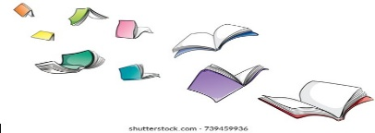Book recommendations if you love Bear Grylls.

* The Find Outers
* The Famous Five
* The Danger Gang
* The Train to Impossible Places
* BOOT small robot, BIG Adventure
* The Midnighters
* Oliver and the Seawigs
* The Spy who loved School Dinners
* The Lion, the Witch and the Wardrobe
* The Nothing to See Here Hotel
* The Great Dream Robbery
* This Is Our World: From Alaska to the

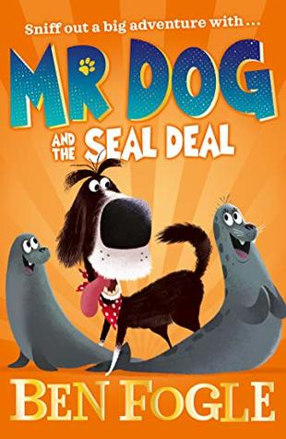Amazon

You may also wish to read some of the ‘Mr. Dog’ books written by the intrepid explorer Ben Fogle.

What else could you read?

* The Magic Faraway Tree (Mrs. Capstack’s favourite!)
* The Creakers
* Varjak Paw
* Dog Man
* Sam Wu
* Charlotte’s Web
* 13 Storey Treehouse
* Hilda and the Troll
* The Nothing to See Here Hotel
* Leon and the Place Inbetween

Poetry recommendations

Micheal Rosen

Roger McGough

[Joseph Coelho](https://www.amazon.co.uk/Joseph-Coelho/e/B00P5HUREM?ref=sr_ntt_srch_lnk_1&qid=1635261552&sr=8-1)

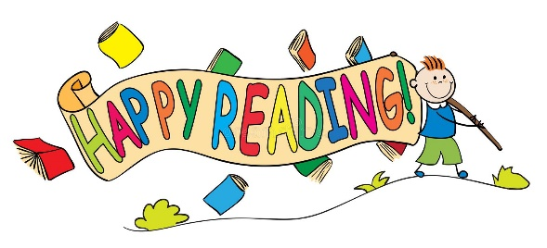

And don’t forget about all the other wonderful books written by **Bear Grylls**– there’s lots at your local library.

