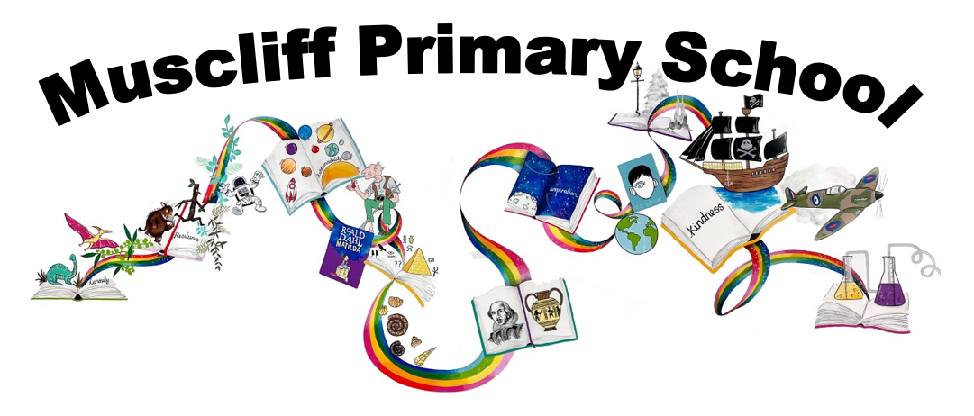
Year 6 PSHE
Autumn 1 & 2: How can the media influence people?
RSHE Themes | Key Questions | Key links to RSHE Objectives  (key vocabulary in bold)
Internet safety and harms  Mental wellbeing  Online relationships | How can what we read or experience online affect our wellbeing?  What might be the impact on our thoughts, how we feel or how we act? | 7e) That the internet can also be a negative place where online abuse, trolling, bullying and harassment can take place, which can have a negative impact on mental health  7f) How to be a discerning consumer of information online including understanding that information, including that from search engines, is ranked, selected and targeted  7g) Where and how to report concerns and get support with issues online  6h) That bullying (including cyberbullying) has a negative and often lasting impact on mental wellbeing  4e) How information and data is shared and used online
 | What do we know about cyberbullying and how it can affect people?
What do you think should and shouldn’t be shared online or social media? Why?
Are there any rules about this that you know of?
Can we believe everything that we read online/on social media/in newspapers or magazines?
Why might we read different messages about the same things?
How might that affect the way people feel or act?
What sorts of text or images are safe to post online or on social media and to whom?
What should we be aware of when posting texts or images?
Is it possible for our texts or images to be changed/manipulated/ invented by other people?
Assessment

If Jim had used the internet to research his adventure, would he still have gone?

or

Create a ‘fake’ social media profile of Long John Silver – convince people that you are actually a kind person.

*children will also need to write a note to themselves to be opened at the end of the year.

What would we say are the most reliable sources of information on the internet?
How can we tell if information is fact or fiction? Propaganda WW2. War in Russian.
 | What sort of internet content might be unsafe or inappropriate a) at our age and b) as adults? (particularly in social media, internet browsing and gaming).
What might make us suspicious about content online?
How can we recognise unsafe or inappropriate content?
What can we do if we suspect content is unsafe or inappropriate for us?
What can we do if something scares us online?
What do we know about gambling websites?
What should we know about gambling websites?
What draws people in? What are the risks?
What can “the internet” learn about us? How?
How is information about us used?
Assessment

What role did propaganda have in supporting resilience?
Imagine the internet existed in WW2. Create a propaganda page in support of the war effort.

Spring 1 & 2: How can we keep healthy as we grow?
RSHE Themes | Key Questions | Key links to RSHE Objectives  (key vocabulary in bold)
Mental wellbeing  Physical health and fitness  Healthy Eating  Drugs, alcohol and tobacco  Health and prevention | In what ways can mental and physical health be linked? | 6a) That mental wellbeing is a normal part of daily life, in the same way as physical health  6e) The benefits of physical exercise, time outdoors, community participation, voluntary and service-based activity on mental wellbeing and happiness  8a) The characteristics and mental and physical benefits of an active lifestyle  8b) The importance of building regular exercise into daily and weekly routines and how to achieve this; for example walking or cycling to school, a daily active mile or other forms of regular, vigorous exercise  8c) The risks associated with an inactive lifestyle (including obesity)  8d) How and when to seek support including which adults to speak to in school if they're worried about their health  9a) What constitutes a healthy diet (including understanding calories and other nutritional content)  9b) The principles of planning and preparing a range of healthy meals  9c) The characteristics of a poor diet and risks associated with unhealthy eating (including, for example, obesity and tooth decay) and other behaviours (e.g. the impact of alcohol on diet or health)  10a) The facts about legal and illegal harmful substances and associated risks, including smoking, alcohol use and drug-taking  11a) How to recognise early signs of physical illness, such as weight loss or unexplained changes to the body  11b) About safe and unsafe exposure to the sun, and how to reduce the risk of sun damage, including skin cancer  11c) The importance of sufficient good quality sleep for good health and that a lack of sleep can affect weight, mood and ability to learn  6i) Where and how to seek support (including recognising the triggers for seeking support), including whom in school they should speak to if they're worried about their own or someone else’s mental wellbeing or ability to control their emotions (including issues arising online)  6j) It's common for people to experience mental ill health. For many people who do, the problems can be resolved if the right support is made available, especially if accessed early enough
 | How can we support our own mental well-being?
What sort of choices can we make to support a healthy balanced lifestyle?
(how to plan a healthy meal, and maintain good physical and dental health through diet)

What sort of choices can we make to support a healthy balanced lifestyle?
(balancing online time with other activities, staying physically active)

What impact can sleep have on our physical and mental well-being?
How can we support ourselves with developing a healthy sleep pattern?

How would we describe a habit?
Can we identify good habits/bad habits?
What sort of strategies can we use to break a bad habit?
Who could support?

Assessment

Victor’s lifestyle (caused by his obsession with science) was unhealthy and full of bad habits. Create a timeline that tracks the significant points in the decline in his health.
Or
Write a text message to Victor explaining you are worried. Urge him to ask for help.

How can we recognise if we are feeling not quite right physically or mentally?
When should we seek help?
How could we seek help?

What might prevent someone from seeking help about a physical or mental health problem?
What could happen if they don’t seek help?
How could we support someone in this situation?

How common are mental health issues?
What sort of mental health issues can we identify?
What support is available for people experiencing mental health issues?

What might prevent someone from seeking help with a physical/mental health problem?
What could happen if help is not sought?
What can we do if we are worried about someone who is reluctant to seek help?

Assessment

Does love and kindness keep us healthy? Is love and kindness essential to growth?
 | How can legal or illegal drugs affect health?
 | How could we manage situations involving drugs in order to keep ourselves safe?

Summer 1 & 2
What will change as we become more independent?
RSHE Themes | Key Questions | Key links to RSHE Objectives  (key vocabulary in bold)
Respectful relationships  Families and people who care for me | How might your relationships with people change as you get older and become an adult? | 3a) The importance of respecting others, even when they're very different (for example, physically, in character, personality or backgrounds), or make different choices or have different preferences or beliefs  3b) Practical steps they can take in a range of different contexts to improve or support respectful relationships  3e) That in school and in wider society they can expect to be treated with respect by others, and that in turn they should show due respect to others, including those in positions of authority  3g) What a stereotype is, and how stereotypes can be unfair, negative or destructive  3h) The importance of permission-seeking and giving in relationships with friends, peers and adults  1c) That others’ families, either in school or in the wider world, sometimes look different from their family, but that they should respect those differences and know that other children’s families are also characterised by love and care  1d) That stable, caring relationships, which may be of different types, are at the heart of happy families, and are important for children’s security as they grow up  1e) That marriage (available to both opposite and same sex couples) and civil partnerships represent a formal and legally recognised commitment of two people to each other which is intended to be lifelong
 | What are the healthy characteristics of a romantic relationship?
How might committed romantic relationships look different?
(married, unmarried, civil partnership, different genders, ethnicity, faith)

Why might people choose to get married/ engage in a civil partnership?
(include should be wanted equally- forcing someone to marry is a crime)

What could be unhealthy in a romantic relationship?
(include that no-one should make you feel like you have to do something you feel worried/uncomfortable about)

What could we do if something in our relationships with anyone makes us feel unsafe or uncomfortable?

What might stop us seeking help? What could support us to manage those feelings?
Assessment
Work with a partner to create an Agony Aunt response to a problem of your choice.
What are we looking forward to about growing up and becoming more independent?
What might we be apprehensive about?
How could we seek support and advice as we grow up?
What are we looking forward to about moving to secondary school?
What might we feel apprehensive about?
How could we seek advice and support with this?
Assessment
Reflect back on your Year 6 experience. What advice would you have liked to have received on your first day? What might you have told this version of you?
Read back your letter to yourself. What do you notice?

