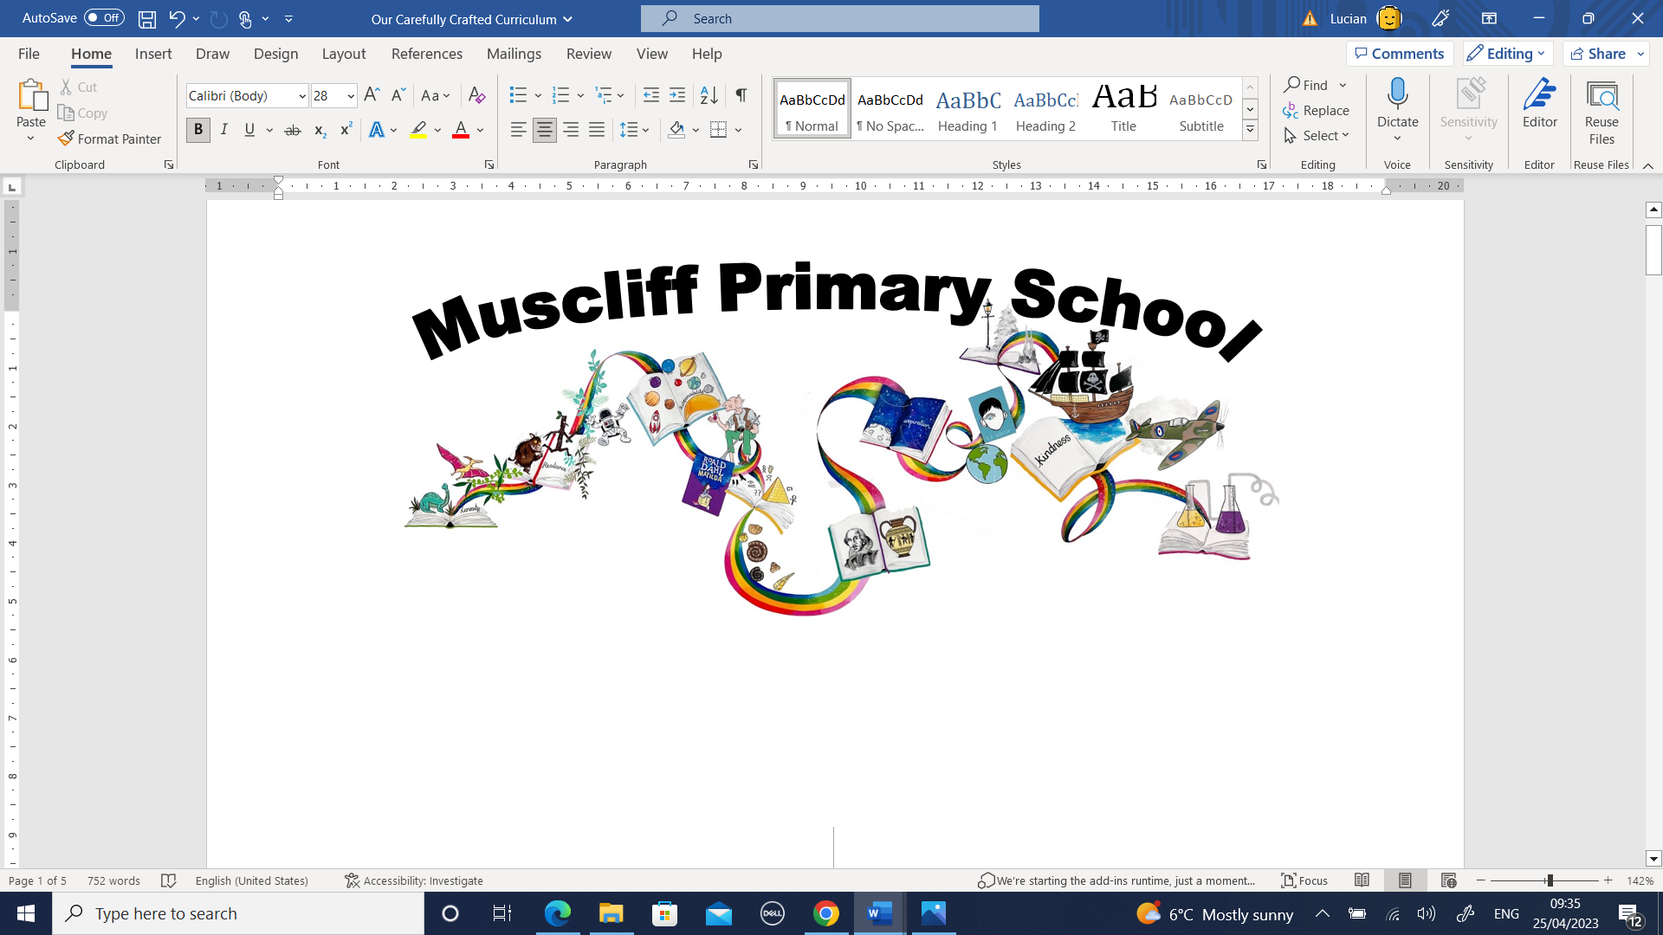
Year 5 PSHE
Autumn 1, Autumn 2 and Spring 1 (split across the half terms as Growing and Changing to run concurrently)
How can friends communicate safely?
RSHE Themes | Key Questions | Key links to RSHE Objectives  (key vocabulary in bold)
Families and people who care for me, Caring friendships, Online relationships, Internet safety and harms | What sort of different relationships do we have in our lives? | 1a) That families are important for children growing up because they can give love, security and stability  2a) How important friendships are in making us feel happy and secure, and how people choose and make friends  2e) How to recognise who to trust and who not to trust, how to judge when a friendship is making them feel unhappy or uncomfortable, managing conflict, how to manage these situations and how to seek help or advice from others, if needed  4a) That people sometimes behave differently online, including by pretending to be someone they're not  4c) The rules and principles for keeping safe online, how to recognise risks, harmful content and contact, and how to report them  4d) How to critically consider their online friendships and sources of information including awareness of the risks associated with people they have never met  7a) That for most people the internet is an integral part of life and has many benefits  7c) How to consider the effect of their online actions on others and know how to recognise and display respectful behaviour online and the importance of keeping personal information private  7d) Why social media, some computer games and online gaming, for example, are age restricted  7g) Where and how to report concerns and get support with issues online
What impact can the different relationships we have with people have on how we feel about ourselves?

Why is family important to children growing up?

What could we do if a friendship/family relationship/online relationship is making us feel worried/uncomfortable/unsafe?

How could we manage a situation where a friend/family member/online contact is asking us to do something we feel uncomfortable/worried about.

Assessment:
How would each character in Charlie and the Chocolate Factory communicate? Imagine a WhatsApp group called Golden Ticket Winners… what would each character say? Who do you think Charlie would tell if the other winners were being unkind online?
In what ways do we communicate with all the different people in our lives?

How can the internet and social media support the communication with those who are special to us?

In what ways is it different knowing someone face to face and knowing someone online?
How can we protect ourselves from any risks with online communication with people?

Assessment:
What are the Golden Rules of using online social media? Do you think Augustus Gloop or Violet would follow these rules?
What sort of things might we share with different people online?

How can we make sure we are keeping ourselves safe when sharing images/personal information with different people online?

What sort of games/social media/internet content might some children our age access?

What do we know about age restrictions and why they are in place?

Assessment:
If Edmund played violent video games, would this affect the way he treats his siblings?

Autumn 1 and Autumn 2: How will we grow and change?
(including puberty)

RSHE Themes | Key Questions | Key links to RSHE Objectives  (key vocabulary in bold)
Changing adolescent bodies | Over 2 longer sessions (see Powerpoint and lesson plans):  What is puberty?  How will our bodies change during puberty?  (including menstruation, menstrual well being, erections, wet dreams)  How might puberty affect our emotions and feelings?  What sort of personal hygiene routines should we develop during puberty?  What can we do if we are worried or anxious about growing up, changing and puberty? | 13a) Key facts about puberty and the changing adolescent body, particularly from age 9 through to age 11, including physical and emotional changes  13b) About menstrual wellbeing including the key facts about the menstrual cycle

Spring 2:
How can we help in an accident or emergency?
How can legal drugs affect health?

RSHE Themes | Key Questions | Key links to RSHE Objectives  (key vocabulary in bold)
Basic first aid, Drugs, alcohol and tobacco, Physical health and fitness. | What sort of drugs can we identify in everyday life?  (smoking/vaping/nicotine/alcohol/caffeine/medicines)  What sort of impact can these have on health and wellbeing? | 12a) How to make a clear and efficient call to emergency services if necessary  12b) Concepts of basic first aid, for example dealing with common injuries, including head injuries  10a) The facts about legal and illegal harmful substances and associated risks, including smoking, alcohol use and drug-taking  8d) How and when to seek support including which adults to speak to in school if they're worried about their health
What sort of help can people get if they are concerned about their smoking/ alcohol/medicine consumption?

What could we do if we were worried about someone’s smoking/ alcohol/medicine consumption?

How could we help in an emergency situation?
(including the importance of remaining calm, providing clear information to an adult/emergency services, keeping yourself safe)

What sort of basic first aid do are we already aware of?
In what situations is first aid appropriate/not appropriate (as further help is needed)?
 | How can we carry out basic first aid for burns, scalds, cuts, bleeds, choking, asthma attacks, head injuries?
Assessment:

Why doesn’t Elliott want to get help for Josie? What would the consequences be of not asking for help?

Summer 1: What makes up our identity?

RSHE Themes | Key Questions | Key links to RSHE Objectives  (key vocabulary in bold)
Respectful relationships | What does every human being have in common?  What sort of differences are there between people? | 3a) The importance of respecting others, even when they're very different (for example, physically, in character, personality or backgrounds), or make different choices or have different preferences or beliefs  3b) Practical steps they can take in a range of different contexts to improve or support respectful relationships  3g) What a stereotype is, and how stereotypes can be unfair, negative or destructive  Paragraphs 36 & 37 Dfe statutory guidance on Relationships, Sex and Health Education 2019.
What sort of things make up someone’s identity?
(e.g ethnicity, family, faith, culture, gender, hobbies, likes/dislikes)

How would you describe yourself, thinking about all the things that make up someone’s identity?
How would you feel if someone was unkind about your identity?

What does the term ‘stereotype’ mean?
How can these be detrimental to respectful relationships?

 | How could we manage a situation where a friend is being disrespectful about someone’s personal identity?
Assessment:

Palecio’s message is to not judge people by their appearance. What are the key features of Auggie’s identity? Do you think the prize he receives at the end of the book is the right prize? What prize would you give him?

Summer 2: What jobs would we like?

RSHE Themes | Key Questions | Key links to RSHE Objectives  (key vocabulary in bold)
 | What do we know about the different jobs that might be open to us when we are older?
 | What might be the skills or educational requirements for different jobs?
What would be important to you when thinking about what you would like to do when you are older?
How does pay differ between jobs?
Are all jobs paid?

What do we know about the different ways we can get into careers and jobs?
(e.g college, apprenticeships, university)

What might influence people when they are choosing a career/job?
Do you know anyone who has changed their job/career path completely?

 | What sort of support might we have as we get older to help think about what job/career we’d like to aim for and how we could get there?
Assessment
Which job from these choices would Auggie most likely become as an adult and why?

An astronaut
A teacher
A surgeon

