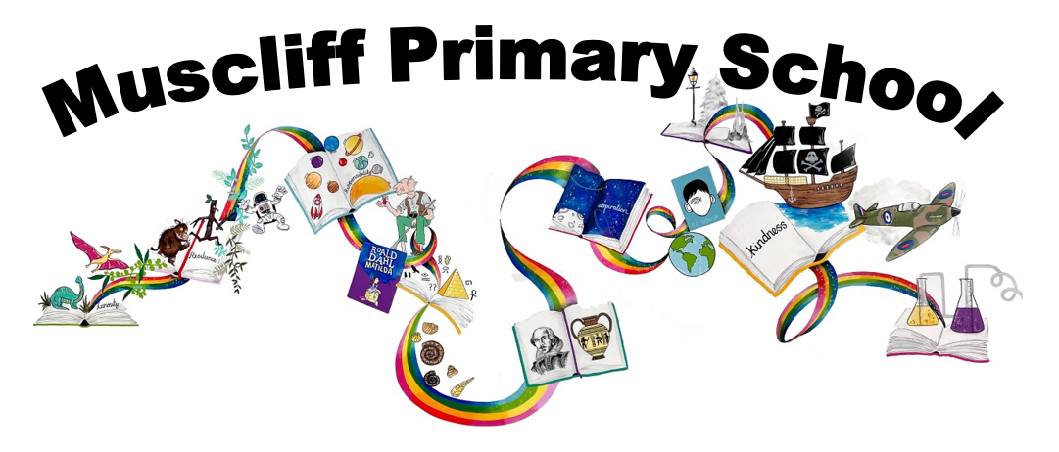

Year 4 PSHE
Autumn 1 & Autumn 2
How do we treat each other with respect?
RSHE Themes | Key Questions | Key links to RSHE Objectives  (key vocabulary in bold)
Respectful relationships, Online relationships, Being safe, Mental well-being, internet safety and harms. | How can our behaviour affect others and ourselves?  (including online, physically and mentally) | 3a) The importance of respecting others, even when they're very different (for example, physically, in character, personality or backgrounds), or make different choices or have different preferences or beliefs  3b) Practical steps they can take in a range of different contexts to improve or support respectful relationships  3d) About different types of bullying (including cyberbullying), the impact of bullying, responsibilities of bystanders (primarily reporting bullying to an adult) and how to get help  3e) What a stereotype is, and how stereotypes can be unfair, negative or destructive  3f) The importance of permission-seeking and giving in relationships with friends, peers and adults  4a) That people sometimes behave differently online, including by pretending to be someone they're not  4b) That the same principles apply to online relationships as to face-to-face relationships, including the importance of respect for others online including when we are anonymous  4c) The rules and principles for keeping safe online, how to recognise risks, harmful content and contact, and how to report them  5b) About the concept of privacy and the implications of it for both children and adults, including that it's not always right to keep secrets if they relate to being safe  5f) How to ask for advice or help for themselves or others, and to keep trying until they're heard  5g) How to report concerns or abuse, and the vocabulary and confidence needed to do so  5h) Where to get advice (e.g. family, school and/or other sources)  6h) That bullying (including cyberbullying) has a negative and often lasting impact on mental wellbeing  ) How to consider the effect of their online actions on others and know how to recognise and display respectful behaviour online and the 7c importance of keeping personal information private  7g) Where and how to report concerns and get support with issues online
 | What can ‘being respectful’ look like in school?
 | What can ‘being respectful’ look like in life outside school?
 | What are the differences between rights and responsibilities?
What can ‘bullying’ look like in different situations?
What are our responsibilities where bullying is concerned?

 | Is it always right to keep a secret?
Assessment
Is Bertie responsible in keeping the white lion?
How can we define a ‘stereotype’?
Can you think of any examples of stereotypical behaviour?

What could we do if we witness any discriminatory or disrespectful behaviour?
(including online)

What could we do if we experience any unwanted physical contact or anything that makes us feel uncomfortable?

What should we do if we don’t feel like someone is listening to our worries?
How can we ensure that the people we have contact with online are trustworthy?
How do we know what information we can trust/not trust online?
 | Assessment:

Spring 1: How can we manage our feelings?

RSHE Themes | Key Questions | Key links to RSHE Objectives  (key vocabulary in bold)
Mental wellbeing. | How many different emotions can we think of that someone might experience at different times in their day/in their lives?  What sort of things can affect our feelings on a daily basis? | 6a) That mental wellbeing is a normal part of daily life, in the same way as physical health  6b) That there is a normal range of emotions (e.g. happiness, sadness, anger, fear, surprise, nervousness) and scale of emotions that all humans experience in relation to different experiences and situations  6c) How to recognise and talk about their emotions, including having a varied vocabulary of words to use when talking about their own and others’ feelings  6d) How to judge whether what they're feeling and how they're behaving is appropriate and proportionate  6f) Simple self-care techniques, including the importance of rest, time spent with friends and family, and the benefits of hobbies and interests  6i)Where and how to seek support (including recognising the triggers for seeking support), including whom in school they should speak to if they're worried about their own or someone else’s mental wellbeing or ability to control their emotions (including issues arising online)
Mental wellbeing. | How can our feelings change over a day/ overnight/ over a period of time?
Mental wellbeing. | Why are our feelings just as important as our physical health?
Mental wellbeing. | How can we help ourselves manage our feelings?
Mental wellbeing. | How many different ways can we think of to express our feelings?
Mental wellbeing. | What could we do if we feel our feelings are too big to manage by ourselves?
 | Assessment:

Spring 2: How can we manage risk in different places?
RSHE Themes | Key Questions | Key links to RSHE Objectives  (key vocabulary in bold)
Caring friendships, Online relationships, Mental wellbeing, internet safety and harms, Health and prevention. | How can we define risk?  How can we assess and manage risk in different situations? What questions can we ask ourselves? | 2b) The characteristics of friendships, including mutual respect, truthfulness, trustworthiness, loyalty, kindness, generosity, trust, sharing interests and experiences, and support with problems and difficulties.  2e) How to recognise who to trust and who not to trust, how to judge when a friendship is making them feel unhappy or uncomfortable, managing conflict, how to manage these situations and how to seek help or advice from others, if needed  4a) That people sometimes behave differently online, including by pretending to be someone they're not  4c) The rules and principles for keeping safe online, how to recognise risks, harmful content and contact, and how to report them  4d) How to critically consider their online friendships and sources of information including awareness of the risks associated with people they have never met  4e) How information and data is shared and used online  6h) That bullying (including cyberbullying) has a negative and often lasting impact on mental wellbeing  7c) How to consider the effect of their online actions on others and know how to recognise and display respectful behaviour online and the importance of keeping personal information private  7e) That the internet can also be a negative place where online abuse, trolling, bullying and harassment can take place, which can have a negative impact on mental health  7g) Where and how to report concerns and get support with issues online  11b) About safe and unsafe exposure to the sun, and how to reduce the risk of sun damage, including skin cancer
What sort of risks might we come across when we are out and about?
(e.g near rail, water, road, fire/fireworks, sun, use of digital devices when out and about)
How can we keep ourselves safe in these situations?

How can the behaviour of our peers/people we look up to influence us?
How can we manage situations where we are asked to do something we are not comfortable with by our peers/someone we look up to?

What could we do if we saw others doing something against the law? Or racist?
How could we manage it if it was a friend doing this and encouraging us to join in?

How can our actions online impact other people?
How can we ensure we are being respectful online?

What sort of personal information is it safe to share and to whom?
How can we be sure we are sharing information with the person we think we are?
What sort of personal information should we avoid sharing online?

Assessment
Would you live in Pompeii?

Imagine you receive a text message from a friend who tells you that they don’t feel that they need to evacuate the island. What would you say to them?

Summer 1: How can our choices make a difference to others and the environment?

RSHE Themes | Key Questions | Key links to RSHE Objectives  (key vocabulary in bold)
Whose responsibility is it to protect the world around us?
In what ways can we protect the world around us?

 | What sort of everyday changes could help protect our environment? How?
How can what we choose to buy or spend money on affect others or the environment?
(e.g Fairtrade, single use plastics, giving to charity)

 | How can we show care and compassion for other people and animals?
 | (Discuss any topical issue based on protecting environment/caring and compassion)
Assessment
How do you make a difference to protect the environment in our local area?

Summer 2: What strengths, skills and interests do we have?

RSHE Themes | Key Questions | Key links to RSHE Objectives  (key vocabulary in bold)
Respectful relationships. | How are we all unique?  What are our personal qualities? | 3d) The importance of self-respect and how this links to their own happiness
Respectful relationships. | What are we proud of about ourselves? This can be a quality we have or an achievement we have made.
Respectful relationships. | How do our strengths, skills and interests affect how we feel about ourselves?
Respectful relationships. | How can we manage the feelings associated with a set back or making a mistake?
Respectful relationships. | Let’s set a personal goal for the summer holiday! Think about something achievable and that will boost your own self esteem.
Assessment:

What goals did the Boy in the Globe set out to achieve? What might your goals be for the summer holiday?

