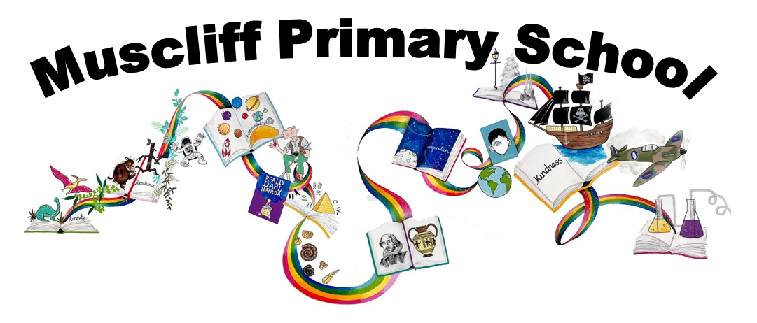

Year 3 PSHE

Autumn 1: How can we be a good friend?

RSHE Themes | Key Questions | Key links to RSHE Objectives  (key vocabulary in bold)
Caring friendships, Mental wellbeing | How can friendships support our mental health and well-being? | 2a) How important friendships are in making us feel happy and secure, and how people choose and make friends  2b) The characteristics of friendships, including mutual respect, truthfulness, trustworthiness, loyalty, kindness, generosity, trust, sharing interests and experiences, and support with problems and difficulties.  2c) That healthy friendships are positive and welcoming towards others, and do not make others feel lonely or excluded  2d) That most friendships have ups and downs, and that these can often be worked through so that the friendship is repaired or even strengthened, and that resorting to violence is never right  2e) How to recognise who to trust and who not to trust, how to judge when a friendship is making them feel unhappy or uncomfortable, managing conflict, how to manage these situations and how to seek help or advice from others, if needed  6g) Isolation and loneliness can affect children and that it's very important for children to discuss their feelings with an adult and seek support
Caring friendships, Mental wellbeing | What could we do if we are finding it difficult to make friends?
Caring friendships, Mental wellbeing | What does feeling lonely feel/look like?  Who could help us if we are feeling lonely?
Caring friendships, Mental wellbeing | What does a good, healthy friendship look like?
Caring friendships, Mental wellbeing | What could an unhealthy friendship look like?  What could support us with un unhealthy friendship? Who could help?
Caring friendships, Mental wellbeing | What strategies can we use to solve arguments?
Assessment:
Stanley falls out with his friend accidentally over a misunderstanding. Give examples of how this might happen in the playground. What do we need to do to keep friendships healthy? Did Stanley sort the misunderstanding out?

Autumn 2: Why should we eat well and look after our teeth?

RSHE Themes | Key Questions | Key links to RSHE Objectives  (key vocabulary in bold)
Healthy eating, Physical health and fitness, Health and prevention. | What sort of foods are the most/least nutritional and in what way? | 9a) What constitutes a healthy diet (including understanding calories and other nutritional content)  9b) The principles of planning and preparing a range of healthy meals  9c) The characteristics of a poor diet and risks associated with unhealthy eating (including, for example, obesity and tooth decay) and other behaviours (e.g. the impact of alcohol on diet or health)  8d) How and when to seek support including which adults to speak to in school if they're worried about their health  11d) About dental health and the benefits of good oral hygiene and dental flossing, including regular check-ups at the dentist
 | How can our diet affect the health of our bodies?
What are the best ways in which we can ensure healthy teeth and gums?
How can our diet affect the health of our teeth and gums?

What sort of choices are we able to make about what we eat and drink?
What/who can help us make those choices?

 | What could we do if we were ever worried about the health of our bodies or our teeth?
Assessment
Should Sohol be worried about keeping healthy?
What if Sohol had a toothache… what should he do?

Spring 1: What makes a community?

RSHE Themes | Key Questions | Key links to RSHE Objectives  (key vocabulary in bold)
Respectful relationships. | What does the word ‘community’ mean?  In what ways can we describe a community? | 3a) The importance of respecting others, even when they're very different (for example, physically, in character, personality or backgrounds), or make different choices or have different preferences or beliefs  3b) Practical steps they can take in a range of different contexts to improve or support respectful relationships
Respectful relationships. | How many different types of group or community do we belong to?  (e.g school, friendship, faith, clubs, classes, year groups)
Respectful relationships. | What similarities/differences could people have within a community?  How can communities be enriched by people’s differences?
Respectful relationships. | How can we ensure everyone is included and respected within our communities?
Assessment
How do we feel when something gets damaged in our local area or school? How would we react if a member of our community deliberately damaged something? How would we feel if someone not a member of our community did the same? How do you think the villagers felt when the kapok tree was about to be damaged?

Spring 2: What keeps us safe?

RSHE Themes | Key Questions | Key links to RSHE Objectives  (key vocabulary in bold)
Respectful relationships, Online relationships, Being safe, Basic first aid. | How do everyday health and hygiene rules help us stay safe?  (including management of medicines, use of household products) | 3h) The importance of permission-seeking and giving in relationships with friends, peers and adults  4b) That the same principles apply to online relationships as to face-to-face relationships, including the importance of respect for others online including when we are anonymous  4c) The rules and principles for keeping safe online, how to recognise risks, harmful content and contact, and how to report them  5e) How to recognise and report feelings of being unsafe or feeling bad about any adult  5f) How to ask for advice or help for themselves or others, and to keep trying until they're heard  5g) How to report concerns or abuse, and the vocabulary and confidence needed to do so  12a) How to make a clear and efficient call to emergency services if necessary  12b) Concepts of basic first aid, for example dealing with common injuries, including head injuries
What sort of hazards are there when we are out and about?
How can we reduce the risks to keep ourselves and others safe?
(including keeping body protected – seatbelts, cycle helmets protective clothing)

What sort of contact is appropriate?
It is ok to feel uncomfortable about appropriate contact – how can you communicate that you don’t like it?
How can we show respect for other’s feelings about appropriate physical contact?

What sort of physical contact might be inappropriate?
(include underwear rule, their body belonging to them)

What could we do if we felt uncomfortable/unsafe/worried about any physical contact?
What could we do if someone asked us to do something that we don’t feel comfortable about?
(including from a family member/friend and incl online)

What could we do to help in different situations?
(including in an emergency and dealing with minor injuries)
Assessment
Was Mary Anning safe in her actions? What risks did she take?

Summer 1: How are families similar/different?

RSHE Themes | Key Questions | Key links to RSHE Objectives  (key vocabulary in bold)
Families and people who care for me. | Why are our families important to us?  Who are our family members? | 1a) That families are important for children growing up because they can give love, security and stability  1b) The characteristics of healthy family life: commitment to each other, including in times of difficulty; protection and care for children and other family members; the importance of spending time together and sharing each other’s lives  1c) That others’ families, either in school or in the wider world, sometimes look different from their family, but that they should respect those differences and know that other children’s families are also characterised by love and care  1d) That stable, caring relationships, which may be of different types, are at the heart of happy families, and are important for children’s security as they grow up  1e) That marriage (available to both opposite and same sex couples) and civil partnerships represent a formal and legally recognised commitment of two people to each other which is intended to be lifelong  1f) How to recognise if family relationships are making them feel unhappy or unsafe, and how to seek help or advice from others if needed
Families and people who care for me. | What makes a happy family?
Families and people who care for me. | What similarities and differences can there be in different families?
Families and people who care for me. | What does commitment mean?  What can that look like within a family?
Families and people who care for me. | In what ways can we care for people in our family?
Families and people who care for me. | What could we do if a family relationship ever made us feel uncomfortable, worried or unsafe?
Assessment
In Accidental Billionaire, who is in Jasper’s family? How does Jasper’s family compare to your family?

Summer 2: Why should we keep active and sleep well?

RSHE Themes | Key Questions | Key links to RSHE Objectives  (key vocabulary in bold)
Physical health and fitness, Mental wellbeing, Internet safety and harms, Health and prevention. | What sort of physical activity and exercise do we enjoy?  How often do you exercise? | 8a) The characteristics and mental and physical benefits of an active lifestyle  8b) The importance of building regular exercise into daily and weekly routines and how to achieve this; for example walking or cycling to school, a daily active mile or other forms of regular, vigorous exercise  8c) The risks associated with an inactive lifestyle (including obesity)  8d) How and when to seek support including which adults to speak to in school if they're worried about their health  6e) The benefits of physical exercise, time outdoors, community participation, voluntary and service-based activity on mental wellbeing and happiness  7b) About the benefits of rationing time spent online, the risks of excessive time spent on electronic devices and the impact of positive and negative content online on their own and others’ mental and physical wellbeing  11c) The importance of sufficient good quality sleep for good health and that a lack of sleep can affect weight, mood and ability to learn.
How does physical activity affect our bodies?
How can physical activity affect our minds?

 | What are the risks of an inactive lifestyle?
How does a good night’s sleep affect our bodies and minds?
How does a bad night’s sleep affect our bodies and minds?

How do you feel after you have spent time concentrating on the computer/games consoles?
What effect does spending lots of time on the computer/games consoles affect our behaviour/mood?

How are we able to contact our friends and family online?
Is all online contact positive? How would we feel if it wasn’t? How could we get help?

Assessment:
Are you as healthy as a Viking?

