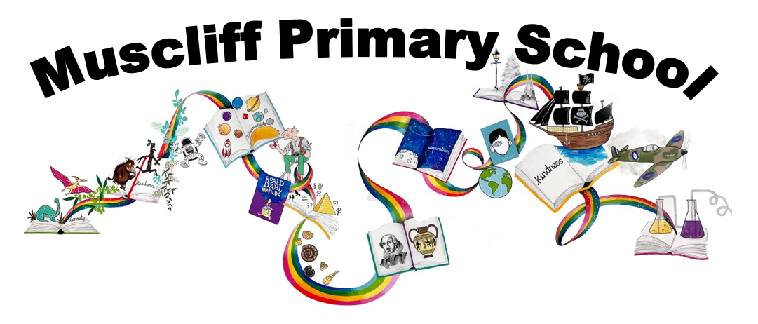

Year 2 PSHE
Autumn 1: What can help us grow and stay healthy?

RSHE Themes | Key Questions | Key links to RSHE Objectives  (key vocabulary in bold)
Healthy eating, health and prevention, mental wellbeing, Internet safety and harms | How can we stay safe in the sun? | 9a) What constitutes a healthy diet (including understanding calories and other nutritional content)  9b) The principles of planning and preparing a range of healthy meals  9c) The characteristics of a poor diet and risks associated with unhealthy eating (including, for example, obesity and tooth decay) and other behaviours (e.g. the impact of alcohol on diet or health)  11b) About safe and unsafe exposure to the sun, and how to reduce the risk of sun damage, including skin cancer  11c) The importance of sufficient good quality sleep for good health and that a lack of sleep can affect weight, mood and ability to learn  11d) About dental health and the benefits of good oral hygiene and dental flossing, including regular check-ups at the dentist  6f) Simple self-care techniques, including the importance of rest, time spent with friends and family, and the benefits of hobbies and interests  7b) About the benefits of rationing time spent online, the risks of excessive time spent on electronic devices and the impact of positive and negative content online on their own and others’ mental and physical wellbeing
Why is it important to look after our teeth?
How can we look after our teeth?
How does the amount of sugar we eat affect our teeth and our health?

What is a “healthy diet?” (include drinking water)
Why is having a balanced diet important for our health?

What sort of activities can we do outside?
Why is being physically active important for our health?

What sort of play and activities can we do at home?
Why is it important to vary our activities and take a break from screen-time?

 | How does sleep and rest help us to stay healthy?
Assessment:

What can help us grow and stay healthy?

Autumn 2: What makes a good friend?
RSHE Themes | Key Questions | Key links to RSHE Objectives  (key vocabulary in bold)
Caring friendships | How can we try to make friends with others? | 2a) How important friendships are in making us feel happy and secure, and how people choose and make friends  2b) The characteristics of friendships, including mutual respect, truthfulness, trustworthiness, loyalty, kindness, generosity, trust, sharing interests and experiences, and support with problems and difficulties.  2d) That most friendships have ups and downs, and that these can often be worked through so that the friendship is repaired or even strengthened, and that resorting to violence is never right  2e) How to recognise who to trust and who not to trust, how to judge when a friendship is making them feel unhappy or uncomfortable, managing conflict, how to manage these situations and how to seek help or advice from others, if needed
Caring friendships | What could we do if we are finding it difficult to make friends?
Caring friendships | What does feeling lonely feel/look like?  Who could help us if we are feeling lonely?
Caring friendships | What does a good, healthy friendship look like?
Caring friendships | What could an unhealthy friendship look like?  What could support us with un unhealthy friendship? Who could help?
Caring friendships | What strategies can we use to solve arguments?
Assessment
How do you help your friends?
How did the friends Plop make in the Owl who was Afraid of the Dark support him?

Spring 1 and Spring 2:
What helps us stay safe?
What jobs do people do?
RSHE Themes | Key Questions | Key links to RSHE Objectives  (key vocabulary in bold)
Families and people who care for me, Online relationships, Being safe, Internet safety and harms. | What sort of rules are there to keep us safe when we are out and about? (cycling/walking/water safety/speed restrictions) | 1f) How to recognise if family relationships are making them feel unhappy or unsafe, and how to seek help or advice from others if needed  4a) That people sometimes behave differently online, including by pretending to be someone they're not  4c) The rules and principles for keeping safe online, how to recognise risks, harmful content and contact, and how to report them  5b) About the concept of privacy and the implications of it for both children and adults, including that it's not always right to keep secrets if they relate to being safe  5e) How to recognise and report feelings of being unsafe or feeling bad about any adult  5f) How to ask for advice or help for themselves or others, and to keep trying until they're heard  5g) How to report concerns or abuse, and the vocabulary and confidence needed to do so  5h) Where to get advice (e.g. family, school and/or other sources)  7a) That for most people the internet is an integral part of life and has many benefits
Are there things in our house that could be dangerous of we are not careful?
(matches, household products, medicines)
How do we use the internet to help us learn/entertain us/ connect with people?
How could the internet be unsafe if we are not careful?
Assessment
Is it more safe today than it was in 1066?
What dangers exist today that didn’t in 1066?
What safety measures do we have today that we didn’t have in 1066?
 | How do we know who/what information we can trust on the internet?
 | What can we do if we come across anything that makes us feel uncomfortable on the internet?
 | Is it always right to keep a secret?
Where could we find help if we ever feel worried/uncomfortable/unsafe?
What could we do if we feel like someone is not listening to our worries?
Why do people go to work?
Who do you know who works? What jobs do they have?
What do we know about the jobs people do?
What skills do people need for different jobs?

 | What are your strengths? What sort of job could suit your strengths?
Assessment
When Max grows up, what job could he have and why?

Summer 1: What is bullying?

RSHE Themes | Key Questions | Key links to RSHE Objectives  (key vocabulary in bold)
Respectful relationships, Online relationships, Being safe, Internet safety and harms. | How can our words and actions make people feel? | 3f) About different types of bullying (including cyberbullying), the impact of bullying, responsibilities of bystanders (primarily reporting bullying to an adult) and how to get help  3h) The importance of permission-seeking and giving in relationships with friends, peers and adults  4b) That the same principles apply to online relationships as to face-to-face relationships, including the importance of respect for others online including when we are anonymous  4c) The rules and principles for keeping safe online, how to recognise risks, harmful content and contact, and how to report them  5c) That each person’s body belongs to them, and the differences between appropriate and inappropriate or unsafe physical, and other, contact  5f) How to ask for advice or help for themselves or others, and to keep trying until they're heard  7g) Where and how to report concerns and get support with issues online
 | What sort of words and actions are unacceptable? Why?
How might people feel about different types of physical contact?
(e.g hugging, playfighting, playing with hair etc)

Does everyone feel the same way about different types of contact?

How can we show respect for people’s feelings?

How can we define ‘bullying’?
Where can it happen?

 | How can we seek help if we are feeling bullied in different situations?
Assessment
Is the giant in Jack and the Jellybean stalk a bully?

Summer 2: How do we recognise our feelings?

RSHE Themes | Key Questions | Key links to RSHE Objectives  (key vocabulary in bold)
Mental wellbeing | What sort of feelings can people experience?  How can we describe them and sort them? | 6a) That mental wellbeing is a normal part of daily life, in the same way as physical health  6b) That there is a normal range of emotions (e.g. happiness, sadness, anger, fear, surprise, nervousness) and scale of emotions that all humans experience in relation to different experiences and situations  6c) How to recognise and talk about their emotions, including having a varied vocabulary of words to use when talking about their own and others’ feelings  6f) Simple self-care techniques, including the importance of rest, time spent with friends and family, and the benefits of hobbies and interests  6g) Isolation and loneliness can affect children and that it's very important for children to discuss their feelings with an adult and seek support  6i)Where and how to seek support (including recognising the triggers for seeking support), including whom in school they should speak to if they're worried about their own or someone else’s mental wellbeing or ability to control their emotions (including issues arising online)
Mental wellbeing | What makes you feel good feelings?  What could we do if we are not feeling good to help us feel better?
Mental wellbeing | What sort of things have an impact on our feelings?  What can help us experience more positive feelings than negative?
Mental wellbeing | How can our different feelings affect our body language/behaviour/health?
Mental wellbeing | What can we do if we feel like our feelings are too hard for us to manage?
Mental wellbeing | How might we spot someone who needs help with their feelings?  What clues might there be?  What sort of things could we do to help them?
Assessment
How do we know how each character is feeling?
Create a feelings graph for a character in the story.

