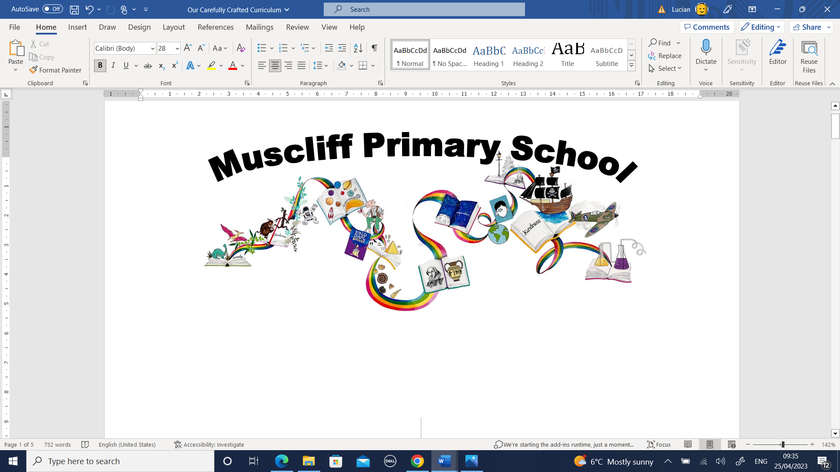

Year 1 PSHE
Autumn 1: What is the same and different about us?

RSHE Themes | Key Questions | Key links to RSHE Objectives  (key vocabulary in bold)
Respectful relationships.  Being safe. | What do you like or dislike and what are your strengths? | 3a) The importance of respecting others, even when they're very different (for example, physically, in character, personality or backgrounds), or make different choices or have different preferences or beliefs.  3d) The importance of self-respect and how this links to their own happiness  5c) That each person’s body belongs to them, and the differences between appropriate and inappropriate or unsafe physical, and other, contact
How are your strengths different to other peoples?
What is special about you?

How is each one of us unique?
What do you like about yourself?

What beliefs do we have in common?
How are they different?
 | What are the main parts of our body called? (correct vocabulary, incl external genitalia)
 | Which parts of your body do you think should be private?
Assessment
What is the same and different about us?

Autumn 2: Who is special to us?

RSHE Themes | Key Questions | Key links to RSHE Objectives  (key vocabulary in bold)
Families and people who care for me. | What sort of groups do we belong to?  (include family) | 1a) That families are important for children growing up because they can give love, security and stability  1b) The characteristics of healthy family life: commitment to each other, including in times of difficulty; protection and care for children and other family members; the importance of spending time together and sharing each other’s lives  1c) That others’ families, either in school or in the wider world, sometimes look different from their family, but that they should respect those differences and know that other children’s families are also characterised by love and care  1d) That stable, caring relationships, which may be of different types, are at the heart of happy families, and are important for children’s security as they grow up  1e) That marriage (available to both opposite and same sex couples) and civil partnerships represent a formal and legally recognised commitment of two people to each other which is intended to be lifelong  1f) How to recognise if family relationships are making them feel unhappy or unsafe, and how to seek help or advice from others if needed
Who are the members of your family?
Who are the people that love and care for you?

 | What do the people who are special to you do to make you feel loved and cared for?
 | What is the same and different about families?
What do families enjoy doing together?
Are there differences and similarities?

Thinking about our families, what might make us feel unhappy or worried?
What can we do if we feel like this?

Assessment
How does Stickman feel about his family? How do we know?

Spring 1: How can we look after each other and the world?
RSHE Themes | Key Questions | Key links to RSHE Objectives  (key vocabulary in bold)
Respectful Relationships | How can people show kindness/unkindness?  How does it feel when someone is kind/unkind to you? | 3b) Practical steps they can take in a range of different contexts to improve or support respectful relationships  3c) The conventions of courtesy and manners  3e) That in school and in wider society they can expect to be treated with respect by others, and that in turn they should show due respect to others, including those in positions of authority
What does polite mean? And courteous?
How can we show politeness and courtesy?
How will that make others feel?

 | How can we create a happy classroom?
 | How can we create a happy playground?
How do people need to be looked after?
How do animals need to be looked after?
Are there any similarities?

 | How can we look after our environment; what should and shouldn’t we do and why?
Assessment
How does Supertato keep the supermarket a happy environment?

Spring 2: How can we make friends?

RSHE Themes | Key Questions | Key links to RSHE Objectives  (key vocabulary in bold)
Caring Friendships | How can we make friends with other people? | 2a) How important friendships are in making us feel happy and secure, and how people choose and make friends  2b) The characteristics of friendships, including mutual respect, truthfulness, trustworthiness, loyalty, kindness, generosity, trust, sharing interests and experiences, and support with problems and difficulties.  2d) That most friendships have ups and downs, and that these can often be worked through so that the friendship is repaired or even strengthened, and that resorting to violence is never right  2e) How to recognise who to trust and who not to trust, how to judge when a friendship is making them feel unhappy or uncomfortable, managing conflict, how to manage these situations and how to seek help or advice from others, if needed
How can we tell if someone is feeling lonely?
What does feeling lonely feel like?
What could we do if we/someone else is feeling lonely?

What does being friendly to someone look like?
What makes a good friend?

 | What can we do if we have an argument with our friends?
 | What could we do if a friendship is making us sad or worried?
Assessment
How can the ugly duckling make friends?
Are the other ducklings good friends?

Summer 1: What helps us stay healthy?
RSHE Themes | Key Questions | Key links to RSHE Objectives  (key vocabulary in bold)
Health and Prevention  Healthy eating | What does being healthy mean?  Who helps us stay healthy? | 11d) About dental health and the benefits of good oral hygiene and dental flossing, including regular check-ups at the dentist  11e) About personal hygiene and germs including bacteria, viruses, how they're spread and treated, and the importance of handwashing  11f) The facts and science relating to immunisation and vaccination  9c) The characteristics of a poor diet and risks associated with unhealthy eating (including, for example, obesity and tooth decay) and other behaviours (e.g. the impact of alcohol on diet or health)
 | How can what we eat make a difference to how we feel?
 | How can medicines (including vaccinations and immunisations) help us to stay healthy?
 | How can we help to stop germs and viruses being passed to each other?
 | What should we do every day to keep ourselves healthy and why?
How do we feel about moving to a new year group?
How can we help ourselves with our feelings about changing teacher and year group?
Assessment
Do you think the gardener in our story is healthy?

Summer 2: Who helps us to keep safe?
RSHE Themes | Key Questions | Key links to RSHE Objectives  (key vocabulary in bold)
Being Safe | Who are our trusted adults?  Who helps us in the school community and the local community? | 5d) How to respond safely and appropriately to adults they may encounter (in all contexts, including online) whom they do not know  5f) How to ask for advice or help for themselves or others, and to keep trying until they're heard  5h) Where to get advice (e.g. family, school and/or other sources)
 | How could we respond (safely) to an adult we don’t know in different places and situations?
Who can we ask for help if I need it? ( in different places and situations)
What could we do if we feel unsafe or worried?
How could we safely ask for help?

 | What could we do if someone we don’t know contacts us online?
When might we need to make an emergency 999 call?
How do we do it and what should we say?

Assessment:
Who helps keep us safe?

