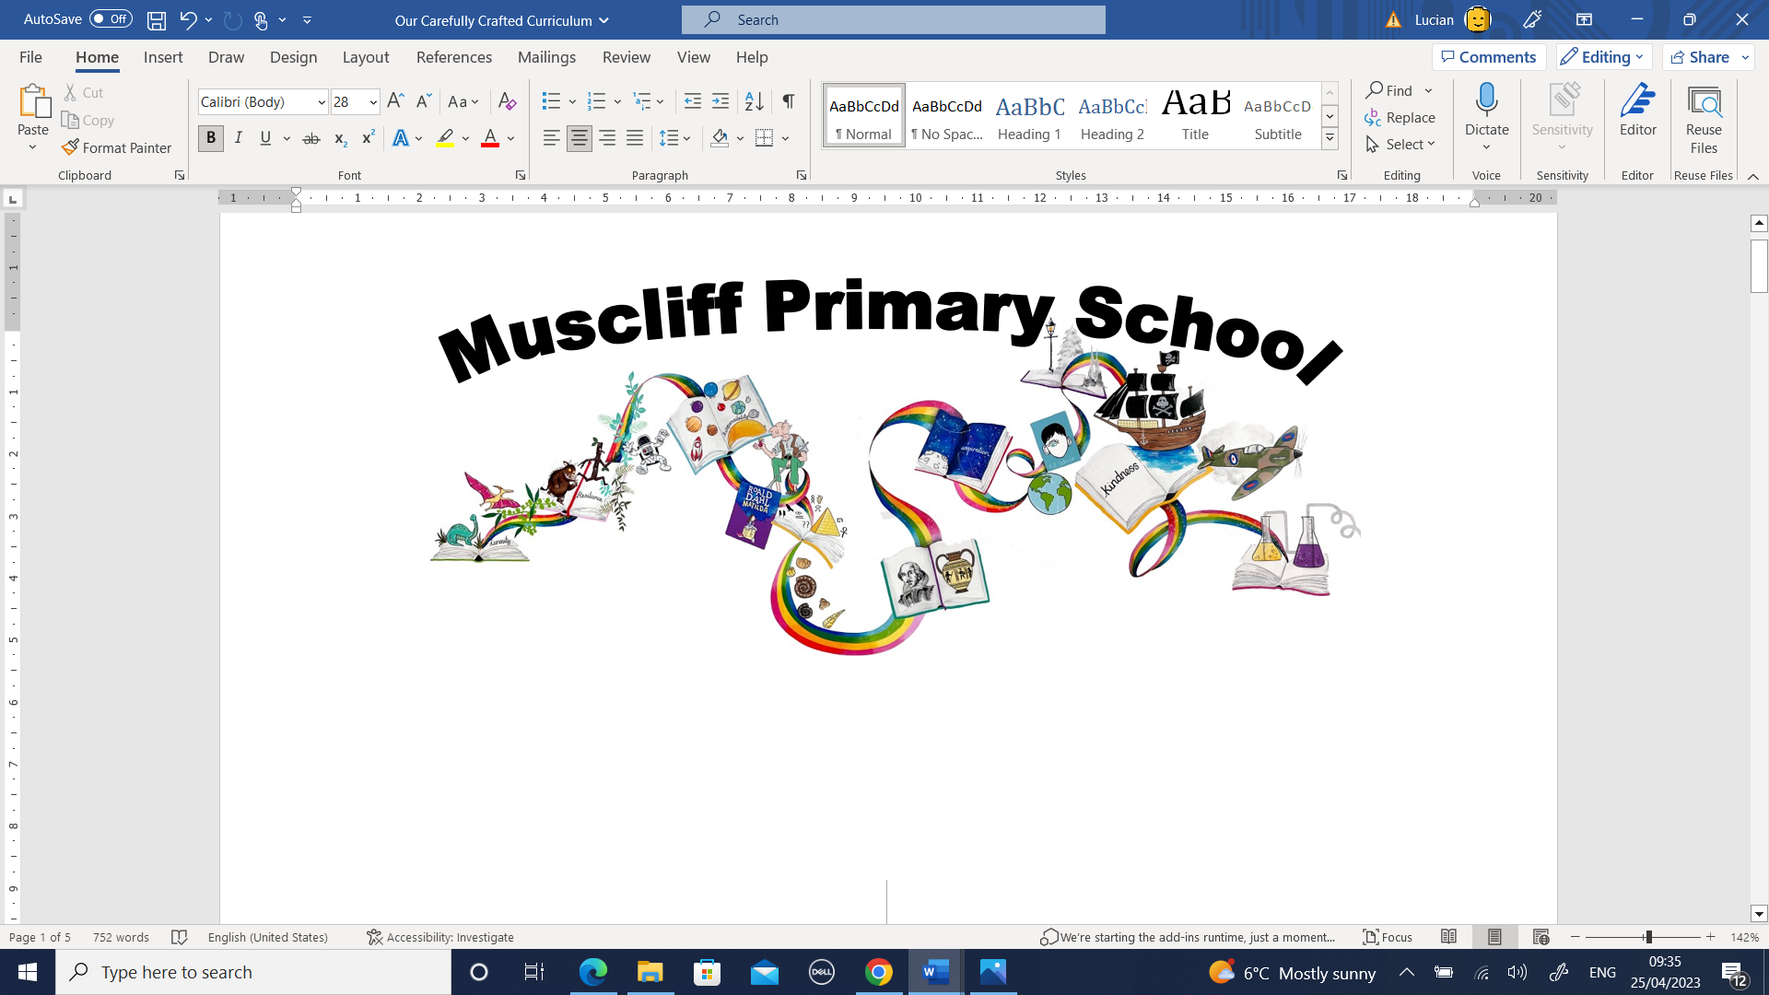
PSHE Whole School Overview
Question-based Curriculum Model
 | Autumn 1 | Autumn 2 | Spring 1 | Spring 2 | Summer 1 | Summer 2
Year 1 | What is the same and different about us? | Who is special to us? | How can we look after each other and the world? | How can we make friends? | What helps us stay healthy? | Who helps to keep us safe?
Text | Marvellous Me | Stickman/Seasons | Supertato | The Ugly Duckling | The Extraordinary Gardener | Where in the World
Value | Aspiration | Curiosity | Responsibility | Kindness | Resilience | Curiosity
Key Assessment  Questions | What is the same and different about us? | How does Stickman feel about his family? | How does Supertato create a happy supermarket? | How can the ugly duckling make friends?  Are the other ducklings good friends? | Do you think the gardener is healthy? | Who helps to keep us safe?
Year 2 | What can help us grow and stay healthy? | What makes a good friend? | What jobs do people do?  What helps us stay safe? | What jobs do people do?  What helps us stay safe? | What is bullying? | How do we recognise our feelings?
Text | Somebody Swallowed Stanley | The Owl Afraid Dark | Hodgeheg | Vlad Great Fire | Jack Jelly Bean | Midsummer Night’s Dream
Value | Responsibility | Resilience | Resilience | Curiosity | Aspiration | Kindness
Key Assessment  Questions | What can help us grow and stay healthy? | How do you help your friends? How did Plop’s friends support his fears? | When Max grows up, what job could he have and why? | Is it more safe today than it was in 1066?  What dangers exist today that didn’t in 1066?  What safety measures do we have today that we didn’t have in 1066? | Is the giant in our story a bully? | How do we know how each character is feeling?  Create a feelings graph for a character in the story.
Year 3 | How can we be a good friend? | Why should we eat well and look after our teeth? | What makes a community? | What keeps us safe? | How are families similar/different? | Why should we keep active and sleep well?
Text | Flat Stanley | The Worries | The Great Kapok Tree | Street Beneath | Accidental Billionaire | Arthur Golden Rope
Value | Curiosity | Resilience | Responsibility | Curiosity | Aspiration | Kindness
Key Assessment  Questions | Stanley falls out with his friend accidentally over a misunderstanding. Give examples of how this might happen in the playground. What do we need to do to keep friendships healthy? Did Stanley sort the misunderstanding out | Should Sohol be worried about keeping healthy?  What would Sohol do if he had a toothache? | If someone wanted to damage something special in our school, how would we react?  How do you think the villagers felt about their kapok tree? | Was Mary Anning safe in her actions?  What risks did she take? | Think about the different families in the books we have read. How do the families compare to Jasper’s family? | Why should we keep active and sleep well?
Year 4 | How do we treat each other with respect? | How can we manage our feelings? | How do we treat each other with respect? | How can we manage risk in different places? | How can our choices make a difference to others and the environment? | What strengths, skills and interests do we have?
Text | Butterfly Lion | Shout Aloud  Firework Maker’s Daughter | Varjak Paw | Escape from Pompeii | Big Book of UK | Boy in the Globe
Value | Kindness | Curiosity | Resilience | Curiosity | Responsibility | Aspiration
Key Assessment  Questions | What responsibilities does Bertie have towards his lion? | When Lila disobeys her father, how might he feel? How does Lila feel?  How do their feelings change? Create a feelings graph. | Should Varjak trust the character he meets in the soggy hide away? | Would you live in Pompeii?  Imagine you receive a text message from a friend saying they are not going to evacuate. What would you say to them? | How do you make a difference to protect the environment in our local area? | Set a personal goal for the holiday.
Year 5 | How can friends communicate safely?  How will we grow and change? (Puberty) | How can friends communicate safely?  How will we grow and change? (Puberty) | How can friends communicate safely? | How can legal drugs affect health?  How can we help in an accident or emergency | What makes up our identity?  (LGBT) | What jobs would we like?
Text | Charlie Chocolate | Narnia | Non-fiction space | Who let the gods out? | Wonder | Wonder
Value | Kindness | Curiosity | Responsibility | Resilience | Kindness | Aspiration
Key Assessment  Questions | How would friends in Charlie and the Chocolate Factory communicate their news via text message? | Online safety – what are the golden rules? | If Fortnite online, would that effect the way he treats his brothers and sisters? | Why doesn’t Elliott want to get help for Josie? What would the consequences be of not asking for help? | Palecio’s message is to not judge people by their appearance. What are the key features of Auggie’s identity? | Which job from these choices would Auggie most likely become as an adult and why?  An astronaut  A teacher  A surgeon
Year 6 | How can the media influence people? |  | How can we keep healthy as we grow? |  | What will change as we become more independent?  (Sex Ed)
Text | Treasure Island | Letters Lighthouse | Frankenstein | Frankenstein | Beedle the Bard | Biography JK Rowling
Value | Curiosity | Resilience | Responsibility | Kindness | Curiosity | Aspiration
Key Assessment  Questions | If Jim had used the internet to research his adventure, would he still have gone?  Create a ‘fake’ social media profile of Long John Silver – convince people that you are a kind person.  *write a letter to your future self. | How did the ‘Great British Spirit’ help Britons during WW2? What role did propaganda have in supporting resilience? | Victor’s lifestyle, caused by his obsession with science, was unhealthy and full of bad habits. Create a timeline that tracks the significant points in the decline in his health.  Write a letter to Victor explaining you are worried. Urge him to ask for help. | Talk to Victor explaining you are worried. Urge him to ask for help.  Is someone born to be kind or unkind?  Does love and kindness keep us healthy? | Create a poster to support someone to seek help.  Agony Aunt | What does it take to be a role model?  Reflect back on your Year 6 experience. What advice would you have liked to have received on your first day? What might you have told this version of you?  *Read your letter from Sept

