Introduction of bar modelling for multiplicative reasoning: Year 3 and 4
 | Bar Models | Concretes and Problem Solving Applications to support
Two step joining/ separating problems.  Pose problems in a variety of combinations e.g. | Joe has 5 marbles. Seb has 3 more than Joe. How many marbles do they have altogether?  Seb ?  Joe 5 3  ?  Joe 5 Seb 8 | 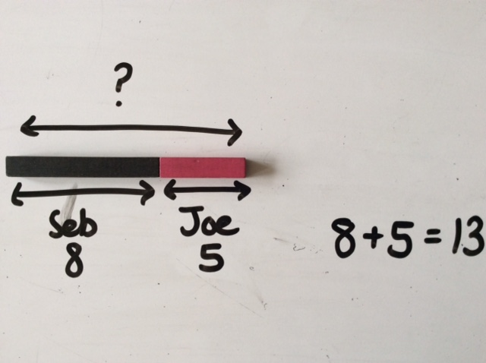  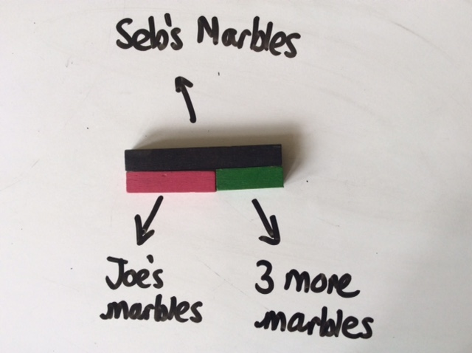
Joe has 5 marbles and Seb has 8 marbles. Megan says, ‘I have double the number of marbles that you have together.’ How many marbles does Megan have?

?
Joe 5 | Seb 8

Megan
Seb and Joe 13

Comparing Problems | Larger Quantity Unknown  Ellie picked 6 apples. Katie Picked four times as many apples as Ellie. How many apples did Katie pick?  Katie?  Ellie 6 | 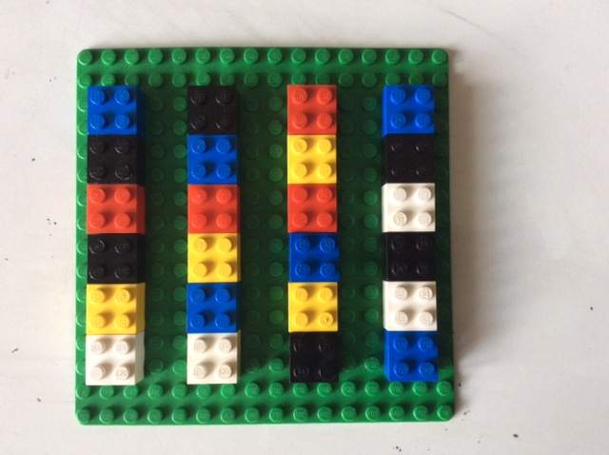  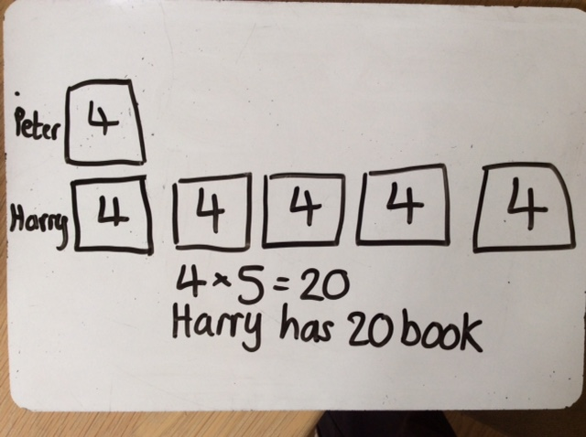  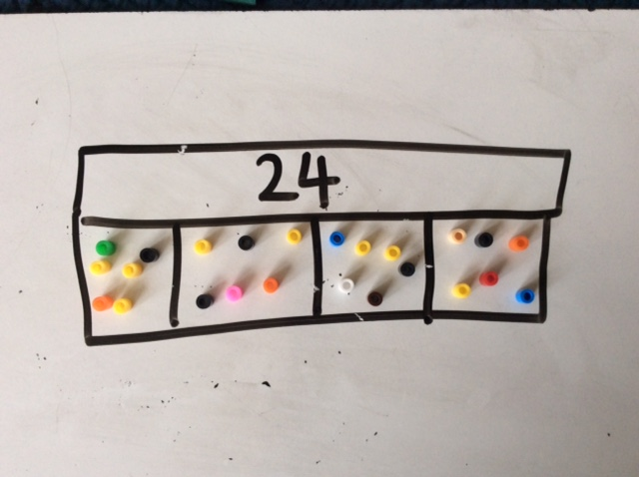
Smaller Quantity Unknown
Ellie picked 24 apples. She picked four times as many apples as Katie. How many apples did Katie pick?

Ellie 24
Katie?

Multiplier Unknown
Ellie picked 24 apples. Katie picked 6 apples. How many times as many apples did Ellie pick than Katie?
Apply to simple scaling problems

Peter has 4 books. Harry had 5 times as
many books as Peter.
How many books does Harry have?

Ellie 24
Ellie 6

Finding the difference  Secure understanding of finding the difference as counting on as an efficient way to solve subtraction problems | Size of part unknown  There are 12 more girls than boys in a football club. There are 94 children in the club altogether. How many girls are there in the club?  12  Boys  94  Girls | 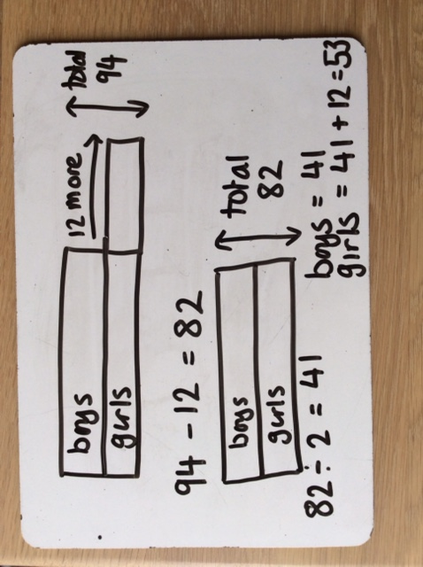
 | Total Unknown  In a football club there are 12 more boys than girls. There are 53 girls in the club, how many children are there in the club altogether?  12  Girls 53  ?  Boys ? | 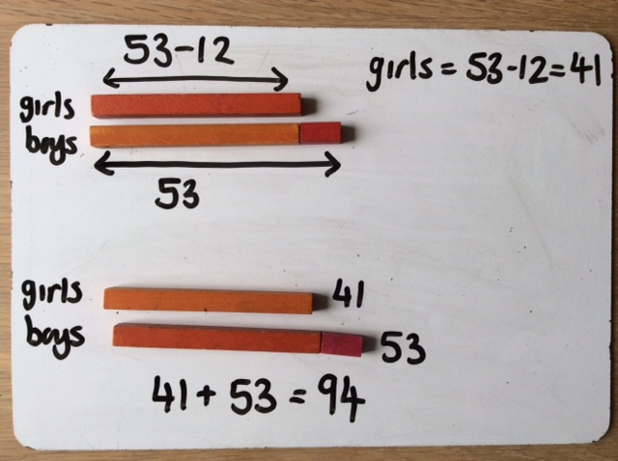
Fraction Problems

 | Size of part of part unknown  What is 1/3 of 21?  21  ?  Repeat with problems where the children have to work out the value of more than one group e.g. 2/3 of a number is 14, what is my number? | 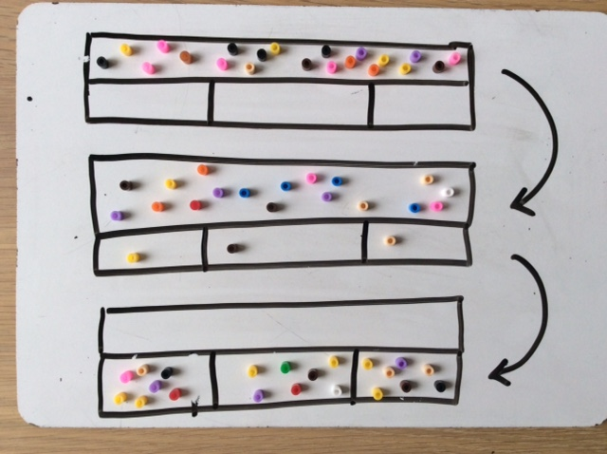  Children find 21 counters etc.  They make 3 groups.  They share the 21 equally between the 3 groups.  They count the total number in each group.
 | Whole unknown  1/3 of a number is 7. What is the number?  ?  7 | 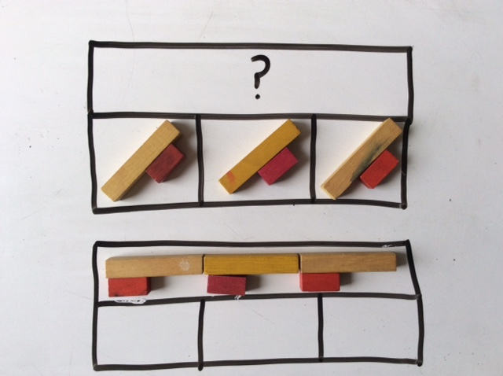  Children make the group of 7.  They make 3 lots of that group.  They put the 3 groups together to show that is the total.  They work out what the total is.
 | Size of one part and whole unknown  2/3 of a number is 14. What is the number?  ?  14  Problem solving application  A computer game is £24 in the sale.  This is one quarter of its original price.  How much did it cost before the sale? | 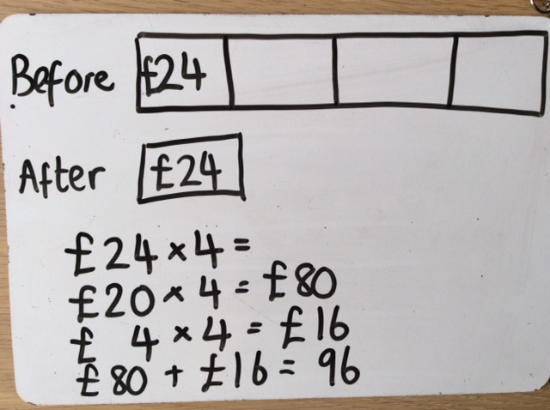  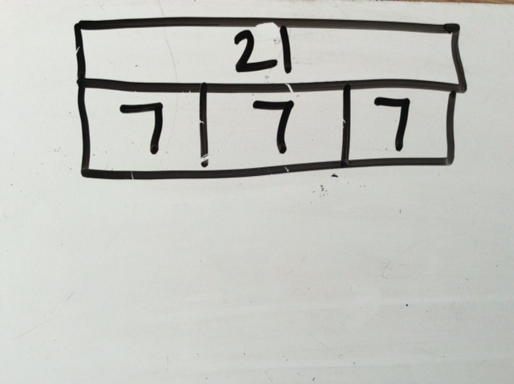  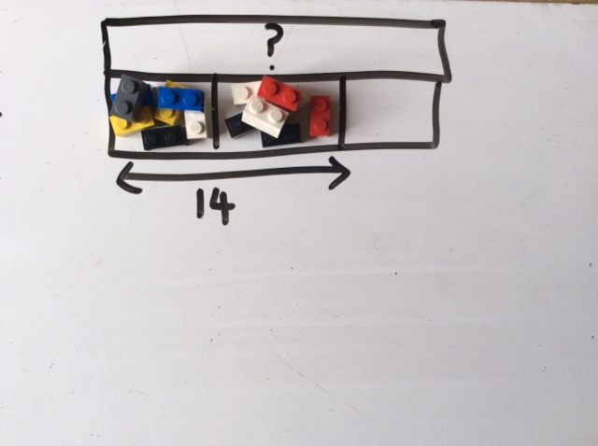  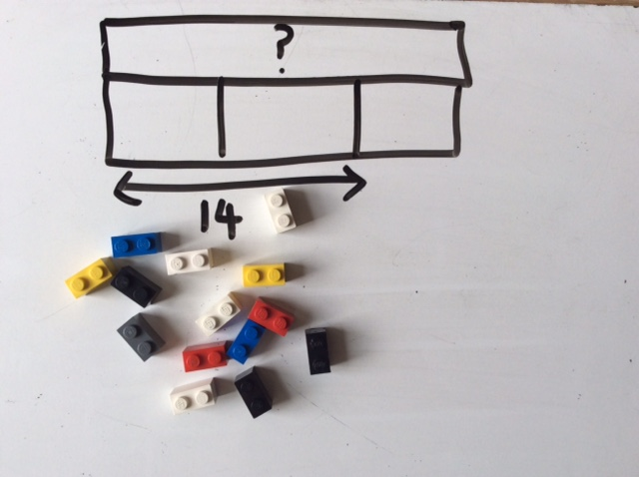

Example bar model problems (NCETM)

Year 3
- There are 334 children at Muscliff and 75 at Holy Trinity Nursery. How many children are there altogether?
- Gemma collected 293 badges but she gave 45 of them to her friend, Rebecca. How many badges did she have left?
- Aiden has seven marbles and Harvey has fifteen. They decide to share them equally. How many do they get each?
- Seven people each put five pens in a pot. Carmen then takes out fifteen pens. How many pens are left?
- If you spend 61p at Costcutter, how much change do you get form £1.00?
- If five apples cost fifty pence, how much would two apples cost?
- Emma buys seven marker pens for 30p each. How much change does she get from £3.00?
- A bookcase in the library holds 5 shelves each with 46 books. How many books are there on the bookcase altogether?
- Which is larger, one third of £60 on one quarter of £88?
- A computer game is £24 in the sale. This is one quarter of it’s original price. How much did it cost before the sale?

Year 4
- Martin has saved £6.78 and spends £4.69. How much does he have left?
- Sally has 40 football cards. She gives two fifths to her friend. How many does she give away?
- Sally has 3o football cards. She fives three fifths to her friend. How much does she have left?
- 8 children each download 59 songs on their iPods. How many songs do they have altogether?
- How many 5s are there in 85?
- At the dressmakers, Debbie buys buttons each weighing 3 grams. If she had 81 grams of buttons, how many buttons did she buy?
- Kelly buys four fifths of the shop’s oranges. If the shop had 20 oranges, how many did she buy?

