Year 1 and 2 Bar Model Progression
 | Addition and Subtraction | Practical examples
Joining Problems  Present addition problems in these different ways so that the children become familiar with them. | Whole unknown  Ben has 5 red marbles and 8 green marbles.  How many marbles does he have altogether?  ?  Red 5 Green 8  Combine two quantities to make a whole. | 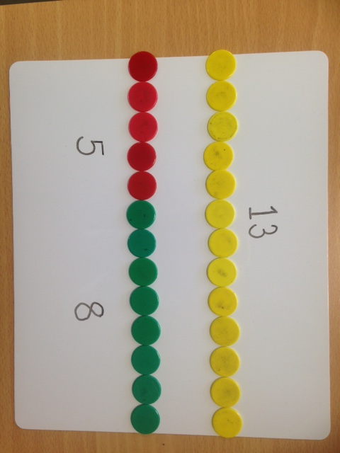  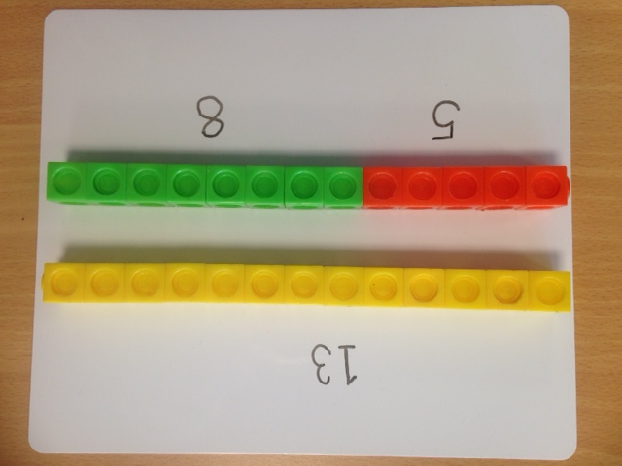
 | Start Unknown  Ben has some marbles. Jack gave him 5 more. Now he has 13 marbles. How many marbles did Ben have to start with?  Ben 13  ? Jack 5  With this bar we know the whole but only one of the parts, children need to identify the missing part (this could be solved by subtraction / counting backwards). | 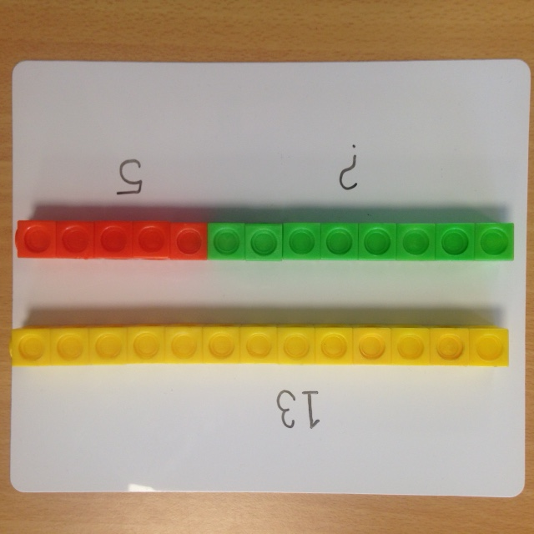  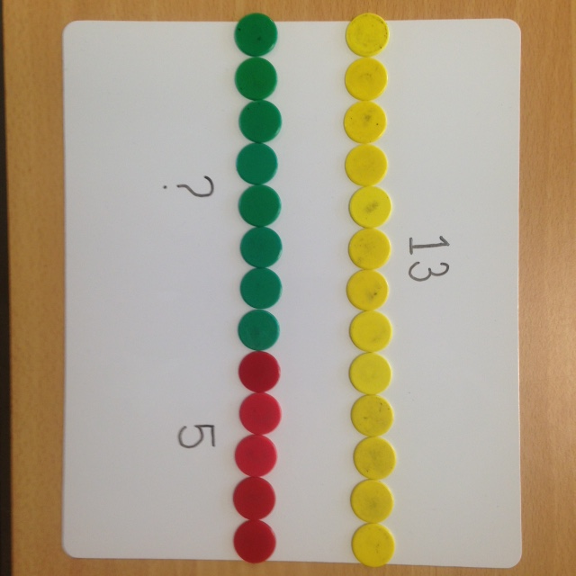
 | Part Unknown  Ben has 13 marbles. 5 are red and the rest are blue.  How many blue marbles does he have?  Ben 13  Red 5 ?  This bar is particularly valuable for seeing the difference between two quantities (this could be solved by counting on). | 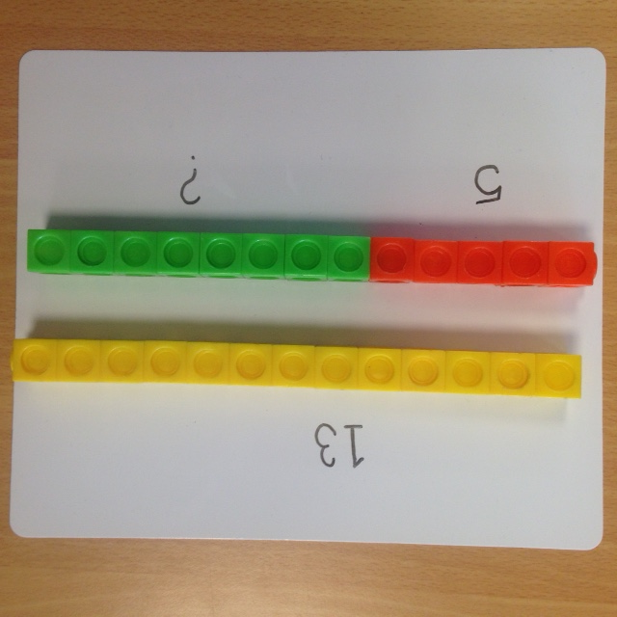  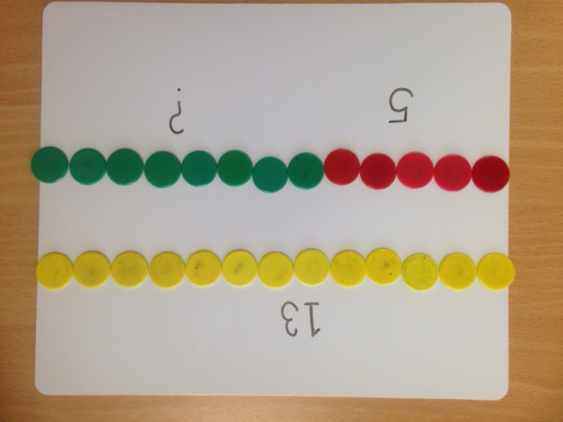
Separating Problems  Present subtraction problems in the different ways so that the children become familiar with them. | Result Unknown  Ben had 13 marbles. He gave 5 to Jack. How many marbles does Ben have left?  Ben 13  ? Jack 5
Part Unknown

Ben had 13 marbles. He gave some to Jack. Now he has 5 marbles left. How many marbles did Ben give to Jack?

Ben 13
Jack ? | 5

 | Start unknown  Ben had some marbles. He gave 5 to Jack, now he has 8 marbles left. How many marbles did Ben have to start with?  ?  8 Jack 5 | 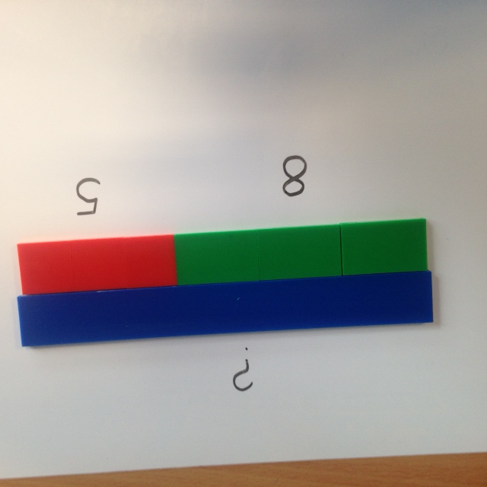  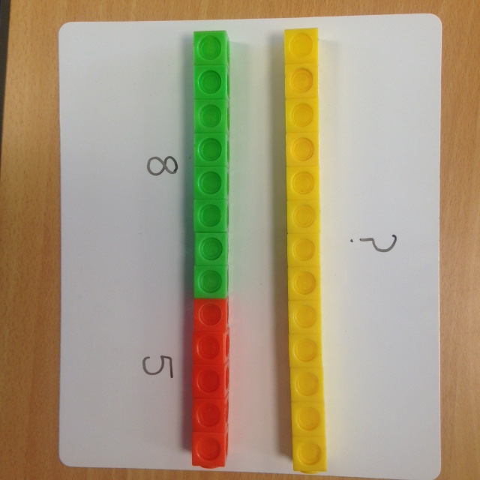

Comparing Problems  This approach is suited to ‘take away’ problems (counting backwards). | Difference Unknown  Ben has 13 marbles. Jack has 5 marbles. How many more marbles does Ben have than Jack?  13  ? Jack 5 | 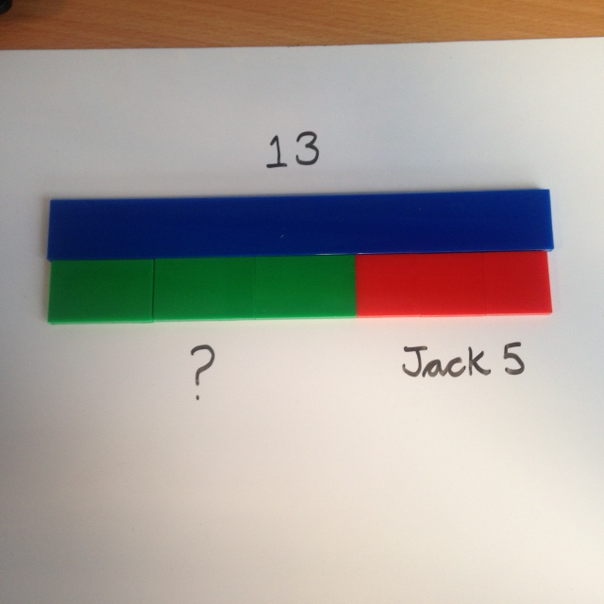
 | Smallest Part Unknown  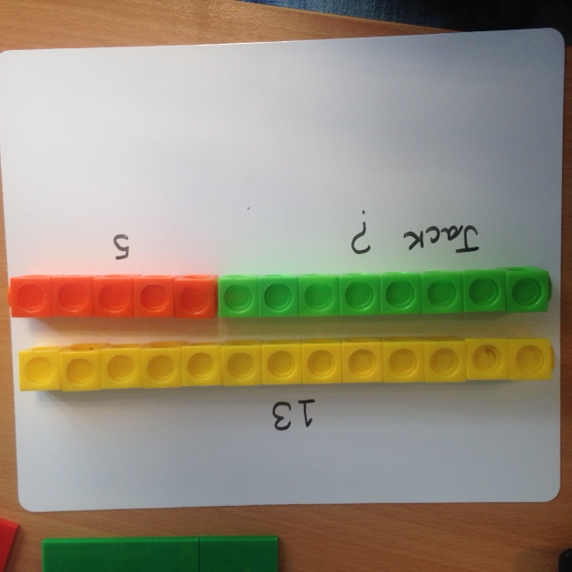  Ben has 13 marbles. He has 5 more marbles than Jack. How many marbles does Jack have?  13  Jack ? 5 | 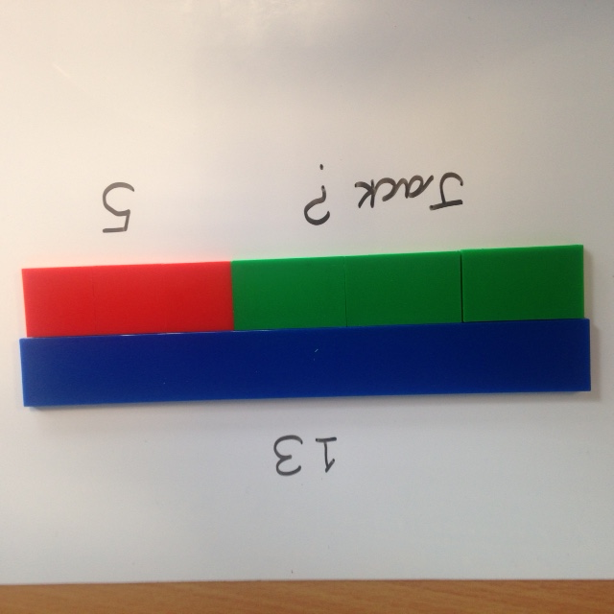
 | Largest Part unknown  Jack has 5 marbles. Ben has 8 more marbles than Jack. How many marbles does Ben have?  ?  8 Jack 5 | n
Comparing Problems  This approach is suited to ‘find the difference between’ problems by counting on. | Difference Unknown  Ben has 13 marbles. Jack has 5 marbles. How many more marbles does Ben have than Jack?  ?  Ben 13  Jack 5 | 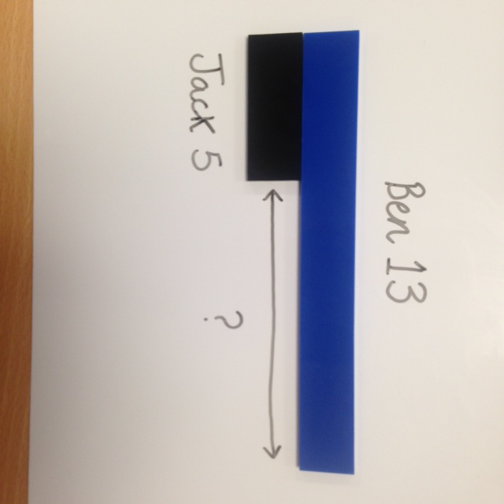  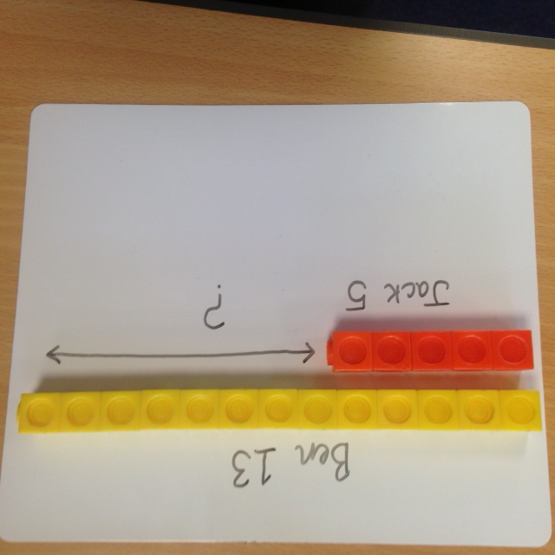  +
 | Smallest Part Unknown  Ben has 13 marbles. He has 5 more marbles than Jack. How many marbles does Jack have?  ?  Ben 13  5 | 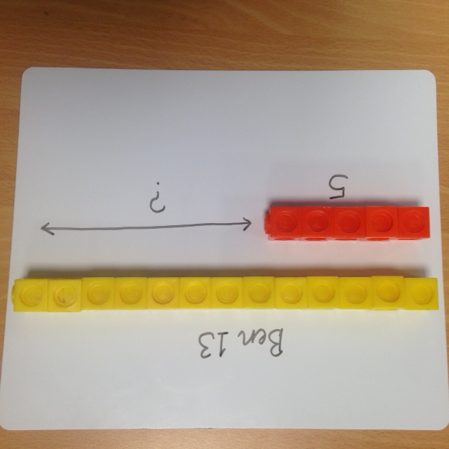  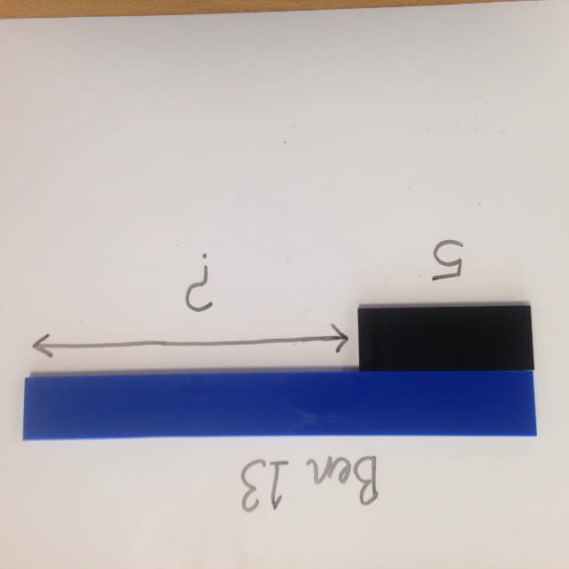
 | Largest Part unknown  Jack has 5 marbles. Ben has 8 more marbles than Jack. How many marbles does Ben have?  Ben ?  ?  Jack 5 | 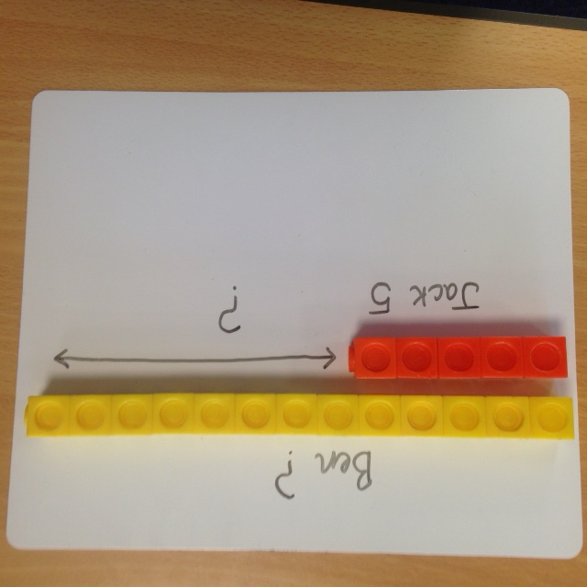  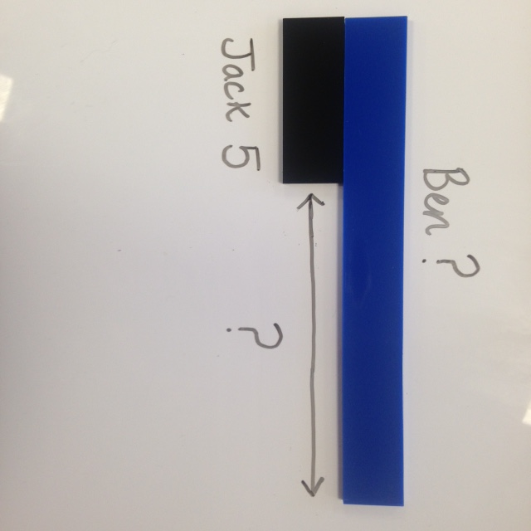

Part-Whole problem  Present calculations in the different ways so children are familiar with all of them. | Multiplication and Division | Practical examples
 | Whole Unknown  Pencils cost 4p each. How much do 6 pencils cost?  Whole  Number of parts  ?  4p 4p 4p 4p 4p 4p  Size of parts | 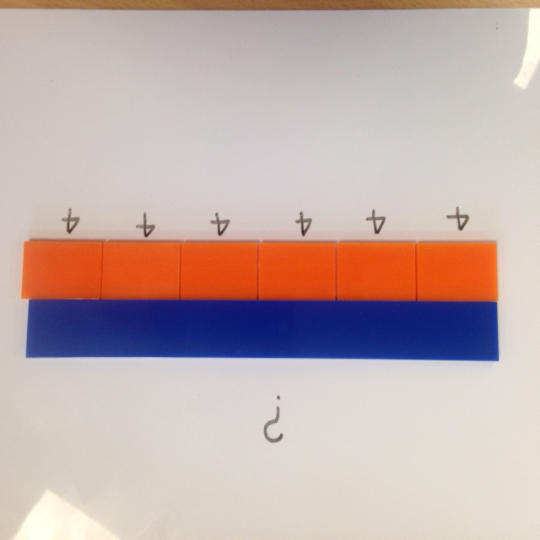
 | Size of Part unknown  Zac bought 6 pencils for 24p. How much does 1 pencil cost?  Whole  Number of parts  24p  ?  Size of parts | 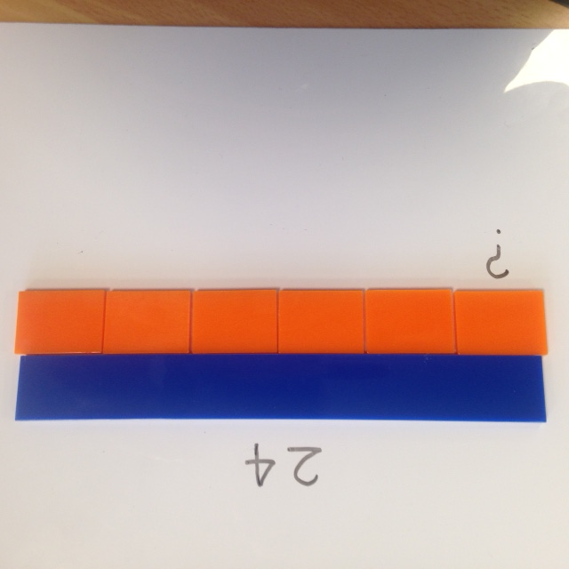
 | Number of parts unknown  Pencils cost 4p each. Zac bought some pencils for 24p. How many pencils did he buy?  Whole  Number of parts  24p  4p  Size of parts | 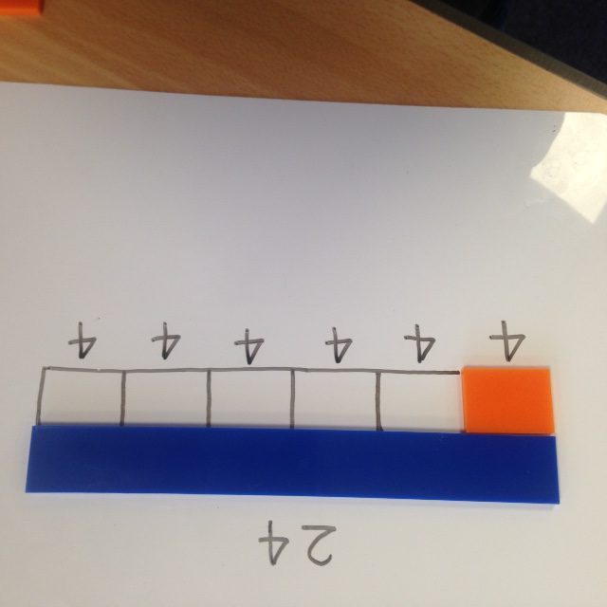

Example bar model problems (NCETM)

Year 1
- Jack has 5p and Daniel has 8p. How much do they have altogether?
- A lolly costs 6p. Holly paid with a 10p coin. How much change does she get?
- Michael says that 16 + 5 = 21. Is he correct?
- I think of a number. I subtract 5. The answer is 4. What was my number?
- How many gloves are there all together in 6 pairs of gloves?
- Twelve people are split into two equal groups. How many are in each group?
- Mrs Small puts five 5p coins into her purse. How much is in her purse altogether?

Year 2
- Dylan has 37coloured pencils ad he buys 30 more. How many does he now have?
- Sophie has 40 beads. She loses 25 of them. How many does she have left?
- What is the difference between seventy six and thirty five?
- I think of a number. I subtract 5. The answer is 4. What was my number?
- Last week Ellie got £1.00 pocket money. She spent half of it. How much has she got left?
- A tub contains 24 coins. Ali takes 5 coins. Jane takes 10 coins. How many coins are left in the tub?
- Amelia writes the calculation below as a multiplication. What might she write?
3 + 3 + 3 + 3+ 3 = 15
- Mr Siddique shares £18 equally between three sons. How much does each son get?
- Charlotte cuts his pizza into 8 equal slices. He eats ¾ of the pizza and gives the rest to his dog. How many pieces does Charlotte eat?

