Addition Model Progression
Peter has five lollipops in a bowl and Jenny has three lollipops in a bowl. How many lollipops do they have altogether?
Model 1 Model 2 | Guidance notes
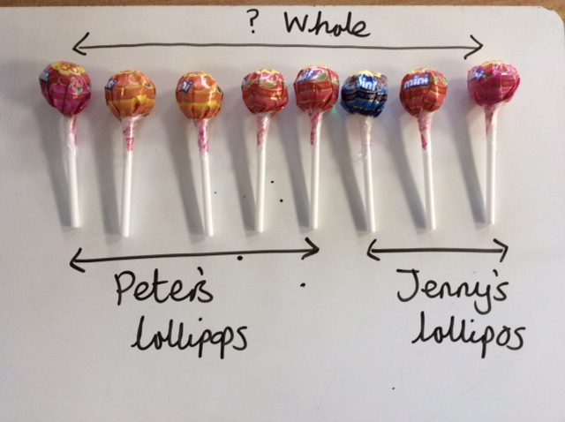  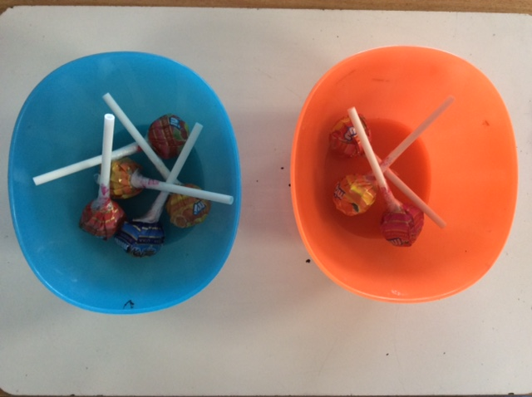  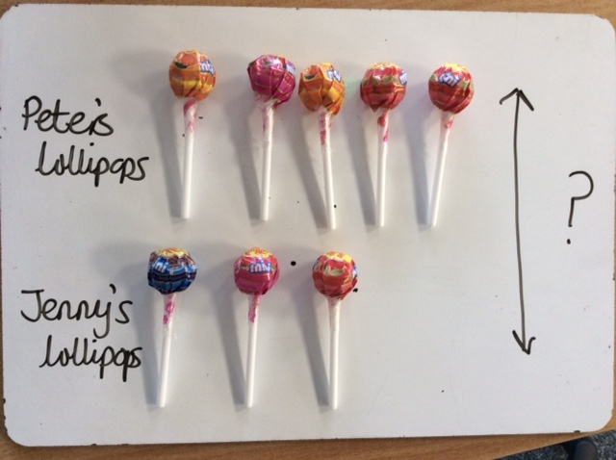  Calculations  5+3=8 | Start with a story and not a Learning Objective.  Make sure the objects are the REAL object in the story and not just concrete materials.  Always show the calculation alongside the models.
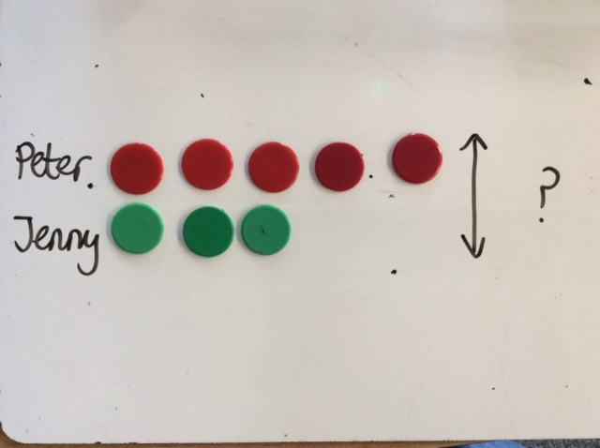  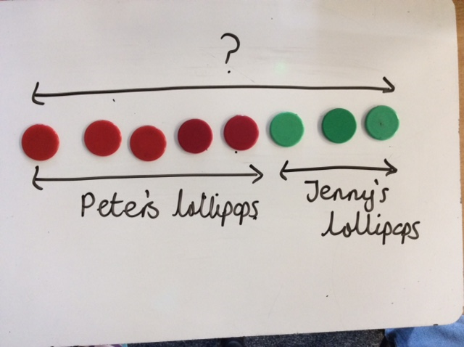  Calculations  5+3=? | Replace the objects with concrete material.
?  Calculations  5+3=?  Peter  ?  Jenny  Jenny’s lollipops  Peter’s lollipops  ? | Move onto pictures of the items being added.  They may draw pictures of the actual object, in this case lollipops or use shapes like in the example shown.
Peter  Calculations  5+3=?  ?  Jenny  Peter’s lollipops  Jenny’s lollipops  ? | The diagrams become increasingly abstract but the one to one correspondance is still there and the children can still count the sqaures if needs be.
Calculations  5+3=?  Peter  5  3  ?  5 3 Jenny  Peter’s lollypops  Jenny’s lollypops | The diagrams become more efficient.  The children needs to understand the relative size of the part and whole.

Subtraction Model Progression
Jenny has 8 lollipops to begin with. She eats 3 lollipops. How many lollipops does Jenny have left? | Peter has 8 lollipops. Jenny has 3 lollipops. How many more lollipops does Peter have than Jenny?
Model 1 | Model 2 | Guidance notes
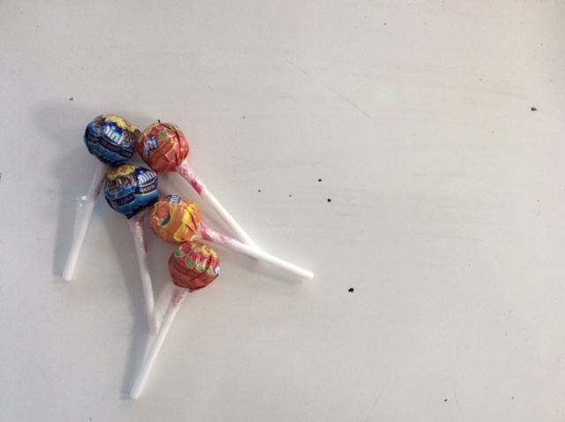
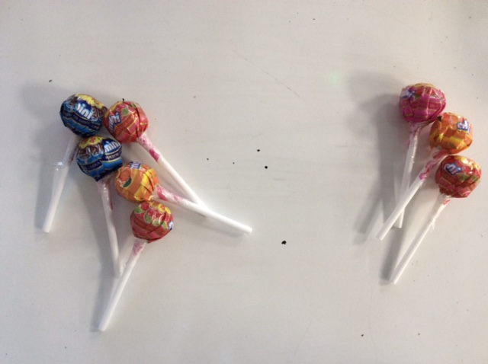
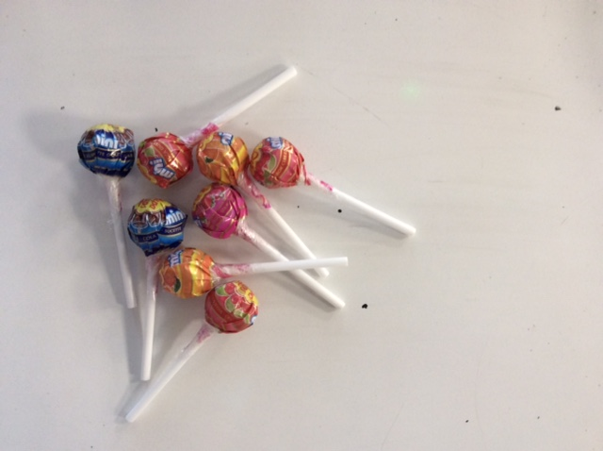
Calculations
8-3=5
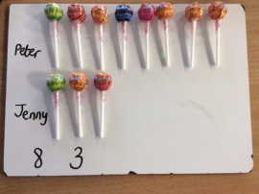  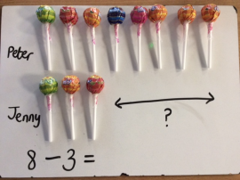  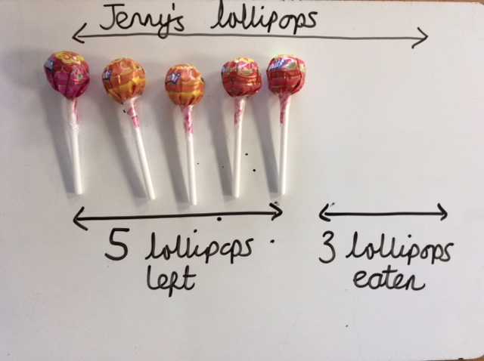  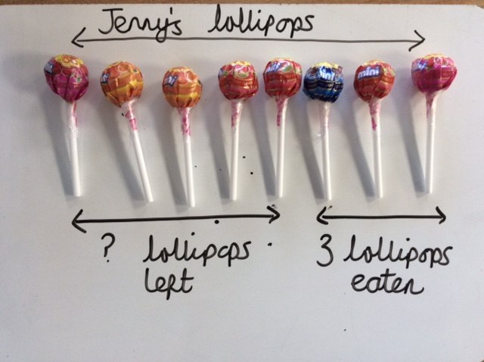  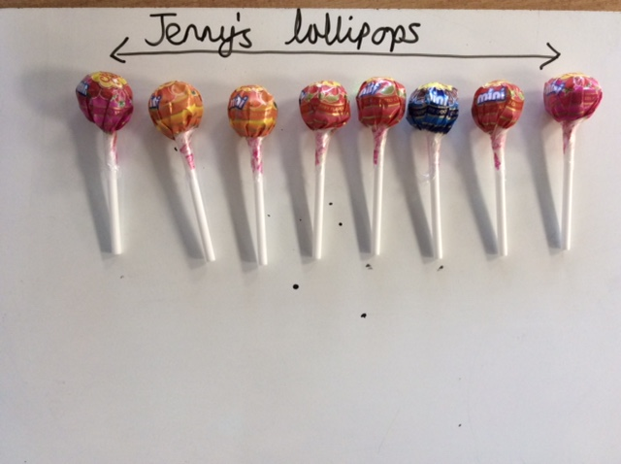  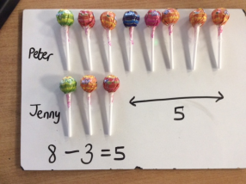  Calculations  8-3=5 |  | Children use real objects to solve the problem.  They see one and two bar model representations in preperation for taking away and finding the difference.
Calculations  8-3=?  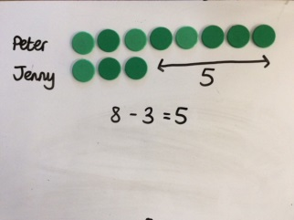  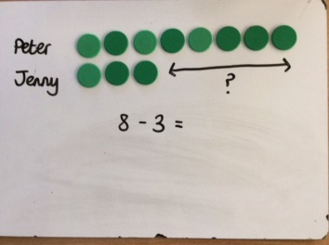  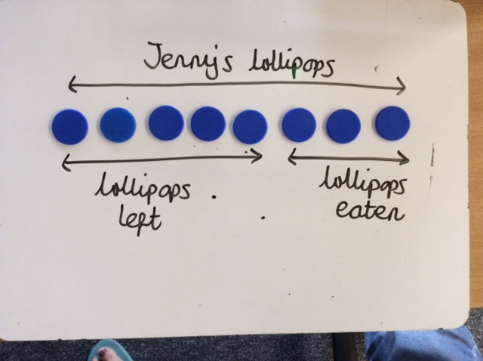  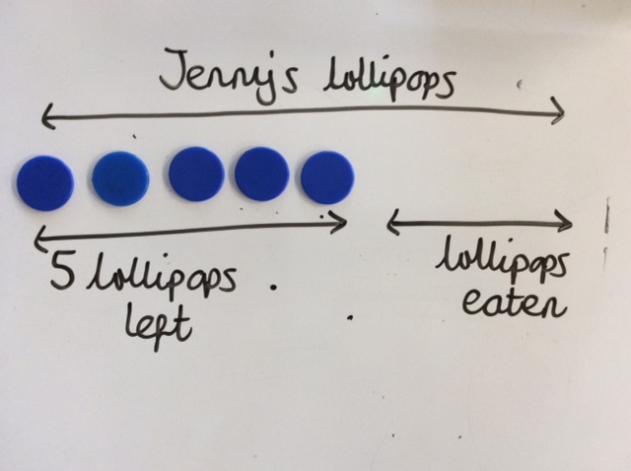 |  | The real objects are replaced by other concrete manipulatives.
Jenny’s lollipops  Calculations  8-3=?  Peter  Jenny  Lollipops left  Lollipops eaten  ? |  | Children draw the problem using symbols. In the one bar method they cross out the ones that are taken away.
×  Calculations  8-3=?  Peter  Jenny’s Lollipops  ×  ×  ?  Jenny  Lollipops left  Lollipops eaten |  | The diagrams become increasingly abstract but one to one correspondacnce remains. Children cross through the ones that are taken away in the one bar model.
8  8  3  Peter  Calculations  8-3=?  ? 3 ? Jenny  Lollipops Left  Lollipops eaten |  | The diagrams are more efficient and the children are confident in the one and two bar model for subtraction.
Multiplication Model Progression
Lollypops come in packs of 3. Peter buys 5 packs of lollipops. How many lollipops does Peter buy altogether?
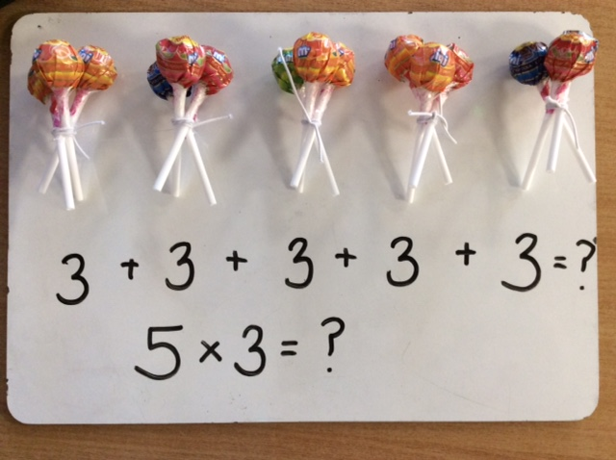  Calculations  3+3+3+3+3=  5x3= | Children make the calculation with the real object. They clearly see that multiplication is making groups/ lots of things.  They see the relationship between multiplication and repeated addition.
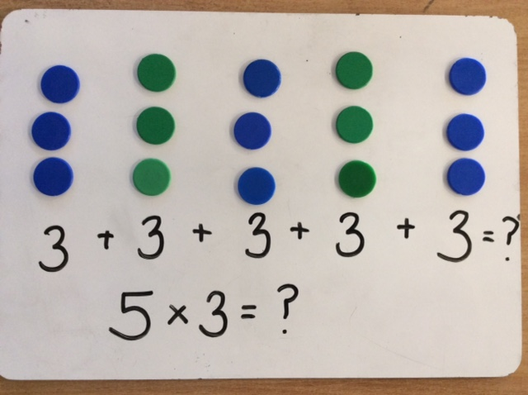  Calculations  3+3+3+3+3=  5x3= | Children move on to using other concrete manipulatives to represent the multiplication problem.  They consolidate their understanding of multiplication being the same as repeated addition.
Calculations  5x3=  3 3 3 3 3  ?  5x3= | Children using drawings to show the multiplication calculations they are able to say that they have drawn ‘x’ lots of groups of ‘y’
Calculations  5x3=  3 3 3 3 3 | Children’s drawings become more efficient as they are able to show the multiplication calculation numerically using the bar model.

Division Model Progression
Partitive (splitting the number into equal groups) | Quotitive (counting how many groups of an amount going into a number)
Jenny has 20 lollipops. She wants to share them equally into 5 boxes. How many lollipops should go into each box? | Jenny has 20 lollipops. She wants to pack them into boxes with 5 lollipops in each box. How many boxes will she need to pack all the lollipops?
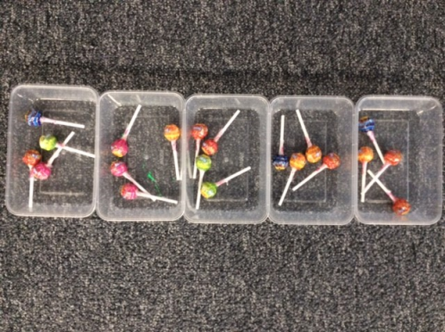  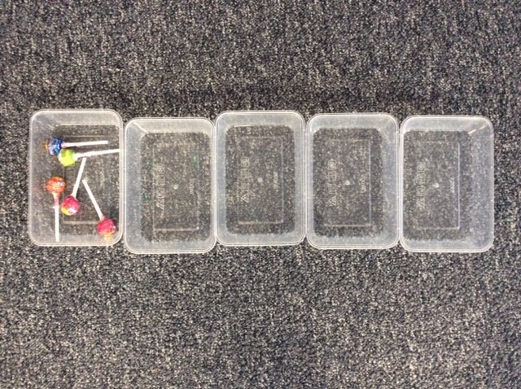  Calculations  20÷5=  Calculations  20÷5= |  | Children use the actual objects to solve the problems seeing the difference between the two different styles.
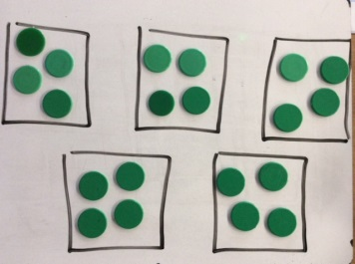  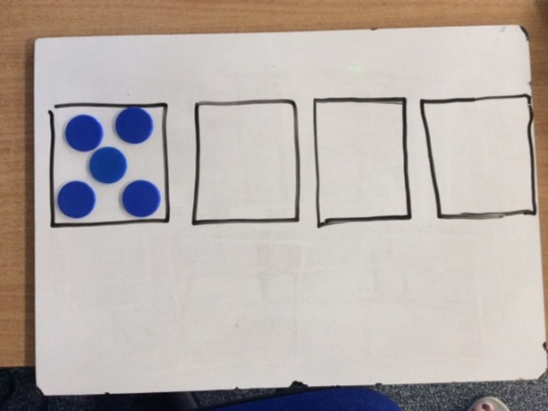  20  20  Calculations  20÷5=  Calculations  20÷5= |  | Children move onto using other concrete manipulatives and consolidate their understanding of grouping equally or making into equal groups.
Calculations  20÷5=  Calculations  20÷5=  20  20 |  | Children use informal jottings and drawings to practise grouping and sharing into equal groups.

5

5 | 5 | 5 | 5

Draw a bar to represent the total number of lollipops.
Place one box of 5 lollipops in the bar.
Work out how many boxes are needed by counting how many 5s go into twenty.
Draw a bar to represent the total number of lollipops.
Split the bar into 5 equal parts.
Share the lollipops equally between the 5 boxes and work out how many are in each box.

? | ? | ? | ? | ?

4 | 4 | 4 | 4 | 4

