Dear Parents and Carers,

We are currently looking for resources to further improve and enhance our water-play area in reception. This area is used by the children every day to help develop their gross motor skills, coordination and physical fitness through lifting, pouring, carrying, running and splashing. Actions such as squeezing help to develop the small muscles in a child's hands. We are trying to do this at a minimal cost and consider reusing and recycling as much as we possibly can. We are therefore kindly asking if anyone has any of the following items which they no longer need and can donate to the Rainbows children.

If you are able to help in any way, please give the resources to the school office or any member of the Rainbows team.

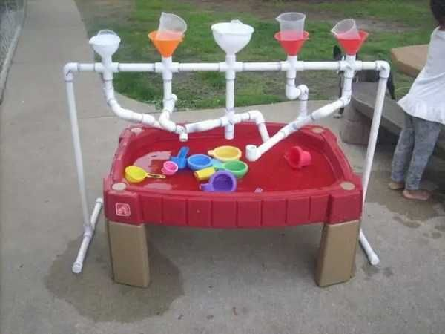Thank you!

* Turkey Basters
* Pipettes
* Old Calpol style syringes
* Empty washing up liquid bottles
* Squeezy sauce bottles
* Clean spray bottle
* Old soap bottles (pump action)
* 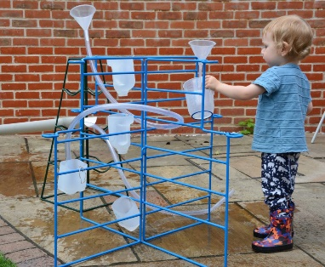Unwanted straws
* Whisks
* Large spoons
* Tongs
* Measuring spoons/cups
* Different sized jugs
* Funnels
* 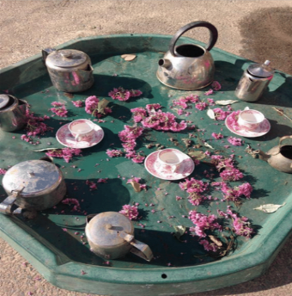Plastic/metal bowls
* Metal/copper teapots and milk jugs
* Pestle and mortar
* Clear/white plastic pipes
* Old hose pipe
* Sieves/colanders