
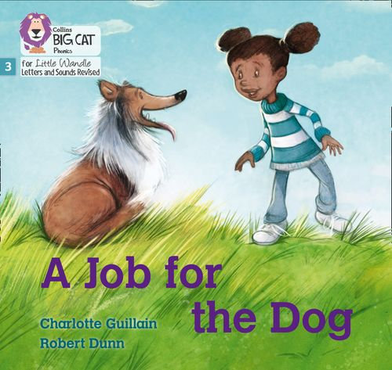

Dear Parent/Carer,
As most of you are aware we use ‘Little Wandle’ as our phonics programme. Since it was introduced last year, the children have read physical copies of the book in school, then been given access to a digital copy through Collins e-Book Reader to share with you at home.
We know that an e-Book is no match for a real book but until now we have only had enough books to read with the children in school.
We have listened to your feedback and spoken to parents about the e-book system and know that is not an ideal system for many families. We have therefore decided to invest a large amount of money into doubling our book stock to enable children in Reception and Year One to take a physical book home.
We will continue to read each book three times a week in school and once we have done so, will send the book home to allow the children to show you what they have learnt. As we have been studying the book all week they should be able to read it fluently by the time they bring it home. This does not mean it is too easy for them but rather that they have learnt to read it. This is what we aim to achieve, reading confidence!
Even after our recent purchase, we still have a very limited number of books and every book is needed to continue teaching reading efficiently. For this reason we can’t afford for books to get damaged or lost so we are introducing a system to help ensure we are able to continue sending real books home. We have spoken to the children about the importance of looking after their books really carefully too – We have asked them not to read their books near food or drink, not to read them where they might get dropped on the ground outside and get dirty. They are special books for everyone to enjoy!
As you know schools are underfunded and if the book we send home to you gets lost or damaged, we wouldn’t be able to replace it, so we ask that you fund the replacement by donating £5 towards the cost of a new book.
If you do not want to purchase a new book, you can continue to access the books your child is reading on the Collins e-book Reader from home. Unfortunately, we will not be able to issue anymore real books.
We really appreciate your understanding with this and your support with helping to preserve our book stock so we can teach our Muscliff children in the most effective way now and in the future.
Kind Regards,
Reception and Year One Teams
*Please note – reception books will now be returned to school on a Thursday and send home again on Friday

