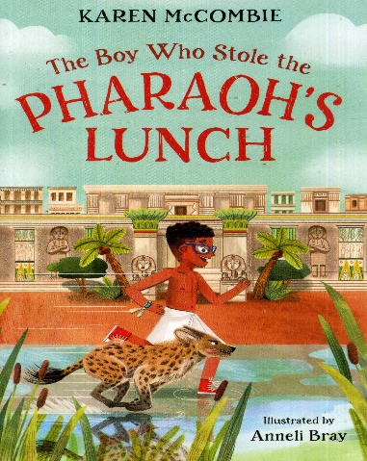
Dear New Y3 Families,
New Year 3!

New Trip, New Book, New Author!

We are proud that our curriculum offer continues to evolve at Muscliff Primary School. The Year 3 Team have been making changes to provide the children with even better learning experiences ready for the Autumn Term.

October Trip
We have booked a new trip for this Year 3 cohort – in fact, it’s two visits in one!
On Monday 14th October, Year 3 will be off to Dorchester for the day. There, they will visit the Tutankhamun Exhibition before popping across the road to visit the Dorset County Museum.
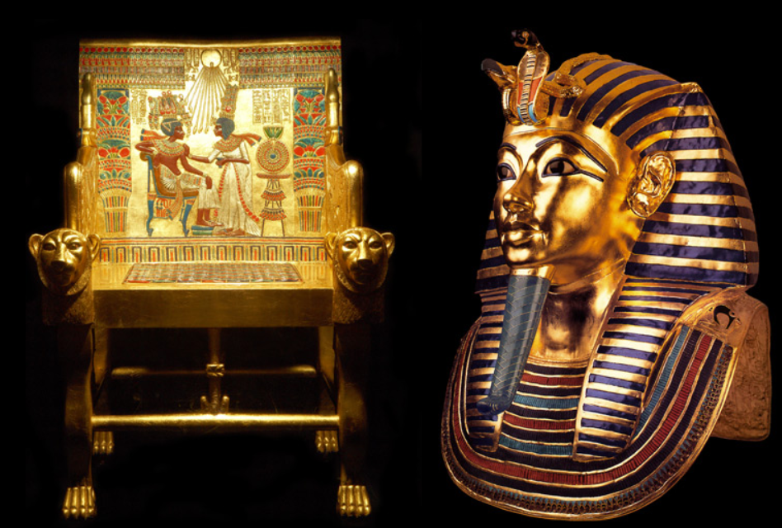
Author Visit
On Tuesday 1st October, as we reach the end of the story, the children will meet Karen McCombie, who is the author of our new book. In their session, the children will get a chance to ask her about how she wrote her book and challenge her on the choices she made as the author. The children will know the book well enough to grill her with their curiosity.

The combined cost of the trip and the author talk is £22.
Please make the payment of £22 at your earliest convenience through Parent Mail or pop into the office.
Children will wear school uniform as normal and we will return back in time at the end of the day for their normal routine.

New Book
We are very excited to be introducing a brand-new text this half term to lead our learning. It’s new to us and it’s a newly published book too. After reading it, we were keen to introduce this text to our Muscliff children.
It’s called, ‘The Boy Who Stole The Pharaoh’s Lunch.’
In KS2, we do encourage our families to get hold of a copy to read at home. We will be reading this book in school every day in the first half term but It is always beneficial for children to read the lead text at home with parents (or to read ahead). Your parental input enriches your child’s vocabulary and supports in their development
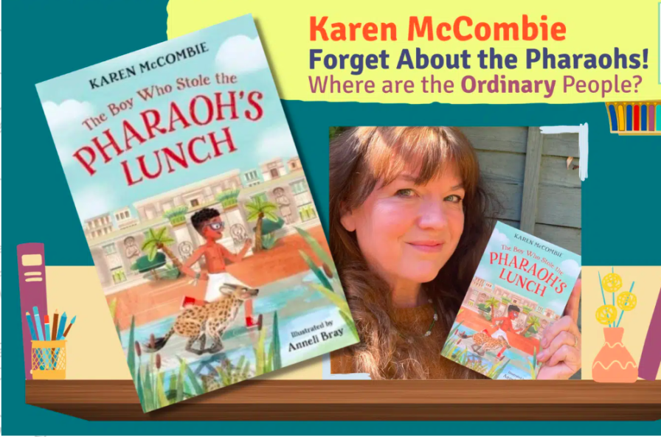
Learning Overviews
We want all our parents to be as informed as possible. We have updated the overviews for this year. These overviews outline the key learning for this half term and will support you to support your child.

