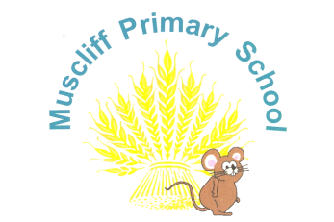
Broadway Lane
Bournemouth
BH8 0AB
Tel: (01202) 549654

muscliff@muscliffprimary.co.uk

Tuesday 5th September 2023

Dear Parents/Carers,

We are very excited about the year ahead and look forward to working with you and your wonderful children! Please keep us informed about any good news, medical needs, concerns or important information you would like us to know through a message on the gate in the morning, with any of the Year 5 team on the gate at the end of the day, a telephone call or a letter/note. Alternatively, you can email: year5stayintouch@muscliffprimary.co.uk

Pencil cases
This year, we will again be providing resources for the classroom and so your child does not need a pencil case.

Home Learning

Maths: Doodle maths online. Please complete these little and often to achieve your 40 stars per week!
Writing: please complete the writing challenge each week
Handwriting: please complete this to help practise your spellings!
Spellings: will send the children home with a spelling list for each week on their homework sheet and they will be tested on these words every Friday.

Reading: at least 4 times per week for 15 minutes (or 5 to earn your stars!)

The Year 5 reading spine will be sent out at the beginning of each term and provides a selection of books for your child to read throughout the year. We are also continuing our subscription to Oxford Reading Buddy, which can count towards your 5 reads per week – aiming towards our reading stars!

The homework sheets will be handed out every Monday and will be due back the following Monday (so you have one week to complete these). Alternatively, you can download them from the ‘home learning’ section of our Year 5 class page (on the Muscliff website).

If your child is unsure of their home learning, please ask them to talk to us before Monday so we can help them have another go at home. Home learning is important for growing children’s independence and helps us to identify any gaps in their learning - as a result any child who has completed all their home learning and reading will have the opportunity of helping our class win Doodle class of the week! Any child who has not completed their home learning or reading, will need to stay in at lunchtime to complete their home learning or reading. This will ensure they are fully prepared for Year 6 and Secondary school.

PE Lessons
PE lessons will take place twice per week on TUESDAY and FRIDAY. For this year, we would like the children to come to school wearing their school PE kit (which they will then stay in for the rest of the day) on the days they have PE.

SWIMMING: as the main lessons took place in Year 4, the children will not have swimming lessons again in Year 5 unless they are having catch up sessions – if this is the case, we will inform you nearer the time.

Thank you - we look forward to getting to know you better in the year to come!

Year 5 Team

