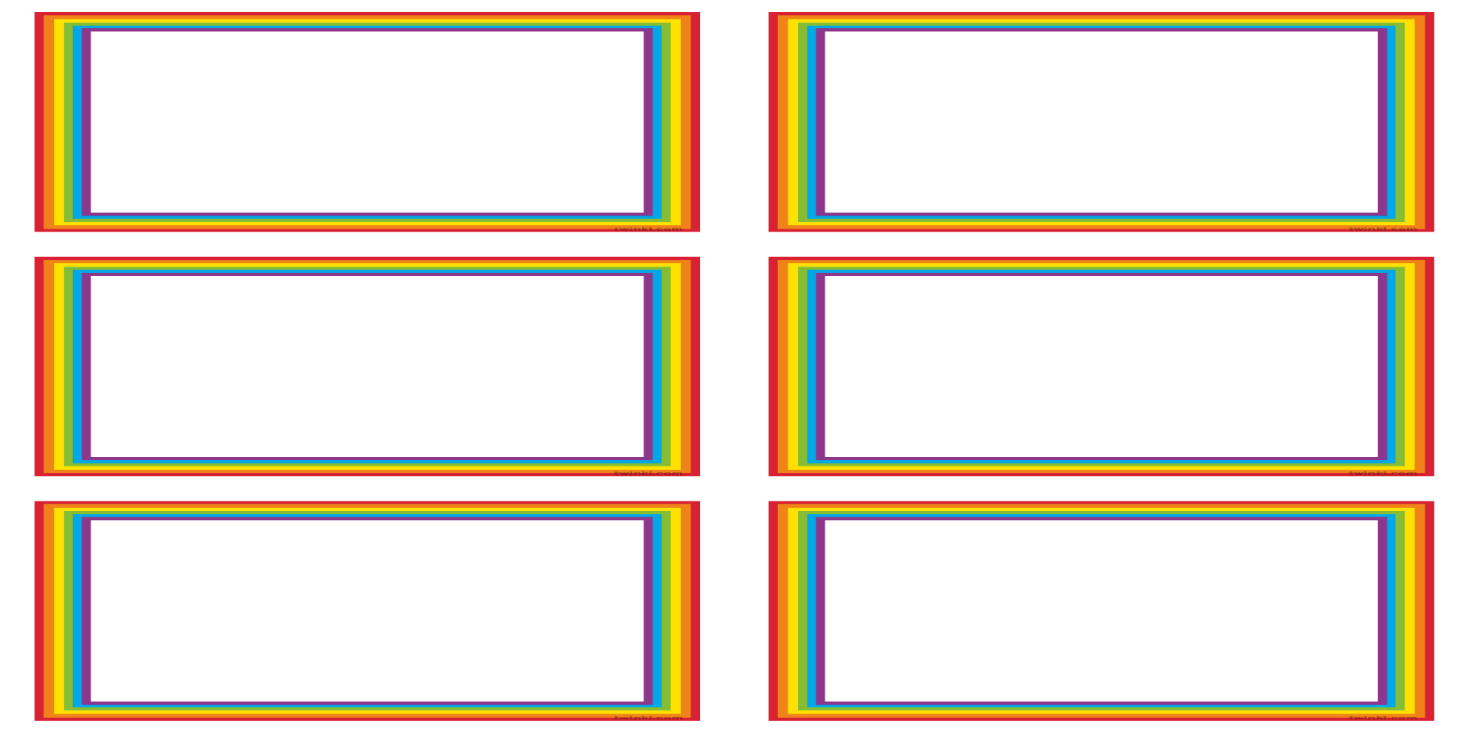

**Maths**

* Understand the composition of 1, 2 and 3

* Understand and use prepositional language such as over, under, behind

*Learn and recognise different shapes such as triangle, circle, square

**Physical Development**

*Developing small motor skills so that they can use a range of tools competently

*Developing pencil control and letter formation

*Co-ordination –inside = gym rolls, outside = using a range of equipment confidently

**Understanding the World**

* Recognise similarities and differences between life in this country and other countries

* Compare and contrast characters from stories

*Talk about members of their immediate family and discuss different types of families from books they read

**Literacy**

* Phonemes: ff,ll,ss,j,v,w,x,y,z,zz,qu,ch,sh,th,ng,nk

* Writing simple words

* Blending simple words

* Reading simple phrases

**Story-telling Rainbows**

**Communication & Language**

* Understand how to listen carefully and why listening is important.

* Learn and use new vocabulary.

* Listen to and talk about stories to build understanding

* Re-tell stories using actions

**PSED**

* Manage own needs

* Expressing their feelings and consider feelings of others

* Build meaningful relationships

* See themselves as valuable individuals

**EAD**

* Learning colour mixing techniques

*To use a range of materials and tools with care and precision

*Participate in a group performance