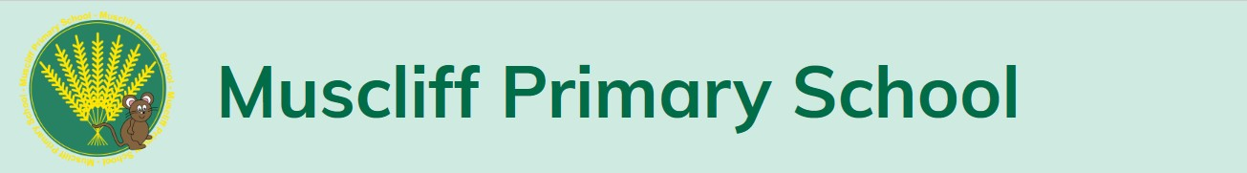
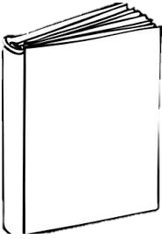
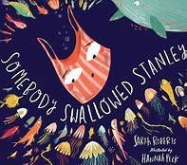
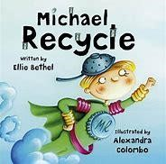
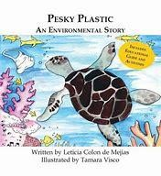
Here’s all of the subjects that will be taught this half term.
Autumn
term
1
Ready
Respectful
Safe
What are the different
emotions Stanley feels
throughout the text?
DT
:
Designing a
reusable bag
Art:
Collage, Jane
Perkins
English
-
Exploring noun phrases
-
Writing command sentences
-
Using conjunctions
-
Comparing fiction and non
-
fiction texts
How you can help at home:
✓
Research some facts about recycling
✓
Practice sorting your rubbish
✓
Compare properties of materials
around the house
How does the
author use noun
phrases to add
description?
What is the story
trying to teach us?
Maths
-
Representing numbers using tens and
ones.
-
Number bonds to 20.
-
Addition and subtraction (crossing 10)
-
Counting in 2s, 5s and 10s
How you can help at home:
✓
u
https://whiterosemaths.com/reso
rces
/
✓
https://www.topmarks.co.uk/math
s
-
5
games/
-
7
-
g
years/countin
Science
:
Properties
of materials
and
recycling
PE
Ball
:
skills,
dance,
circuits
PSHE:
Staying
healthy
RE:
Christianity
Geography

:
The 5 oceans
and
countries
within the
UK
:
-
Our Magical Starter will be on Tuesday 6th September. Please come to school dressed in blue and/or green mufti clothes and bring along a plastic bag. I wonder what we will be doing…

PE days this half term are Tuesday and Thursday. Children are asked to come to school wearing their PE kits, which is a new change for this year.
-
-
-
t
Key Tex
How can you tell the
difference between a
fiction and non
-
fiction
book?

