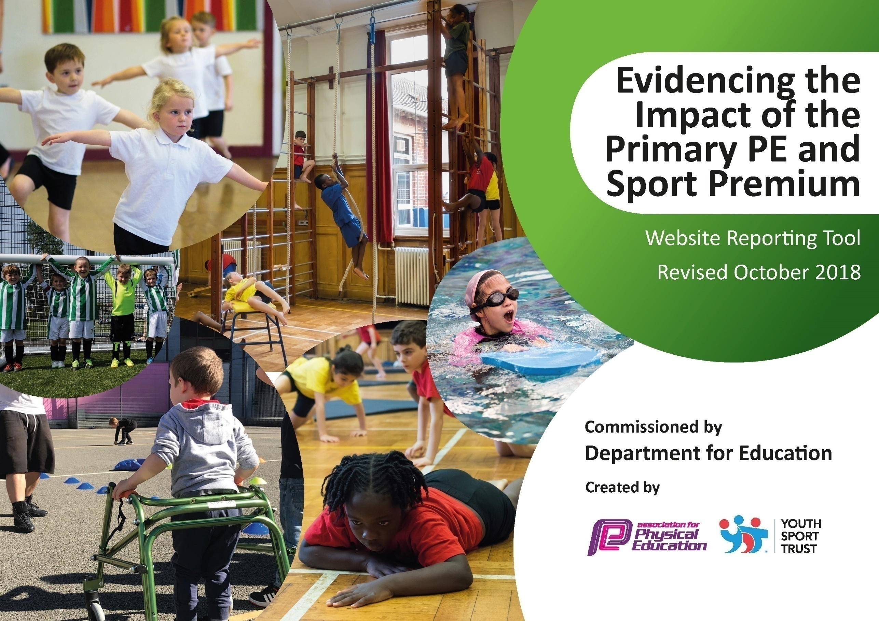

**Kayleigh Vella**

***PE and Sport Vision Statement***

***At Muscliff Primary School, we pride ourselves on providing a high-quality Physical Education curriculum that inspires every child to succeed; promoting excellence and equality for all. We believe that all our children should leave primary school physically literate, with a memorable experience of playing, leading and competing in a range of challenging and enjoyable active opportunities; developing sporting values, friendship and a life-long passion for physical activity and sport.***

**Muscliff Primary School**

**2019/2020**

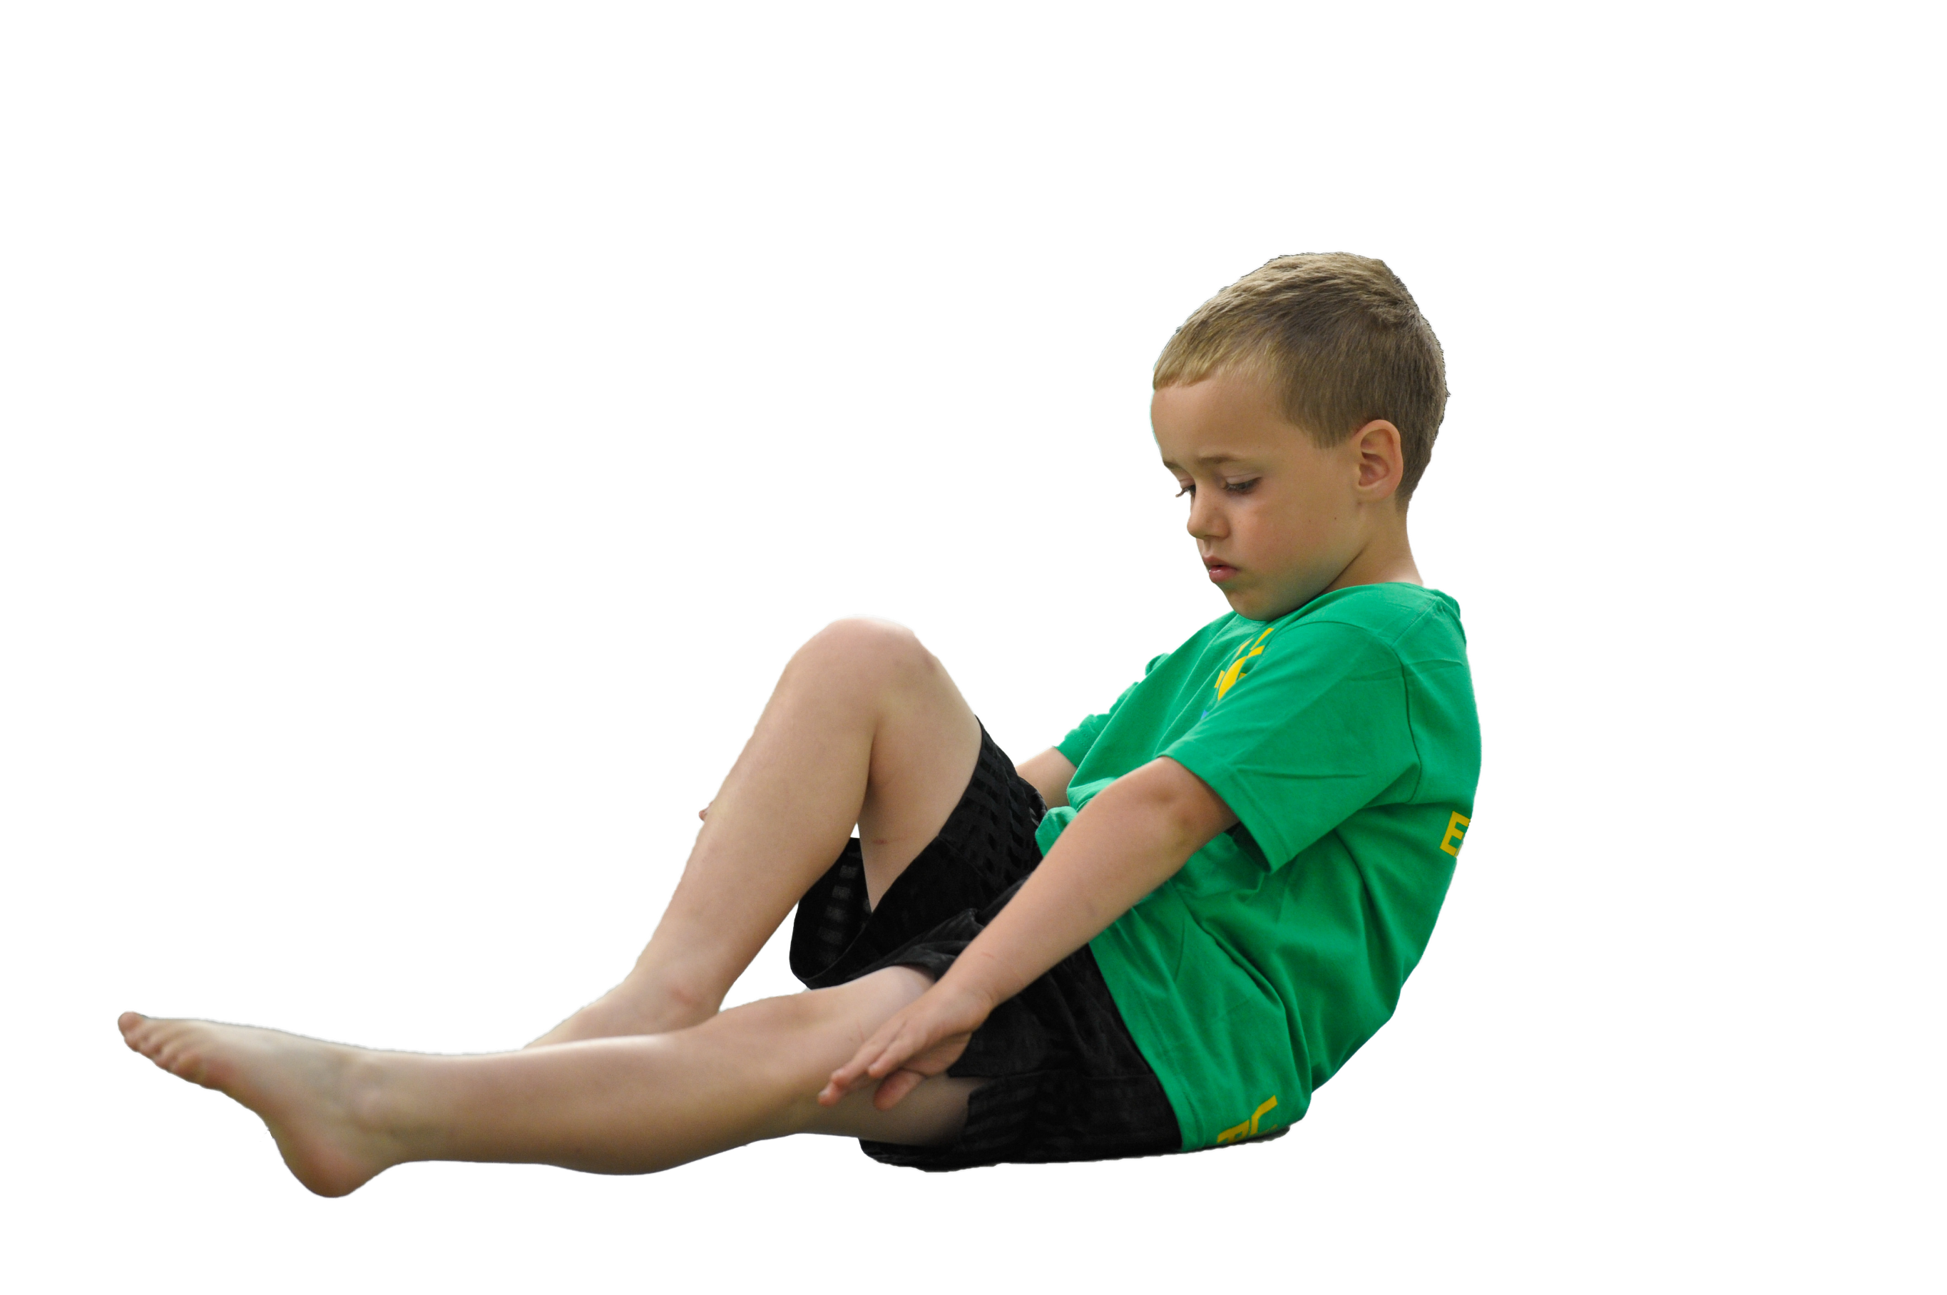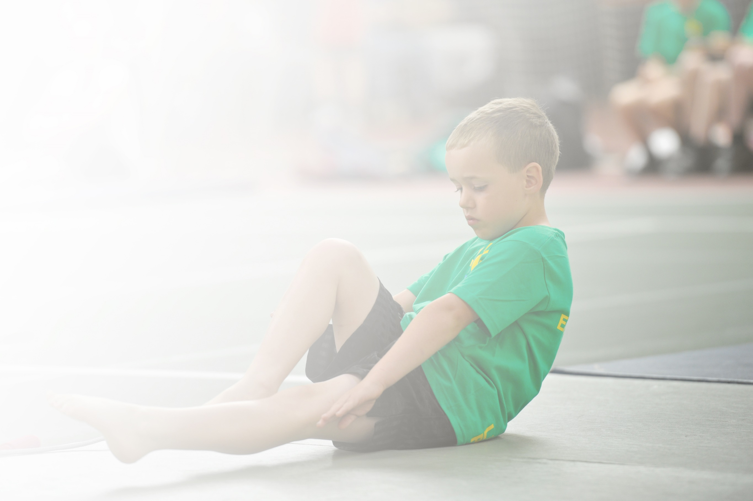Schools must use the funding to make **additional and sustainable** improvements to the quality of Physical Education, Sport and Physical Activity (PESPA) they offer. This means that you should use the Primary PE and Sport Premium to:

* Develop or add to the PESPA activities that your school alreadyoffer
* Buildcapacityandcapabilitywithintheschooltoensurethatimprovementsmadenowwillbenefitpupilsjoiningthe school in futureyears

Please visit [gov.uk](https://www.gov.uk/guidance/pe-and-sport-premium-for-primary-schools)for the revised DfE guidance including the 5 key indicators across which schools should demonstrate an improvement. This document will help you to review your provision and to report

your spend. DfE encourages schools to use this template as an effective way of meeting the reporting requirements of the Primary PE and Sport Premium.

We recommend you start by reflecting on the impact of current provision and reviewing the previous

spend.Underthe[OfstedSchoolsInspectionFramework](https://www.gov.uk/government/publications/school-inspection-handbook-from-september-2015),inspectorswillassesshoweffectivelyleadersusethe PrimaryPEandSportPremiumandmeasureitsimpactonoutcomesforpupils,andhoweffectively[governors](https://www.gov.uk/government/publications/governance-handbook)hold them to account for this.

Schools are required to [publish details](https://www.gov.uk/guidance/what-maintained-schools-must-publish-online#pe-and-sport-premium-for-primary-schools)of how they spend this funding as well as on the impact it has on pupils’ PE and sport participation and attainment by the end of the summer term or by **31 July 2019** at the   
latest.   
  
We recommend regularly updatingthe table and publishing it  
on your website throughout the year, as evidence of your   
ongoing review into how you are using the money to   
secure maximum, sustainable impact. To see an   
example of how to complete the table please   
click [HERE](http://www.afpe.org.uk/physical-education/wp-content/uploads/afPE-Example-Template-Indicator-2018-Final.pdf).

The funding has been provided to ensure impact against the following objective.

**OBJECTIVE:**To achieve self-sustaining improvement in the quality of PE and sport in primary schools.  
  
**It is expected that schools will see an improvement against the following 5 key indicators:**

**Key Indicator 1:**The engagement of all pupils in regular physical activity - the Chief Medical Officer guidelines recommend that all

children and young people aged 5 to 18 engage in at least 60 minutes of physical activity a day, of which 30 minutes should be in school.

**Key indicator 2:** The profile of PE and sport is raised across the school as a tool for whole-school improvement.

**Key indicator 3:** Increased confidence, knowledge and skills of all staff in teaching PE and sport.

**Key indicator 4:** Broader experience of a range of sports and activities offered to all pupils.

**Key indicator 5:** Increased participation in competitive sport.

Vision for the Primary PE and Sport Premium

**ALL** pupils leaving primary school **physically literate** and with the **knowledge, skills and motivation** necessary to equip them for a **healthy, active lifestyle** and **lifelong participation** in physical activity and sport.

Evidencing the Impact of Primary PE and Sport Premium – 2019/20

**MUSCLIFF PRIMARY SCHOOL**

Support for review and reflection - considering the 5 key indicators from DfE, what development needs are a priority for your setting and your students now and why? Use the space below to reflect on previous spend, identify current need and priorities for the future.

|  |  |
| --- | --- |
| Key achievements to date: | Areas for further improvement and baseline evidence of need: |
| * Ensured LT and MT plans show a broad and balanced curriculum (new scheme of work) * PE and Sport promoted around school * Playtime activities – new zones for playground areas. * Broad range of extra-curricular activities on offer (parent paid and free clubs) including non traditional sports such as Cross Country, Golf and Multi-sports. * Specific CPD – increased staff confidence particularly in Gymnastics, Tennis, fundamental movement skills * Strong, contributing member of the Septenary Trust Schools. New staff polos/ jumpers for new staff to promote PE, raise profile within and outside of school at events. * Bronze Sainsbury’s Quality Mark 2014-2015 * Gold Sainsbury’s Quality Mark 2015-2016 * Gold Sainsbury’s Quality Mark 2016-2017 * Gold Sainsbury’s Quality Mark 2017-2018 * Gold Sainsbury’s Quality Mark 2018-2019 * Gold Sainsbury’s Quality Mark 2019-2020 (retained) * AfPE Quality Mark with Distinction 2016 | * Continue to look into offering a variety of extra-curricular clubs, promoting non-traditional sports such as archery, fencing, cheerleading and street dance etc. * Continue to increase community club links by creating new clubs / providing introductory sessions. * Staff questionnaire analysis, new CPD needs, areas of development, review of PE apprentice * Aspire to achieve Platinum Sainsbury’s Quality Mark 2020-2021 by raising uptake on extra-curricular clubs, and include c teams for inter-school tournaments. * Increase swimming competency-Risk to 2020/2021 due to COVID * Continue to develop LT and MT plans with set sports for year groups to focus on progression of skills within lessons. * Sports leaders to increase roles and responsibilities (Year 6) * Increase KS1 and SEND participation * Develop further links with secondary schools to increase opportunity for CPD * Apply for new AfPE Quality Mark (June 2021) |

|  |  |
| --- | --- |
| Meeting national curriculum requirements for swimming and water safety | Please complete all of the below: |
| What percentage of your current Year 5 cohort swim competently, confidently and proficiently over a distance of at least 25 metres?  **N.B.** Even though your children may swim in another year please report on their attainment on leaving  Primary school. | 74% (2019/2020 data)  65.4% (2019 data) |
| What percentage of your current Year 5 cohort use a range of strokes effectively [for example, front crawl, backstroke and breaststroke]? | 57% (2019/2020 data)  65.4% (2019 data) |
| What percentage of your current Year 5 cohort perform safe self-rescue in different water-based situations? | 68% (2019/2020 data)  54.8% (2019 data) |
| SchoolscanchoosetousethePrimaryPEandSportPremiumtoprovideadditionalprovision for swimming but this must be for activity **over and above** the national curriculum requirements. Have you used it in this way? | No |

**Action Plan and Budget Tracking**

Capture your intended annual spend against the 5 key indicators. Clarify the success criteria and evidence of impact that you intend to measure to evaluate for students today and for the future.

|  |  |  |  |  |  |
| --- | --- | --- | --- | --- | --- |
| **Academic Year:** 2019/2020 | | **Total fund allocated:** £21,070 | **Date Updated: Jan 21** | |  |
| **Key indicator 1:** The engagement of all pupils in regular physical activity – Chief Medical Officer guidelines recommend that primary school children undertake at least 30 minutes of physical activity a day in school | | | | | Percentage of total allocation: |
| 51% |
| School focus with clarity on intended **impact on pupils**: | Actions to achieve: | | Funding allocated: | Evidence and impact: | Sustainability and suggested next steps: |
| Improved engagement for all children in regular physical activity with a focus on increasing physical activity at playtimes and lunchtimes.  All pupils to take part in the recommended 2 hours per week. Children to take part in an indoor and outdoor lesson each week, in addition to play time/lunchtime. | * Whole staff professional learning to include teachers, teaching assistants and lunchtime supervisors throughout the year. PE assistant to be present at lunchtimes to support lunchtime supervisors. * PE subject leader to provide updates throughout the year in staff meetings. Kinks with Curriculum team. * PE leader to meet with a broad range of children to talk to them about their daily physical activity. Sports leaders conducted a questionnaire on what equipment children would like to use at playtimes. * During lockdown PE lead to re-write PE overview for each Year group. Dance specialist to support with dance overviews. Basketball to be included within taught PE lessons. Request from sport Survey * Due to COVID 19 each year group has their own equipment from September 2020. Therefore year groups will not share equipment-this will help to reduce risk of infection. | | PE Assistant £3075  New playground equipment £2733.76  Re-write plans £0  Basketball posts: £3300.14  £1565.90 | * All staff aware of the recommended guidelines for daily activity and considering this throughout the school day. * The focus on increased physical activity evident at all playtimes and lunchtimes and within daily lessons. * Playground and lunchtime activities to target those less active through personal challenge events created by sports leaders. * Children will be more engaged within PE lessons. | * PE subject Leader to identify any staff who need further support and to provide appropriate professional learning (NQT’S September) * PE Subject Leader to monitor and to provide support as appropriate in order to ensure progress and achievement are maintained by all children. * Change for life club to start in the summer term 2.021. Carried over from 18/19. * From September 2020 PE lead to check all Year groups have suitable warm ups and correct terminology is used by all staff. |
| **Key indicator 2:** The profile of PESSPA being raised across the school as a tool for whole school improvement | | | | | Percentage of total allocation: |
| 0.13% |
| School focus with clarity on intended **impact on pupils**: | | Actions to achieve: | Funding allocated: | Evidence and impact: | Sustainability and suggested next steps: |
| PE and Sport used to engage and increase children’s attainment in cross curricular subjects.  To increase participation in physical activity of children in specific groups/KS1 (i.e. less confident children, children who are PP).  The profile of children’s achievements and successes in PE and Sport highlighted in whole school events and clearly evident around school. | | * PE subject leader to provide updates, provision and strategies for whole school improvement throughout the year in staff meetings / professional conversations.   Continue to raise cross curricular links  Children who do not normally take part in sporting events attended the following events:   * CAN DO FESTIVAL YEARS 3/4 * CAN DO FESTIVAL YEARS 5/6   KS1: Year 2 attended a multi-skills festival   * Team and individual achievements in sport celebrated in class, during whole school celebration assembly, on the PE notice board. | £0  £27.50 | * Active lesson plans in place to ensure a sustained part of whole school curriculum and therefore reduced need for subscriptions from outside agencies. * Increase in confidence and participation. * KS1 children can feel more confident competing against a range of children. * Trophies handed out at sports events for man/women of the match. | * PE Subject Leader to monitor and to provide support for cross-curricular learning opportunities. Ensure key terminology is in place for 2020. * PE subject Leader to identify any staff that need further support and arrange sharing of teaching styles and strategies in each Key Stage to incorporate active learning. * PE subject lead to continue to enter KS1 children into tournaments. * Have a sports superstar of the week. |

|  |  |  |  |  |  |  |  |  |
| --- | --- | --- | --- | --- | --- | --- | --- | --- |
| **Key indicator 3:** Increased confidence, knowledge and skills of all staff in teaching PE and sport | | | | | | | | Percentage of total allocation: |
| 27% |
| School focus with clarity on intended  **impact on pupils**: | | Actions to achieve: | | | Funding  allocated: | | Evidence and impact: | Sustainability and suggested  next steps: |
| Improved quality of children’s physical education, gymnastics across the school to ensure they are confident and competent in key skills.  Improved quality of children’s physical education in a range of sports across KS1&2.  Raised profile of healthy active lifestyle behaviours by all school staff to reach all children.  Improved quality of children’s physical education in swimming to ensure 74% of children are confident and competent to swim 25m at the end of KS2. | | * All teaching staff (Teachers and TAs) to participate in professional learning and CPD in Gymnastics – Gemma Coles * CPD to be delivered in planned blocks across the year to ensure whole school coverage. * Children to be clearly signposted to gymnastics club and competition opportunities after school. * PE equipment inspection and replacement gym mats * New equipment purchased for PE lessons. * Dance specialist to create a broad dance overview. * PE subject leader to discuss with Year Leads positive outcomes and what areas are for development. PE lead spoke to KS1 and SEND staff regarding equipment that would best support the children * Importance of warming up and cooling down incorporated into lesson discussions. * Exercise and healthy lifestyles taught within science lessons across the whole school. * Staff CPD in swimming from qualified instructors. * Liaise with Littledown swimming instructors to ensure children are confident to perform safe self-rescue in different water-based situations. | | | £2228  £686.80  £1219  KS1-£237.07  SEND-£148  £1250 | | * All year groups to receive CPD in the area of gymnastics * The focus of lessons are child centred and as a result children are engaged and keen to improve. * As a result children make good or better progress both in lessons and over time * Increased number of children involved in Dorset gymnastics competition and extra-curricular dance and gymnastics clubs. * Increased number of children taking part in KS1 and SEND events and increased participation in PE lessons. | * PE subject Leader to support new staff in school with planning for delivery of physical education. * Teacher to use CPD to plan gymnastic sessions. * PE subject Leader to identify any staff that needs further support and to provide appropriate professional learning. * PE Subject leader networks with colleagues (particularly secondary schools) at other schools to encourage ongoing sharing of good practise. * To continue to increase SEND participation. |
| **Key indicator 4:** Broader experience of a range of sports and activities offered to all pupils | | | | | | | | Percentage of total allocation: |
| 2% |
| School focus with clarity on intended  **impact on pupils:** | | Actions to achieve: | Funding  allocated: | | | Evidence and impact: | | Sustainability and suggested  next steps: |
| Additional achievements:  Improved children’s awareness of the board and balanced PE and sports opportunities in and outside of school.  Extra Curricular clubs before COVID-19:  Year 4,5 and 6 Athletics  Year 5 Boys Football  Year 6 Boys Football  Year 5/6 Girls Football  Gymnastic club | | * BSSA Application * Dorset Schools swimming competition. Training provided for children who entered. * Community link with Victoria school for sports opportunities and link to secondary SEND provision. Boccia Competition (Jet’s group) * Children identified as priority for extra- curricular clubs. * Children to gain experiences of a range of sports. Particular children can be targeted to ensure a good range of children taking up sports | £325  £75 | | | * Children have the opportunity to represent Muscliff Primary School in a range of competitions. * This will lead to an increase in participation. * Provision given for 10% + of children identified as SEND. Children have the opportunity to represent Muscliff | | * Look to increase % of children attending AC clubs by providing non traditional sports for those less active. * PE Team to support staff (particularly NQT’s) in school with planning for a broad and balanced curriculum. * PE Lead to track children’s provision and attendance for SENd children. * PE Lead to track children’s provision and attendance for less active children. * PE subject leader keeps up-to-date with government policies and recommendations (e.g. obesity paper2016) |
| **Key indicator 5:** Increased participation in competitive sport | | | | | | | | Percentage of total allocation: |
| 6% |
| School focus with clarity on intended  **impact on pupils**: | | Actions to achieve: | Funding  allocated: | | | Evidence and impact: | | Sustainability and suggested  next steps: |
| Increased range of BSSA and other local competitions entered.  . | | * PE team to enter the majority of competitions in the BSSA (Bournemouth Primary Schools Association). Increase in participation of girls within PE * Inter-house competitions to be set up to increase participation. * New equipment and football kit purchased | £312.60  (Mini bus and coach transport over the year)    £816 | | | * Sports news on School Facebook page and Assembly. * Increased % of children representing the school in inter competitions. * Evidence through School Games organiser for Bournemouth Sarah Dunsford – Achievement criteria of Gold Mark 2018 -19. Remained for 19/20. * Increased number of children consistently attending extracurricular clubs * Identified target children have made significant improvements in confidence, health and fitness (class data) and attendance in extra-curricular clubs and involvement in inter competitions increased. Visible within Athletics club. * Year 5/6 dodge ball competition increased participation amongst all abilities. * Athletics equipment, footballs, netballs and football kit purchased to increase motivation amongst team member. | | * Continue to enter all BSSA and School Games competitions. As well as any additional competitions appearing in the calendar run by local schools or organisations entered under head teacher/PE team’s discretion. E.G AFC Bournemouth’s festival of football. * Enter C teams where applicable * Due to COVID-19 summer clubs stopped, this is to resume when safe to do so. |
| Signed off by | | | |
| Head Teacher: |  | | |
| Date: | 27.01.20 | | |
| Subject Leader: | K Vella | | |
| Date: | 27.01.20 | | |
| Governor: |  | | |
| Date: |  | | |