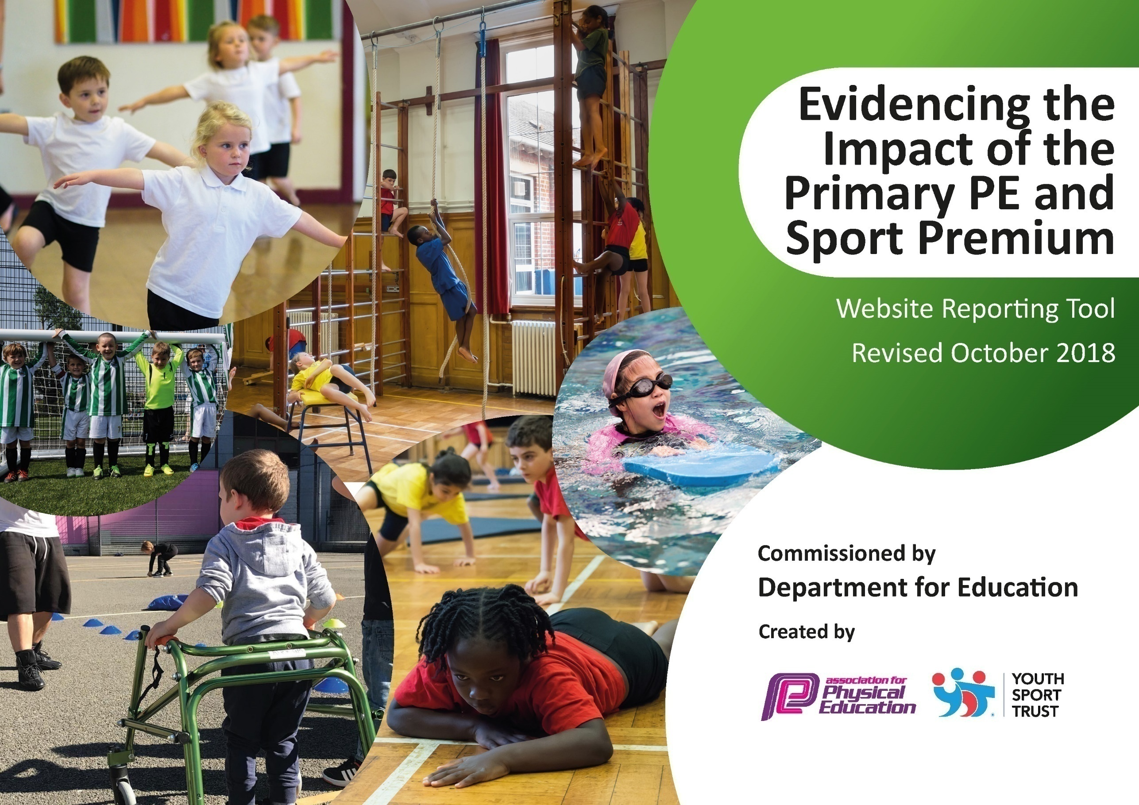
Muscliff Primary School
PE and Sport Vision Statement

At Muscliff Primary School, we pride ourselves on providing a high-quality Physical Education curriculum that inspires every child to succeed; promoting excellence and equality for all. We believe that all our children should leave primary school physically literate, with a memorable experience of playing, leading and competing in a range of challenging and enjoyable active opportunities; developing sporting values, friendship and a life-long passion for physical activity and sport.

Kayleigh Vella & Jack Earl
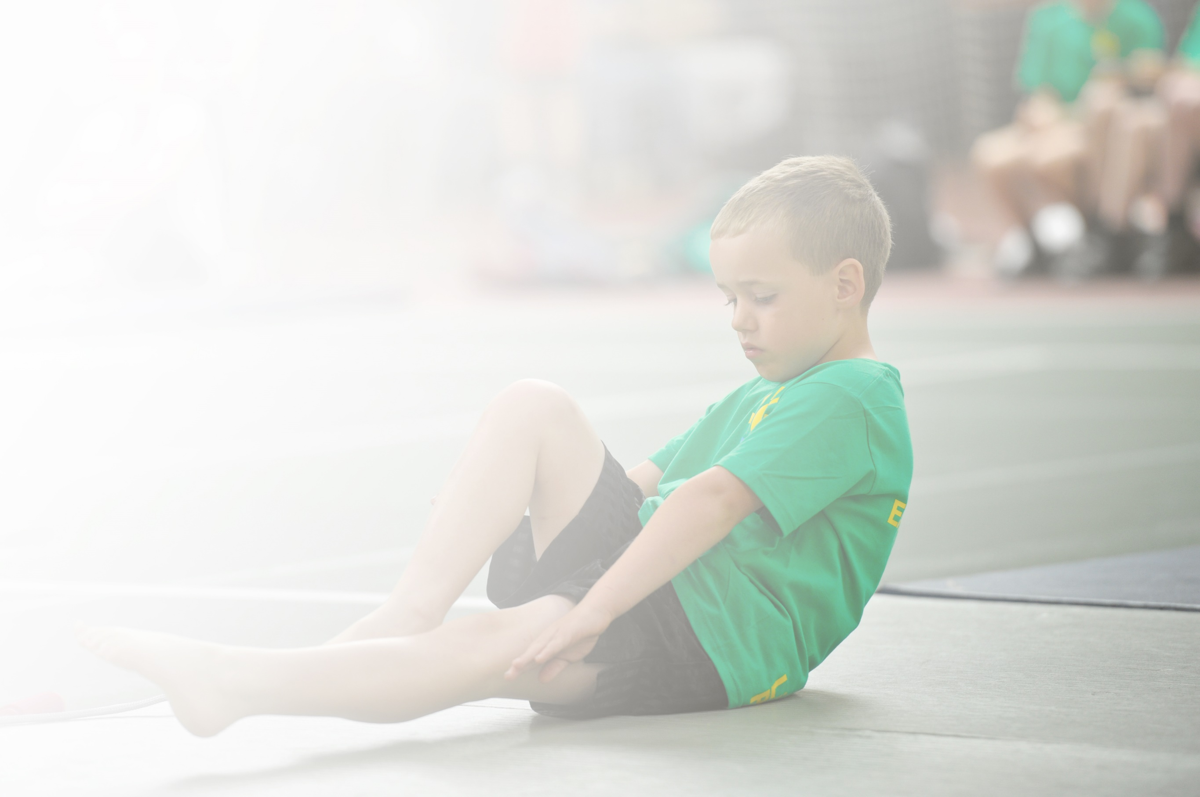
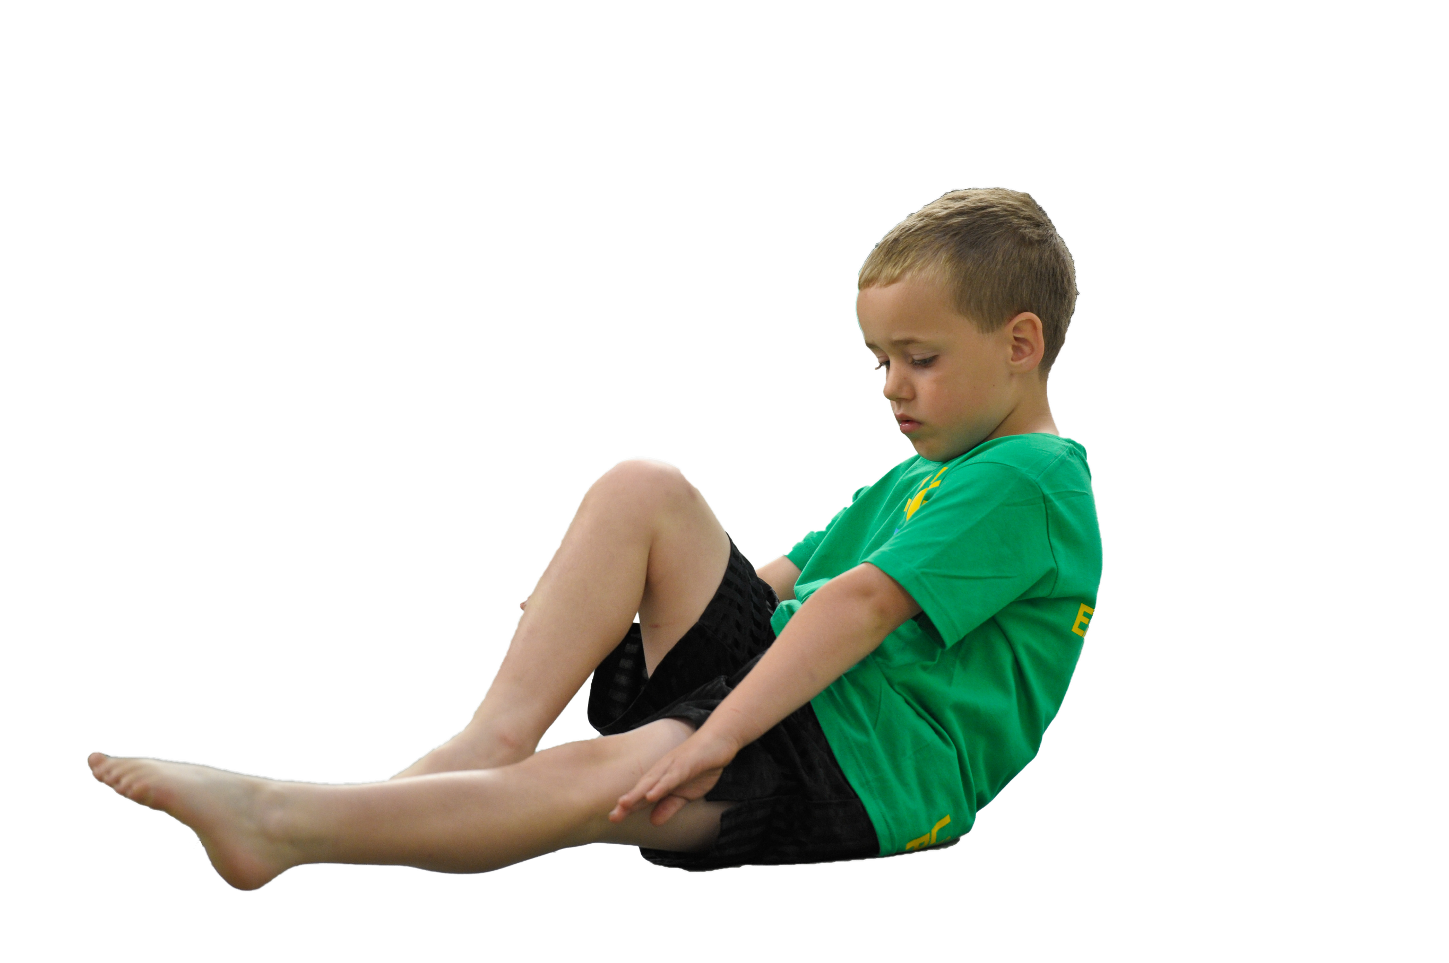
Schools must use the funding to make additional and sustainable improvements to the quality of Physical Education, Sport and Physical Activity (PESPA) they offer. This means that you should use the Primary PE and Sport Premium to:

- Develop or add to the PESPA activities that your school alreadyoffer
- Buildcapacityandcapabilitywithintheschooltoensurethatimprovementsmadenowwillbenefitpupilsjoiningthe school in futureyears

Please visit gov.ukfor the revised DfE guidance including the 5 key indicators across which schools should demonstrate an improvement. This document will help you to review your provision and to report
your spend. DfE encourages schools to use this template as an effective way of meeting the reporting requirements of the Primary PE and Sport Premium.

We recommend you start by reflecting on the impact of current provision and reviewing the previous
spend.UndertheOfstedSchoolsInspectionFramework,inspectorswillassesshoweffectivelyleadersusethe PrimaryPEandSportPremiumandmeasureitsimpactonoutcomesforpupils,andhoweffectivelygovernorshold them to account forthis.

Schools are required to publish detailsof how they spend this funding as well as on the impact it has on pupils’ PE and sport participation and attainment by the end of the summer term or by 31 July 2019 at the
latest.
We recommend regularly updatingthe table and publishing it
on your website throughout the year, as evidence of your
ongoing review into how you are using the money to
secure maximum, sustainable impact. To see an
example of how to complete the table please
click HERE.

MUSCLIFF PRIMARY SCHOOL
Evidencing the Impact of Primary PE and Sport Premium – 2018/19

Vision for the Primary PE and Sport Premium

ALL pupils leaving primary school physically literate and with the knowledge, skills and motivation necessary to equip them for a healthy, active lifestyle and lifelong participation in physical activity and sport.

The funding has been provided to ensure impact against the following objective.

OBJECTIVE:
To achieve self-sustaining improvement in the quality of PE and sport in primary schools.
It is expected that schools will see an improvement against the following 5 key indicators:
Key Indicator 1:The engagement of all pupils in regular physical activity - the Chief Medical Officer guidelines recommend that all
children and young people aged 5 to 18 engage in at least 60 minutes of physical activity a day, of which 30 minutes should be in school.
Key indicator 2: The profile of PE and sport is raised across the school as a tool for whole-school improvement.
Key indicator 3: Increased confidence, knowledge and skills of all staff in teaching PE and sport.
Key indicator 4: Broader experience of a range of sports and activities offered to all pupils.
Key indicator 5: Increased participation in competitive sport.

Support for review and reflection - considering the 5 key indicators from DfE, what development needs are a priority for your setting and your students now and why? Use the space below to reflect on previous spend, identify current need and priorities for the future.

Key achievements to date: | Areas for further improvement and baseline evidence of need:
- Ensured LT and MT plans show a broad and balanced curriculum (new scheme of work)  - PE and Sport promoted around school – notice board, newsletters, website, assemblies, sports super star of the week, sports ambassadors  - PE apprentice role increased to impact on whole school PE and sport; raising the profile and standard of PE (including lessons) across school (increased extra-curricular provision and support for specific groups of children in class and targeted children across the school)  - Playtime activities – new zones for playground areas.  - Broad range of extra-curricular activities on offer (parent paid and free clubs) including non traditional sports such as Golf and Multi-sports.  - Specific CPD – increased staff confidence particularly in Gymnastics, Tennis, fundamental movement skills  - Strong, contributing member of the Septenary Trust Schools. New staff polos/ jumpers for new staff to promote PE, raise profile within and outside of school at events.  - Bronze Sainsbury’s Quality Mark 2014-2015  - Gold Sainsbury’s Quality Mark 2015-2016  - Gold Sainsbury’s Quality Mark 2016-2017  - Gold Sainsbury’s Quality Mark 2017-2018  - Quality Mark 2018-2019 Submitted  - AfPE Quality Mark with Distinction 2016 (valid for 3 years) | - Continue to look into offering a variety of extra-curricular clubs, promoting non-traditional sports such as archery, fencing, cheerleading and street dance etc. (Sports identified from children’s questionnaire)  - Setting up cross country club and entering a variety of competitions.  - Continue to increase community club links by creating new clubs / providing introductory sessions.  - Staff questionnaire analysis, new CPD needs, areas of development, review of PE apprentice  - Aspire to achieve Gold Sainsbury’s Quality Mark 2019-20 by raising uptake on extra-curricular clubs, and include c teams for inter-school tournaments.  - Increase swimming competency  - Continue to develop LT and MT plans with set sports for year groups to focus on progression of skills within lessons.  - Sports leaders to increase roles and responsibilities (Year 6)  - Develop further links with secondary schools to increase opportunity for CPD  - Apply for new AfPE Quality Mark

Meeting national curriculum requirements for swimming and water safety | Please complete all of the below:
What percentage of your current Year 6 cohort swim competently, confidently and proficiently over a distance of at least 25 metres?  N.B. Even though your children may swim in another year please report on their attainment on leaving  primary school. | 65.4% (2019 data)  76% (2018 data)  63% (2017 data)
What percentage of your current Year 6 cohort use a range of strokes effectively [for example, front crawl, backstroke and breaststroke]? | 65.4% (2019 data)  72% (2018 data)  61% (2017 data)
What percentage of your current Year 6 cohort perform safe self-rescue in different water-based situations? | 54.8% (2019 data)  89% (2018 data)  61% (2017 data)
SchoolscanchoosetousethePrimaryPEandSportPremiumtoprovideadditionalprovision for swimming but this must be for activity over and above the national curriculum requirements. Have you used it in this way? | No

Action Plan and Budget Tracking
Capture your intended annual spend against the 5 key indicators. Clarify the success criteria and evidence of impact that you intend to measure to evaluate for students today and for the future.

Academic Year: 2018/19 |  | Total fund allocated: £21,070 | Date Updated: July 19
Key indicator 1: The engagement of all pupils in regular physical activity – Chief Medical Officer guidelines recommend that primary school children undertake at least 30 minutes of physical activity a day in school |  |  |  |  | Percentage of total allocation:
 |  |  |  |  | 75%
School focus with clarity on intended impact on pupils: | Actions to achieve: |  | Funding allocated: | Evidence and impact: | Sustainability and suggested next steps:
Improved engagement for all children in regular physical activity with a focus on increasing physical activity at playtimes and lunchtimes.  Kick start healthy active lifestyles – 10% increase in activity of less active children in upper Key Stage 2. | - Whole staff professional learning to include teachers, teaching assistants and lunchtime supervisors throughout the year.  - PE subject leader to provide updates throughout the year in staff meetings (sports day etc).  - PE leader to meet with a broad range of children to talk to them about their daily physical activity.  - PE Apprentice to organise multi skills sessions targeting less active children after school. |  | PE Apprentice  £15,440  £50 | - Whole staff aware of the recommended guidelines for daily activity and considering this throughout the school day.  - The focus on increased physical activity evident at all playtimes and lunchtimes and within daily lessons.  - Evidence from questioning children. | - Playground and lunchtime activities to target those less active through personal challenge events  - PE subject Leader to identify any staff who need further support and to provide appropriate professional learning  - Further professional learning opportunities for staff who request it. For example: Teachers to buddy up and carry out peer observations to support continual learning.  - PE Subject Leader to monitor and to provide support as appropriate in order to ensure progress and achievement are maintained by all children.  - Change for life club to start in the summer term 2.020
Key indicator 2: The profile of PESSPA being raised across the school as a tool for whole school improvement |  |  |  |  | Percentage of total allocation:
 |  |  |  |  | 5%
School focus with clarity on intended impact on pupils: |  | Actions to achieve: | Funding allocated: | Evidence and impact: | Sustainability and suggested next steps:
PE and Sport used to engage and increase children’s attainment in core subjects, in particular for targeted specific groups in Numeracy.  Improved quality of children’s physical literacy, particularly in KS1.  The profile of children’s achievements and successes in PE and Sport highlighted in whole school events and clearly evident around school. |  | - PE subject leader to provide updates, provision and strategies for whole school improvement throughout the year in staff meetings / professional conversations.  - PE across the curriculum 30:30  PE Apprentice to provide opportunities within PE for cross-curricular activities, raising attainment and providing CPD for teachers.  ‘Maths of the Day’ will be used across the school as starters or workshop sessions.  - Promote sporting success and achievements in ‘Good News Assembly’, on the website and on PE board. Sports Superstar of the week – awarded across school for effort and commitment towards sporting values.  - 30:30 Activity  KS1 children take part in Go Noodle exercises before literacy to increase their physical literacy and gross motor skills.  - ‘Active Literacy’ strategies which will be used across the school as starters or workshop sessions.  - Weekly ‘Sports Superstar’ announced in assembly, with trophy and certificate. Clear recognition for why they have been awarded (sporting value they have shown)  - Sports Superstar board visible in sports hall and website, trophy provided  - All teachers provided with mini sports certificates to recognise sporting values shown achievements in lessons  - Team and individual achievements in sport celebrated in class, during whole school celebration assembly, on the PE noticeboard and on the school website and newsletter. | £0  £595  PE Apprentice Above  £75 MPA funded trophies ‘Sports superstar of the week  £0  £0 | - PE and active style of teaching and learning evident in School Improvement Plan (Numeracy)  - All year groups have access to additional resources (Maths of the day) to adapt lessons and add active approach.  - KS1 significant improvement in handwriting as a result of Go Noodle active start to literacy. 70% of children leave Year 1 with cursive handwriting.  - Sports success and heightened profile recognised in whole school parent questionnaire. Increase on 80% of parents last year. | - Active lesson plans in place will ensure a sustained part of whole school curriculum and therefore reduced need for subscriptions from outside agencies.  - PE Subject Leader to monitor and to provide support for active teaching and learning opportunities across all phases to ensure impact on all children.  - PE subject Leader to identify any staff who need further support and arrange sharing of teaching styles and strategies in each Key Stage to incorporate active learning.  - PE Subject Leaders to ensure staff are up to date with latest strategies and resources

Key indicator 3: Increased confidence, knowledge and skills of all staff in teaching PE and sport |  |  |  |  |  | Percentage of total allocation:
 |  |  |  |  |  | 10%
School focus with clarity on intended  impact on pupils: | Actions to achieve: |  | Funding  allocated: |  | Evidence and impact: | Sustainability and suggested  next steps:
Improved quality of children’s physical education, gymnastics across the school to ensure they are confident and competent in key skills.  Improved quality of children’s physical education in dance across KS2 to ensure children are confident and competent.  Raised profile of healthy active lifestyle behaviours by all school staff to reach all children.  Improved quality of children’s physical education in swimming to ensure 70% of children are confident and competent to swim 25m at the end of KS2. | - All teaching staff (Teachers and TAs) to participate in professional learning and CPD in Gymnastics – Gemma Coles  - CPD to be delivered in planned blocks across the year to ensure whole school coverage.  - Children to be clearly signposted to gymnastics club and competition opportunities after school.  - PE subject leader to meet with a broad range of children to talk about their gymnastics and dance skills and to ascertain their knowledge and understanding of the subject.  - PE subject leader to discuss with Year Leads positive outcomes and what areas are for development.  - Focus on growing confidence of PE Apprentice HTLAs to work with a range of children particularly when covering.  - Importance of warming up and cooling down incorporated into lesson discussions.  - Exercise and healthy lifestyles taught within science lessons across the whole school.  - Staff CPD in swimming from qualified instructors.  - Liaise with Littledown swimming instructors to ensure children are confident to perform safe self-rescue in different water-based situations. |  | £2000  £0  £  Above CPD |  | - All year groups to receive CPD in area of weakness identified from staff questionnaire (EG. Tennis CPD in Year 5).  - The focus of lessons are child centred and as a result children are engaged and keen to improve.  - As a result children make good or better progress both in lessons and over time (see teacher’s assessment tracking data).  - Increased number of children involved in Dorset gymnastics competition and extra-curricular dance and gymnastics clubs.  - PE Apprentice shares knowledge and expertise with other teachers during non-directed CPD times  - Extra-curricular club (Golf) targeted to encourage less active children will show a % increase in summer data showing an increase in attendance of pupils most in need.  - Questioning of children provides supporting evidence of knowledge of healthy active lifestyle behaviours | - PE subject Leader to support new staff in school with planning for delivery of physical education.  - Arrange team teaching opportunities and supportive lesson observations in order to develop the quality of teaching, learning and assessment.  - PE subject Leader to identify any staff who need further support and to provide appropriate professional learning.  - Further professional learning opportunities for staff who request it. For example: Teachers to buddy up and carry out peer observations to support continual learning.  - PE Subject Leader to monitor and to provide support as appropriate in order to ensure progress and achievement are maintained by all pupils.  - PE Subject leader networks with colleagues (particularly secondary schools) at other schools to encourage on going sharing of good practise.
Key indicator 4: Broader experience of a range of sports and activities offered to all pupils |  |  |  |  |  | Percentage of total allocation:
 |  |  |  |  |  | 5%
School focus with clarity on intended  impact on pupils: | Actions to achieve: | Funding  allocated: |  | Evidence and impact: |  | Sustainability and suggested  next steps:
Additional achievements:  Improved children’s awareness of the board and balanced PE and sports opportunities in and outside of school.  Engage at least 60% of children in extra-curricular clubs.  Target provision for 15% children identified as less active.  All children experience a broad and balanced curriculum and aware of at least 5 community sport links and pathways in the local area.  Engage 15% of children in leading, managing and officiating.  Increased opportunities within school for children with SEND and other targeted groups. | - Promote inclusive PE and Sport opportunities to children, parents and the local community at least once a fortnight using newsletters, website, assemblies and school notice board.  - Community clubs clearly signposted for children in noticeboard, during extra-curricular clubs and PE lessons.  - PE Apprentice to identify children across school with potential to attend community clubs.  - Ensure accurate registers of all extra-curricular clubs are retained and used for data analysis, comparisons and to target specific groups of children.  - Use sports premium to provide ‘free’ clubs for children. (Gymnastics, Tennis, Cricket, Tag Rugby)  - Sports council and children’s questionnaire used to identify new clubs and interest.  - Year group analysis and discussions with year leads to identify less active children.  - Curriculum PE: All children to gain a good understanding of the positive benefits of being physically active.  - Curriculum PE: Adapted physical activities through which children can develop and apply a broad range of skills in different contexts — enhancing their creative, social and thinking skills in PE.  - Provide NGB coaches taster sessions, curriculum CPD and extra-curricular club opportunities for all children to access community sports clubs.  - Clubs clearly signposted on PE notice board, school website and newsletter.  - Sports leaders opportunities in KS1 and KS2 at break and lunch time. All children in Year 5 participate officiating and leading in KS1 Sports Day.  - All upper KS2 Reception siblings participate officiating and leading Reception Sports day.  - Bronze Ambassadors and Sports Leaders to organise structured activities at playtimes and within intra competitions.  - Attendance at new SGO ‘Can do’ sports competitions provided by Bournemouth SGO. (Specific competition for SENd children), liaise with SENCo and class teachers to identify key children.  - Community link with Victoria school for sports opportunities and link to secondary SEND provision.  - Children identified as priority for extra- curricular clubs. | £0  £1000  £400  New equipment  £0  £Within  Transport to events funding allocation |  | - Promote inclusive PE and Sport opportunities to children, parents and the local community at least once a fortnight using newsletters, website, assemblies and school notice board.  - Community clubs clearly signposted for children in noticeboard, during extra-curricular clubs and PE lessons.  - PE Apprentice to identify children across school with potential to attend community clubs.  - Provision given for 15% + of children identified as less active.  - Provision given for 10% + of children identified as SEND.  - 15% + children involved in officiating and leading.  - Questioning of children provides supporting evidence.  - Data in summer shows evidence to support impact. (Exceeded and emerging %)  - Strong links with community clubs: Tennis Bound, Gymnastics, etc  - Increased confidence of children and participation in lessons noticed by teachers. |  | - Look to increase % of children attending EC clubs by providing non traditional sports for those less active.  - PE Team to support staff (particularly NQT’s) in school with planning for a broad and balanced curriculum.  - Year group folders regularly updated with planning, MTP and LTP  - PE Lead to track children’s provision and attendance for SENd children.  - PE Lead to track children’s provision and attendance for less active children.  - PE subject leader keeps up-to-date with government policies and recommendations (e.g. obesity paper2016)  - Children’s questionnaires to identify future sports of interest.  - PE Leader to work closely with community clubs to ensure a clear pathway and sign posting to nearest club opportunities.  - Focus on SENd community club opportunities and specific sports.  - Target children provided opportunities to take part in additional sports activities (Change 4 Life club)
Key indicator 5: Increased participation in competitive sport |  |  |  |  |  | Percentage of total allocation:
 |  |  |  |  |  | 5%
School focus with clarity on intended  impact on pupils: | Actions to achieve: | Funding  allocated: |  | Evidence and impact: |  | Sustainability and suggested  next steps:
Increased range of BSSA and other local competitions entered.  Increased number of children competing in B and C team competitions.  Increased competitive opportunities for children with SEND and other targeted groups.  Increased number of children involved in intra competitions and aware of sports pathways in school and within the community. | - PE team to enter the majority of competitions in the BSSA (Bournemouth Primary Schools Association) and all competition where relevant in the Dorset School Games competition.  - Potential children identified by PE Apprentice and teachers with PE lessons and extracurricular clubs.  - Enter a minimum of 3 B teams in competitions (Silver quality mark)  - Children identified who have not represented the school yet.  - Year round programme of activities delivered in extra-curricular time.  - Intra competitions are built from competitions introduced in PE, focussed on games and personal challenge activities that use the skills and characteristics of NGB sports.  - Target children identified within PE planning and throughout lessons, with a focus on increased engagement.  - Intra competition embedded into PE lessons, PE apprentice to organise and liaise with Year Leads.  - Weekly intra football competitions in Year 6 (3 times a week). PE Lead to organise and liaise with lunchtime supervisors. Pathway to Year 6 football team and other community sports clubs.  - Fun and engaging non-traditional/alternative intra competitive activity formats that get children and young people active in themed multi-activity environments.  - PE Apprentice to introduce simple messages around health throughout intra competitions | £1000  (Mini bus and coach transport over the year)  Cost of supply for teachers to be released for events  Transport (as above)  £500 (NGB Coaches)  £0 |  | - Evidence through website, PE notice board, Blogs.  - Increased % of children representing the school in inter competitions.  - Evidence through School Games organiser for Bournemouth Sarah Dunsford – Achievement criteria of Gold Mark 2017 -18  - Increased number of children consistently attending extracurricular clubs  - Identified target children have made significant improvements in confidence, health and fitness (class data) and attendance in extra-curricular clubs and involvement in inter competitions increased.  - Lesson planning incorporates and builds up sports specific skills needed to achieve within intra school competitions.  - PE Apprentice records significant improvements on assessment sheets of targeted children.  - All children aware of intra competitions in their year group. |  | - Continue to enter all BSSA and School Games competitions. As well as any additional competitions appearing in the calendar run by local schools or organisations entered under head teacher/PE team’s discretion. E.G AFC Bournemouth’s festival of football.  - Enter C teams where applicable  - Local club coaches to support running of matches and tournaments. Chance to shine, Will Bound Tennis, Gemma Coles Gymnastics.  - Ensure B and C team children’s success are shared equally in celebration assembly and within the newsletter and website.  - Ensure they are clearly signposted to extra-curricular opportunities and community clubs to encourage sustained participation.  - Creation of a intra competition timetable across each year group across the school year.  - Key children identified for future competitions or pathways.  - Investigate further links additional satellite clubs within school or at local secondary schools (Bishop of Winchester).

